Choose and write.
Whose |  | hers | his | theirs
B
A
B
A
B
A
B
A
B
A
1 | 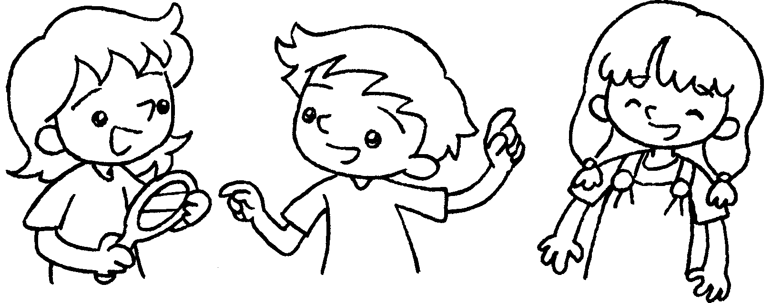 |  | A : Whose mirror is this?  B : It’s .
2 | 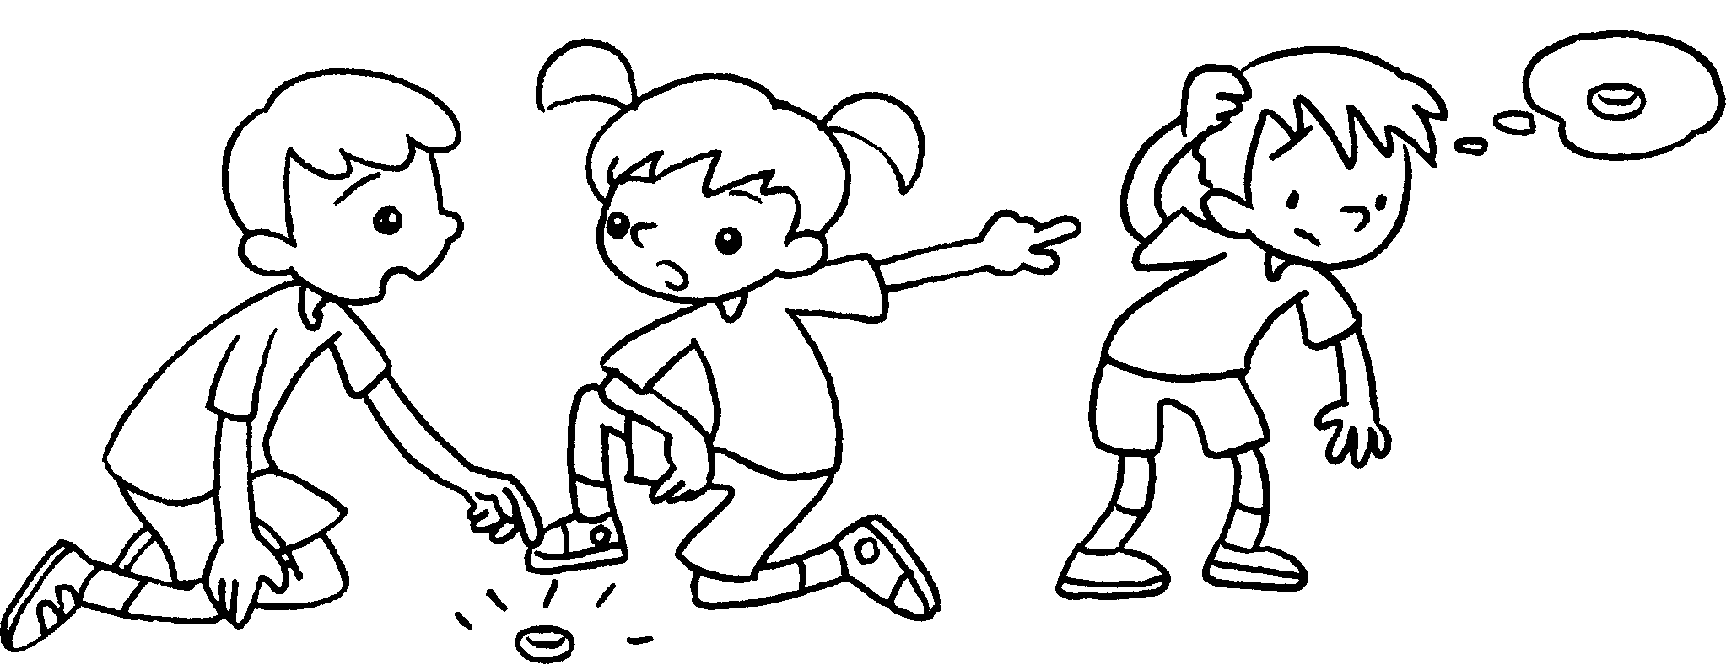 |  | A : Whose silver ring is this?  B : It’s .
3 | 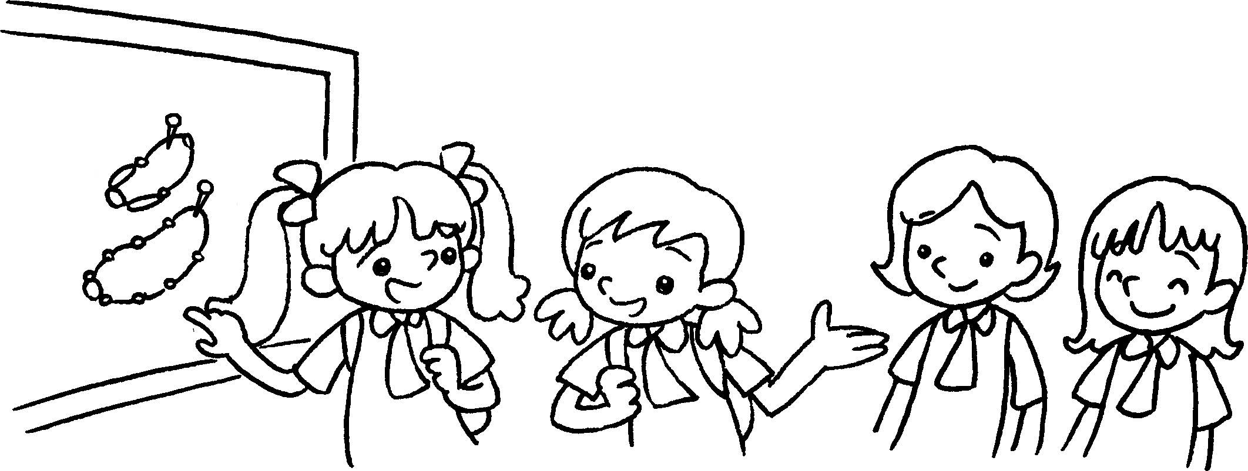 |  | A : necklaces are  these?  B : They’re .
4 | 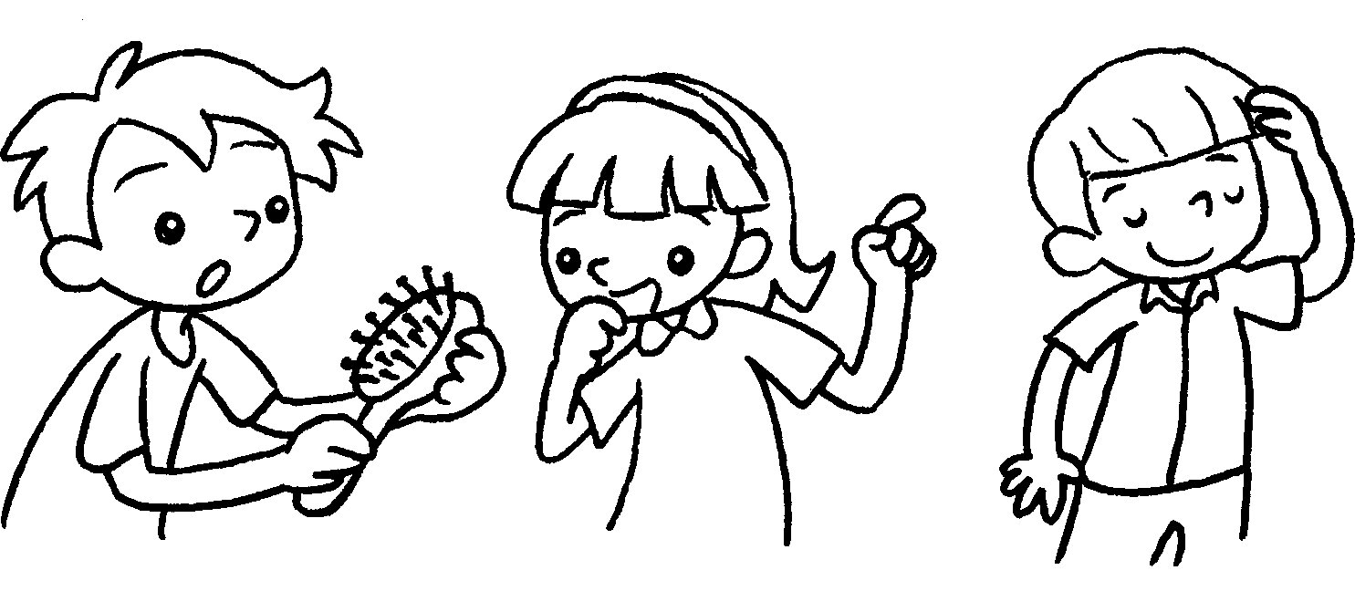 |  | A : hairbrush is this?  B : It’s .
5 | 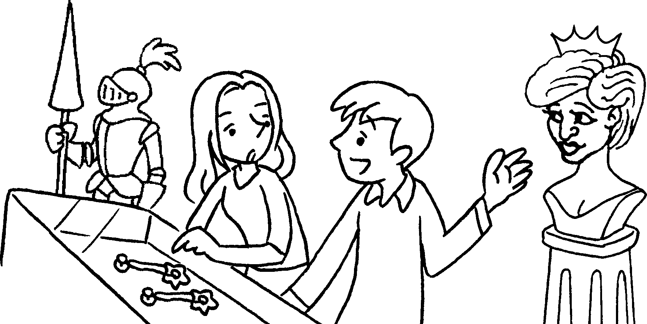 |  | A : earrings are  these?  B : They’re .


Book 5A Chapter 4 Graded Worksheets
Worksheet 3⬇
- hers
- his
- Whose
theirs
- Whose
his
- Whose
hers

