( earrings )
Finish the questions and answers.
( hairbrush )
 | hers | his | theirs
B
A
B
A
B
A
B
A
B
A
( necklaces )
1 | 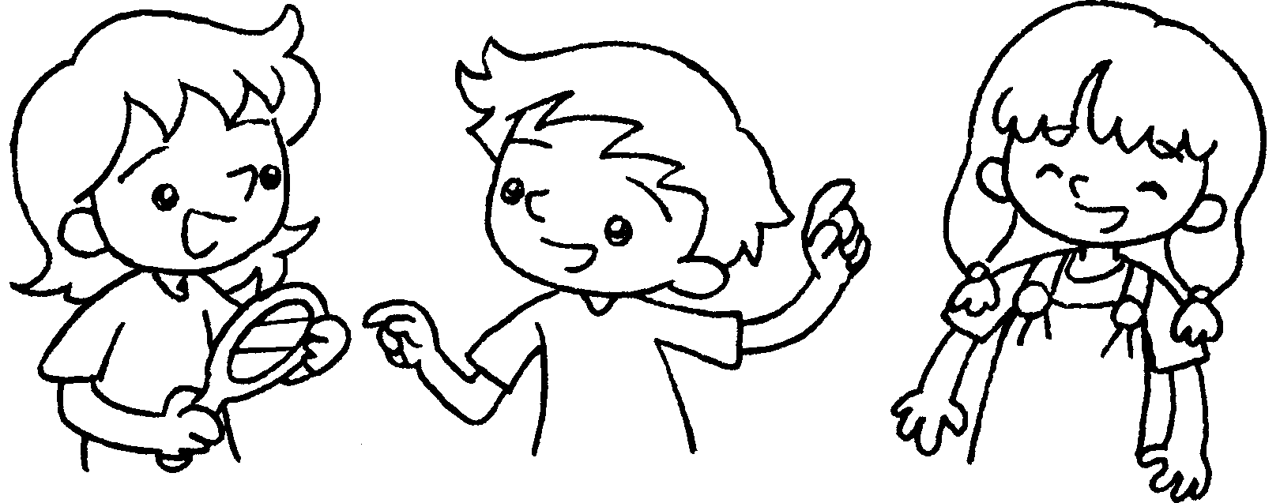 |  | A : Whose mirror is this?  B : It’s .
2 | 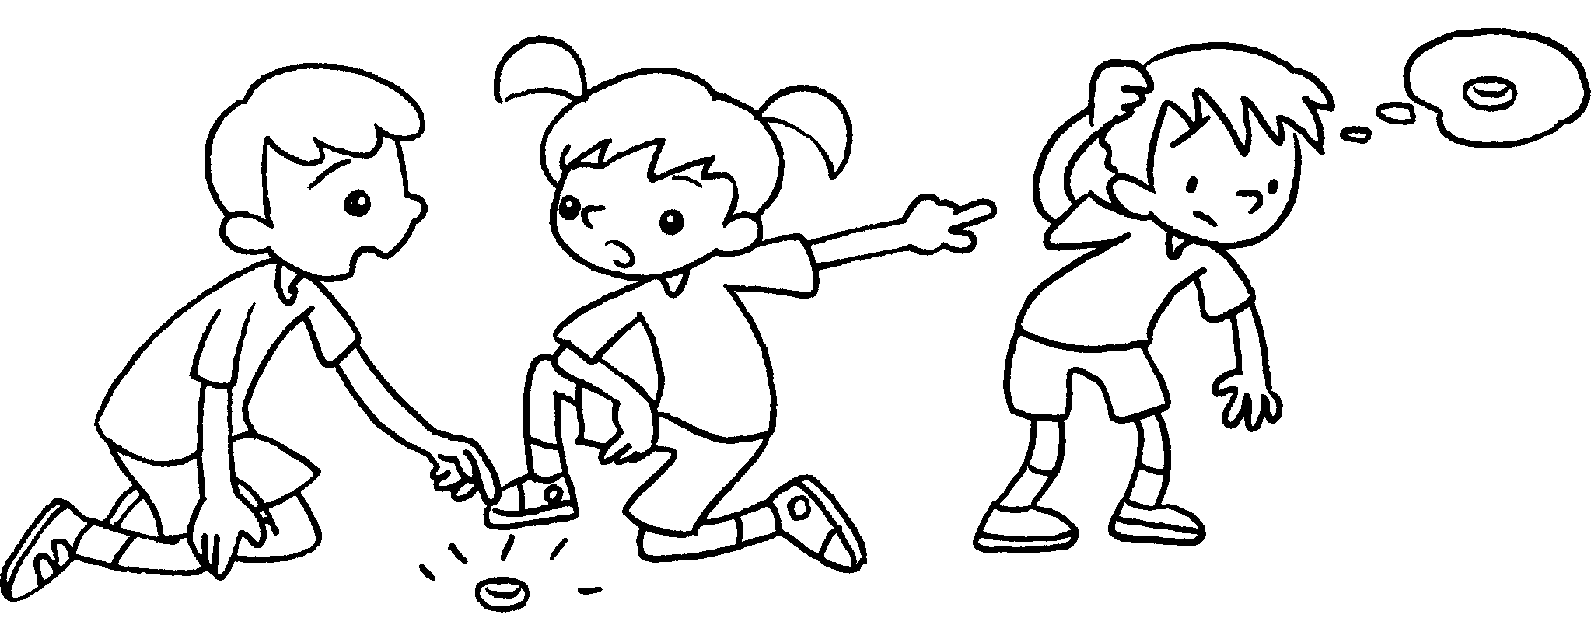 |  | A : Whose silver ring is this?  B : It’s .
3 | 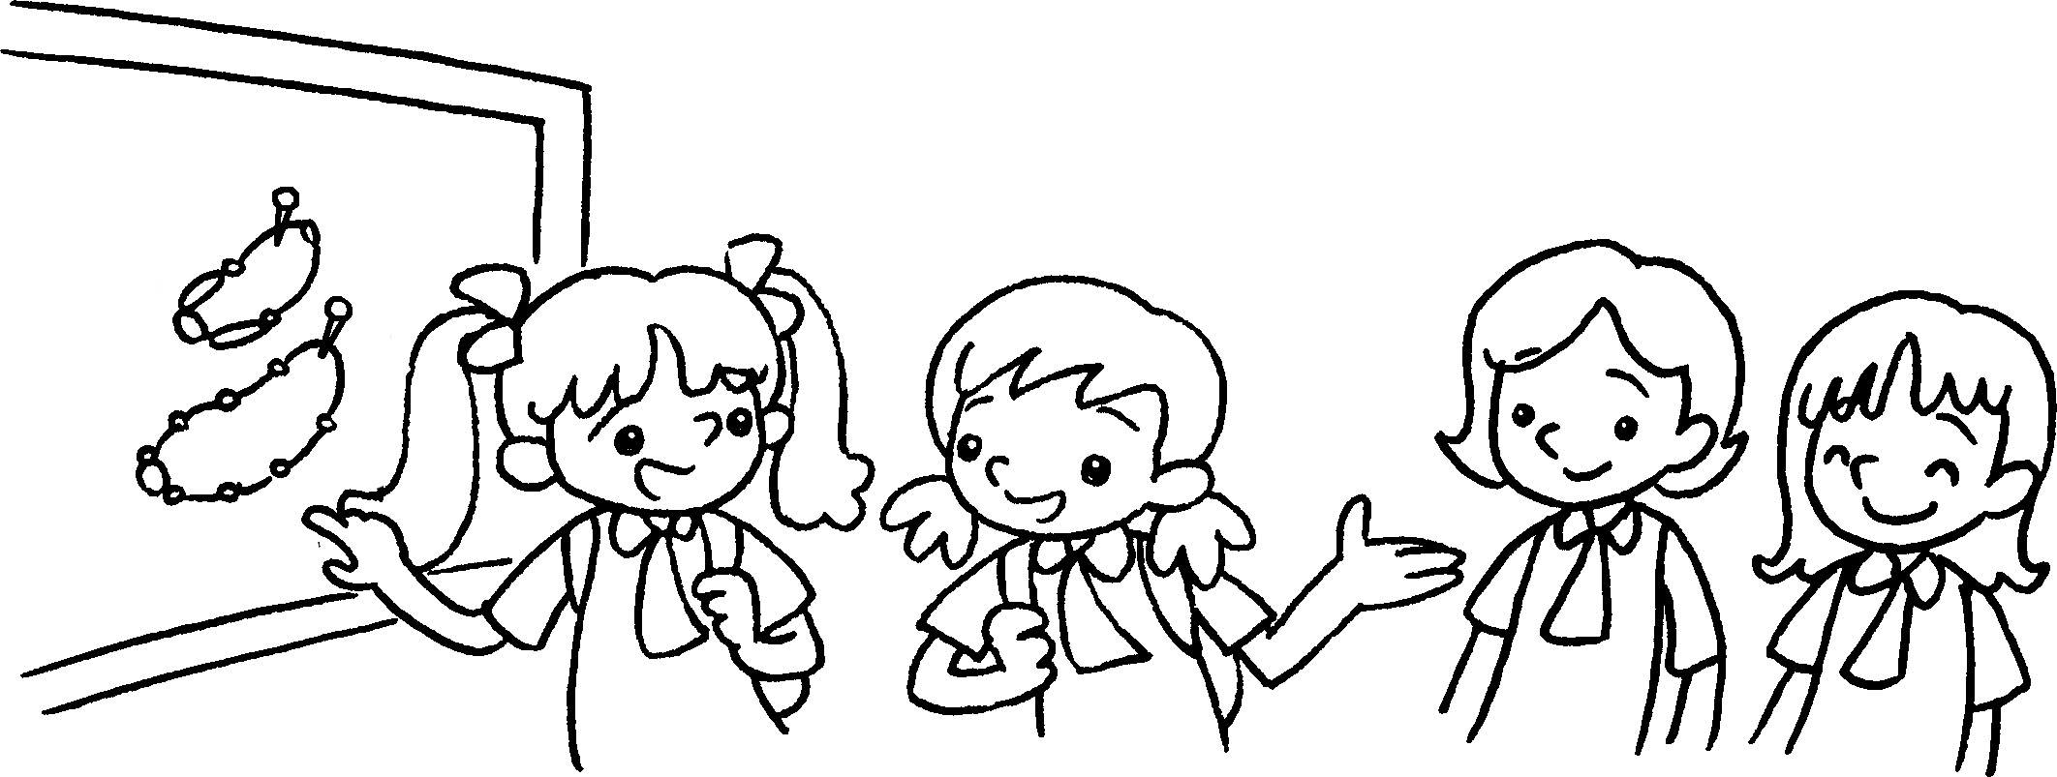 |  | A : are  these?  B : They’re .
4 | 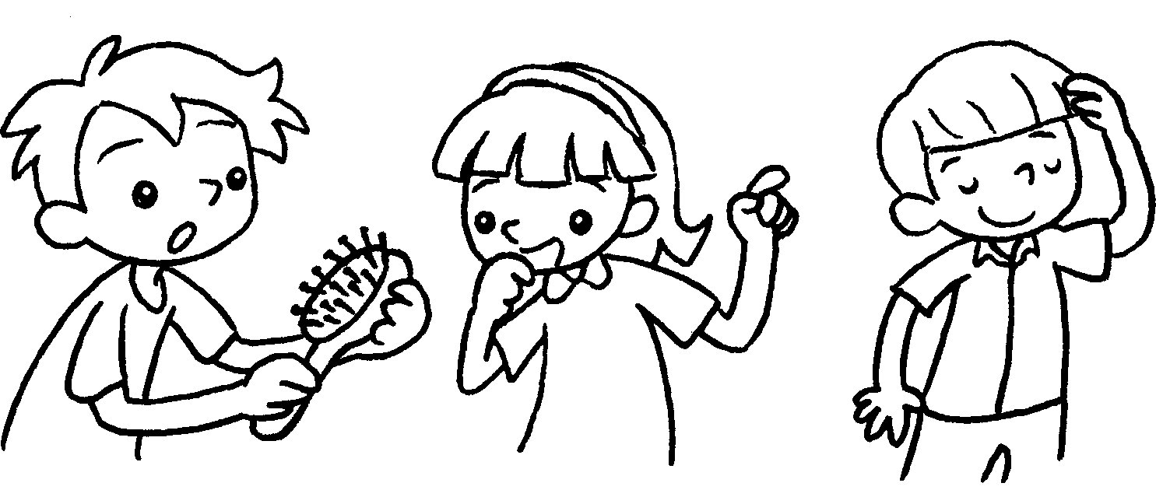 |  | A :  B : It’s .
5 | 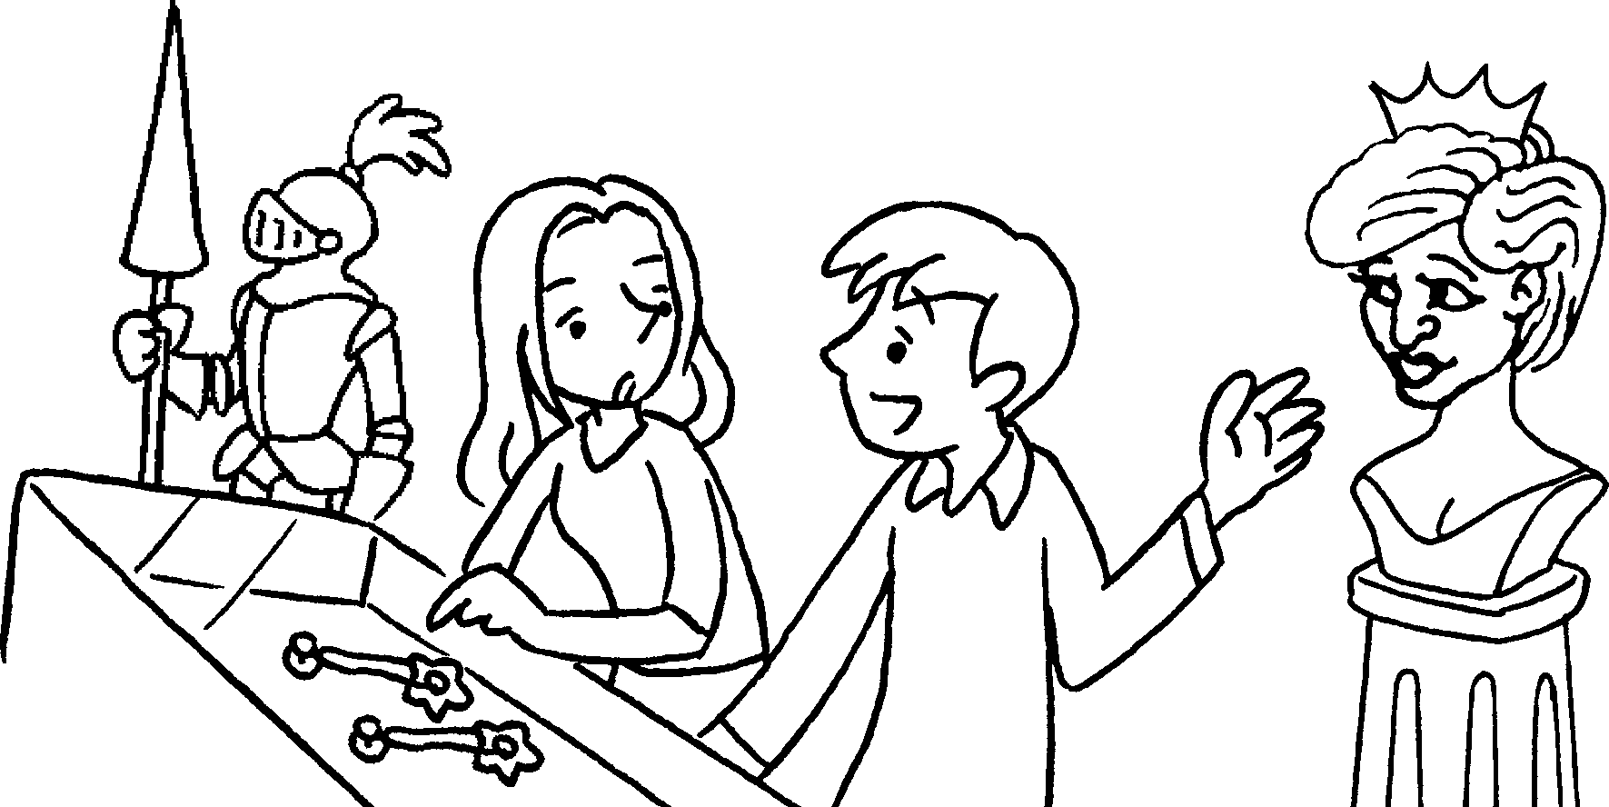 |  | A :  B : They’re .


Book 5A Chapter 4 Graded Worksheets
Worksheet 3⬇⬇
- hers
- his
- Whose necklaces
theirs
- Whose hairbrush is this?
his
- Whose earrings are these?
hers

