Finish the questions and answers.
B
A
B
A
B
A
B
A
B
A
1 | 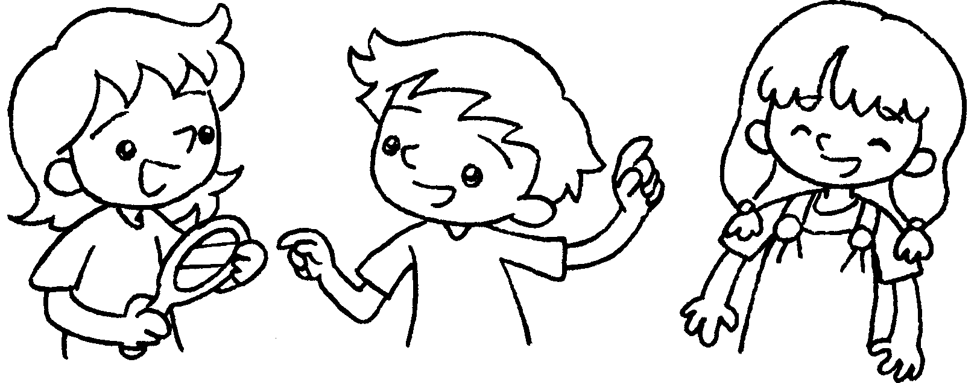 |  | A : Whose mirror is this?  B : It’s .
2 | 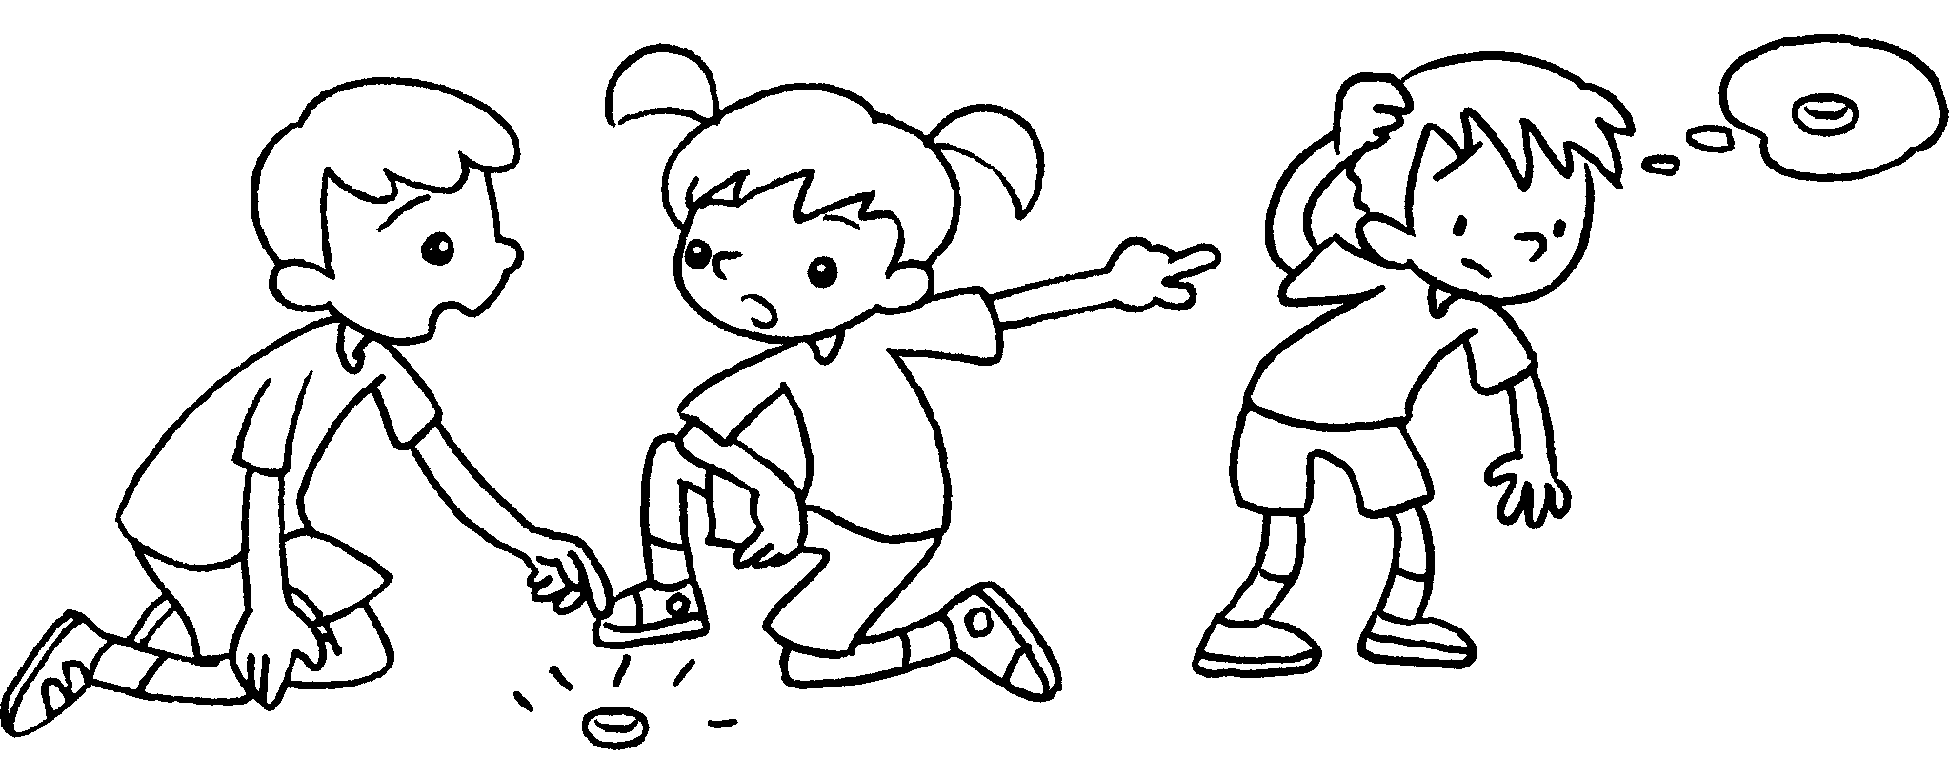 |  | A : silver ring is this?  B : It’s his.
3 | 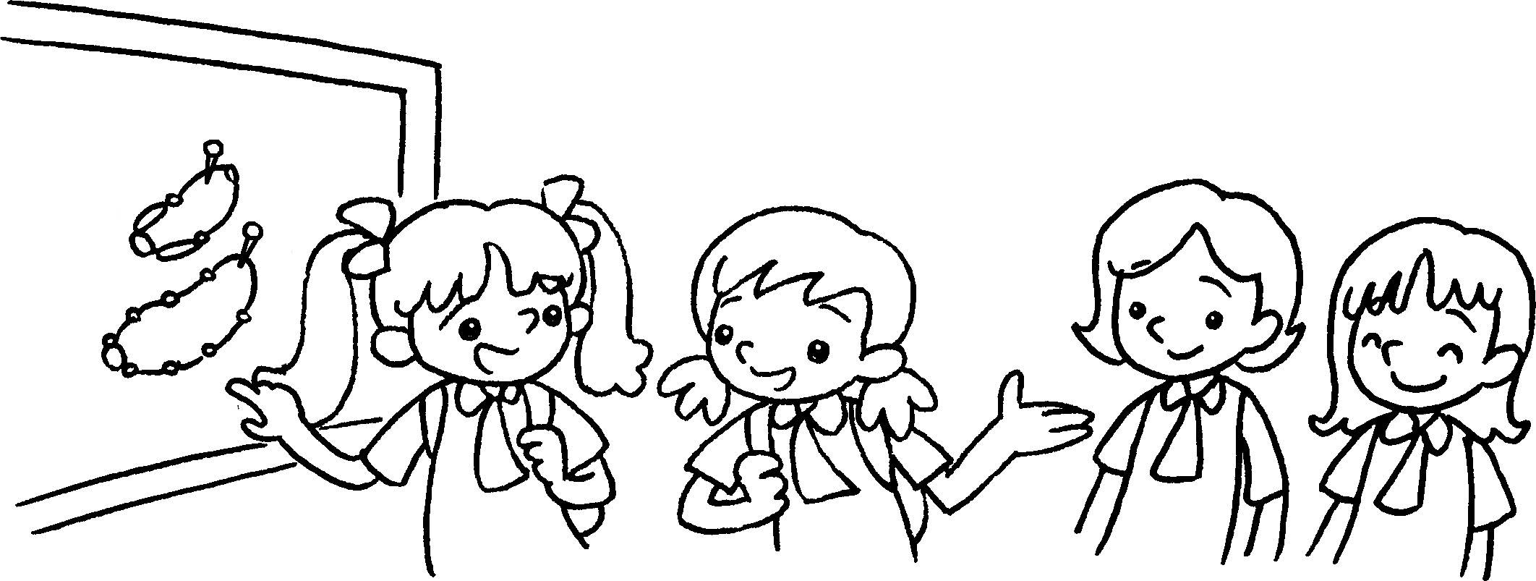 |  | A : are  these?  B : They’re .
4 | 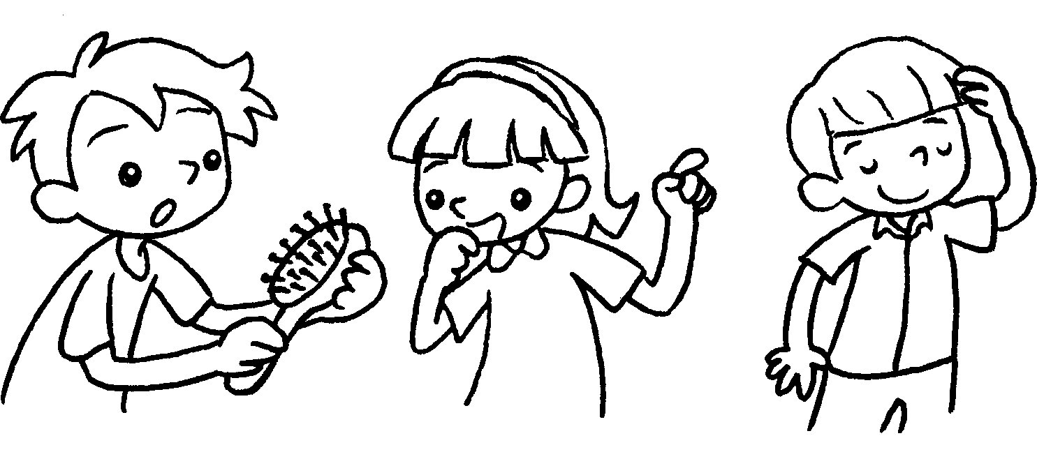 |  | A :  B :
5 | 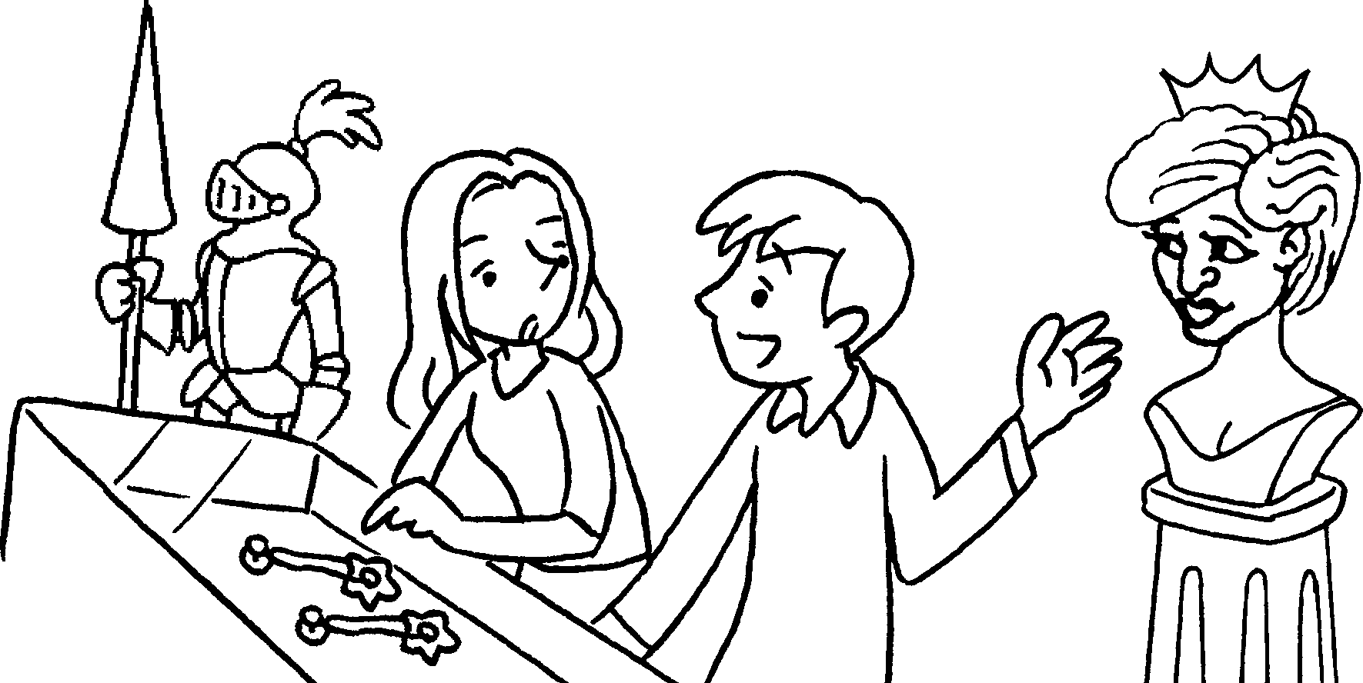 |  | A :  B :


Book 5A Chapter 4 Graded Worksheets
Worksheet 3⬇⬇⬇
- hers
- Whose
- Whose necklaces
theirs
- Whose hairbrush is this?
It’s his.
- Whose earrings are these?
They’re hers.

