- The New Cinderella (Part 2)
This is Act 2 of the play The New Cinderella. What can you remember about Act 1? Read the play and find out what happens next.

Characters
Cinderella (not his real name) ― a poor boy
Chris and Paul ― Cinderella’s rich step-brothers
‘Princess’ Peach ― a very rich girl
Flora ― a maid
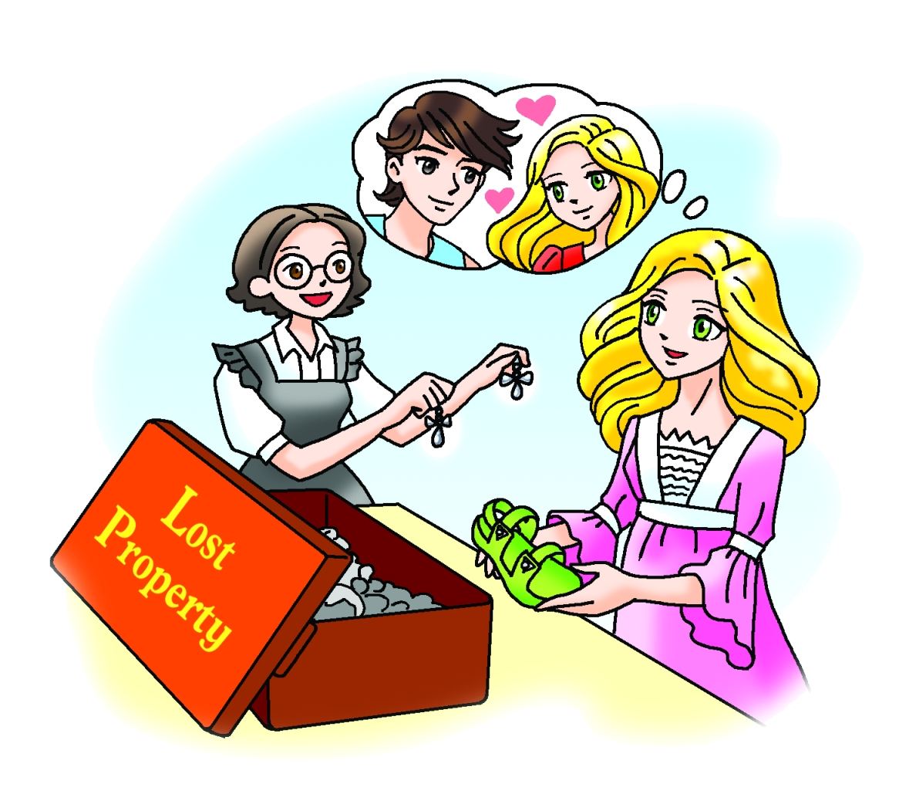

Act 2 Scene 1: At Peach Castle
Flora is putting some things in a box.
Enter Peach.
Flora : Morning, ‘Princess’. Your friends left a lot of things at the party
last night. Whose earrings are these?
Peach : Laura often wears silver jewellery. Maybe they’re hers. Oh,
Flora, I had a fantastic night. I met a boy! He’s tall, with dark
eyes and a lovely smile.
Flora : Oooh! What’s his name?
Peach : I don’t know!
Flora : You don’t know his name?
Peach : No, but he dropped this sandal.
Flora : Why don’t we make a ‘Found’ notice? Then maybe the boy will
come here to get his sandal.
Peach : That’s a brilliant idea!

Act 2 Scene 2: At Peach Castle
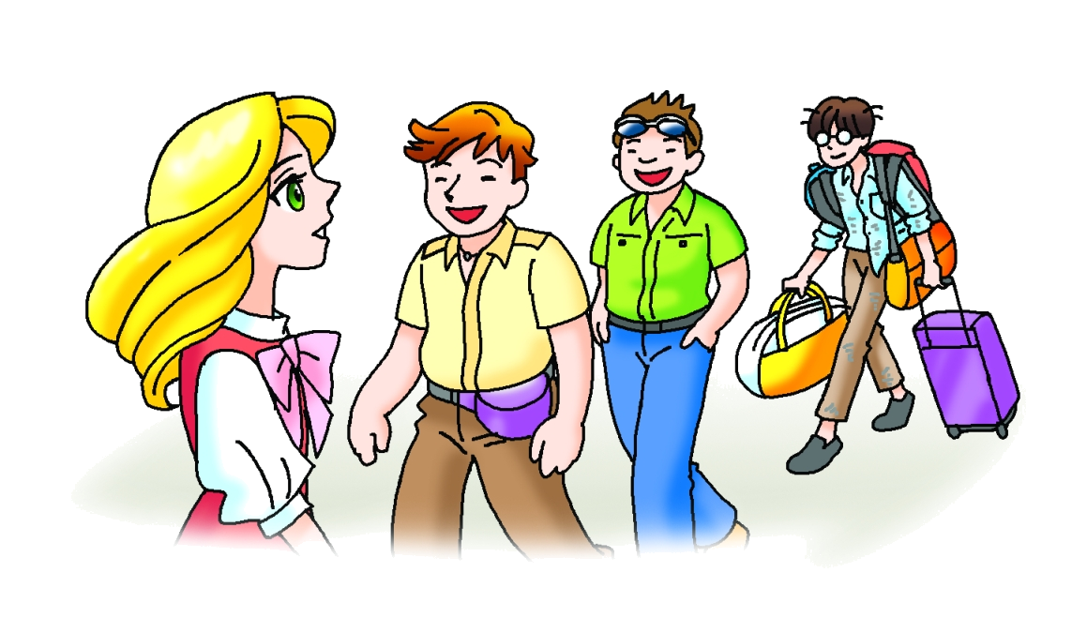
Enter Paul, Chris and Cinderella.
Chris : Hi, Peach. We were on holiday for two weeks. We just saw your
notice. The sandal is mine.
Paul : No, it’s mine!
Peach : (impatiently) Well, whose sandal is it?
Chris and Paul try. It is too small.
Peach : It’s not theirs. (to Cinderella) Why don’t you try it on?
Paul : It’s not his!
Peach : (to Cinderella) Please try it on.
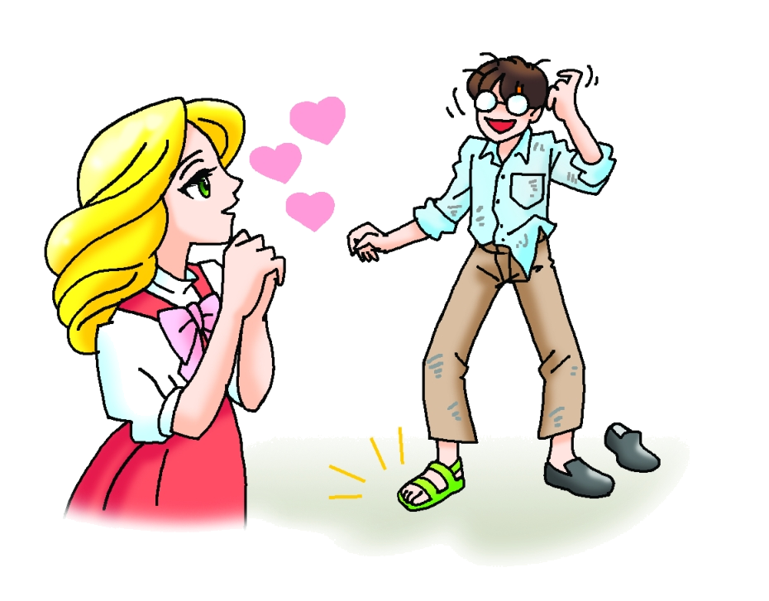
The sandal fits.

Peach : It’s yours! Why didn’t you answer my notice?
Cinderella : Because I’m a poor boy. You don’t want to have dinner with a poor boy like me.
Peach : Don’t be silly! I’d love to, but I still don’t know your name.
Cinderella : It’s Wang Zi.
Peach : Wang Zi! I’ve found my prince!
Flora : Hurray!
Cinderella and Peach dance away.

― The End ―

