Complete the table.
RP no: Century Gothic 15pt
(所有圈號用15pt)

 |  | Present | Past | Past participle
1 | 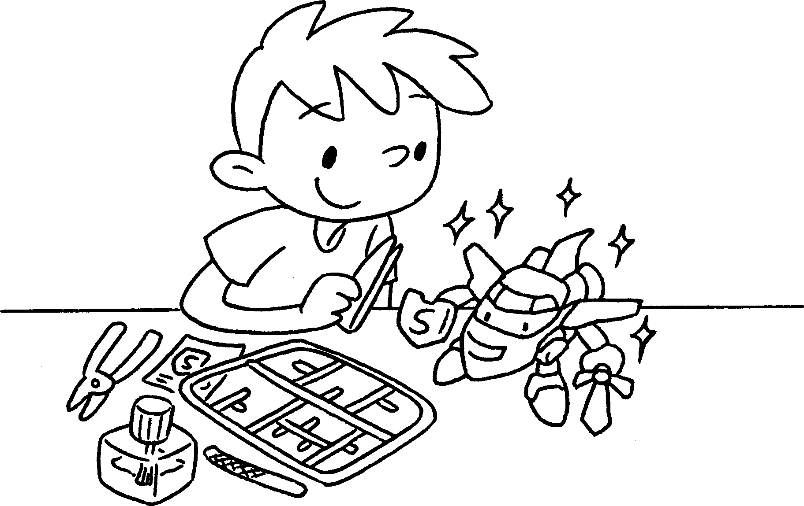 | finish | finished
2 | 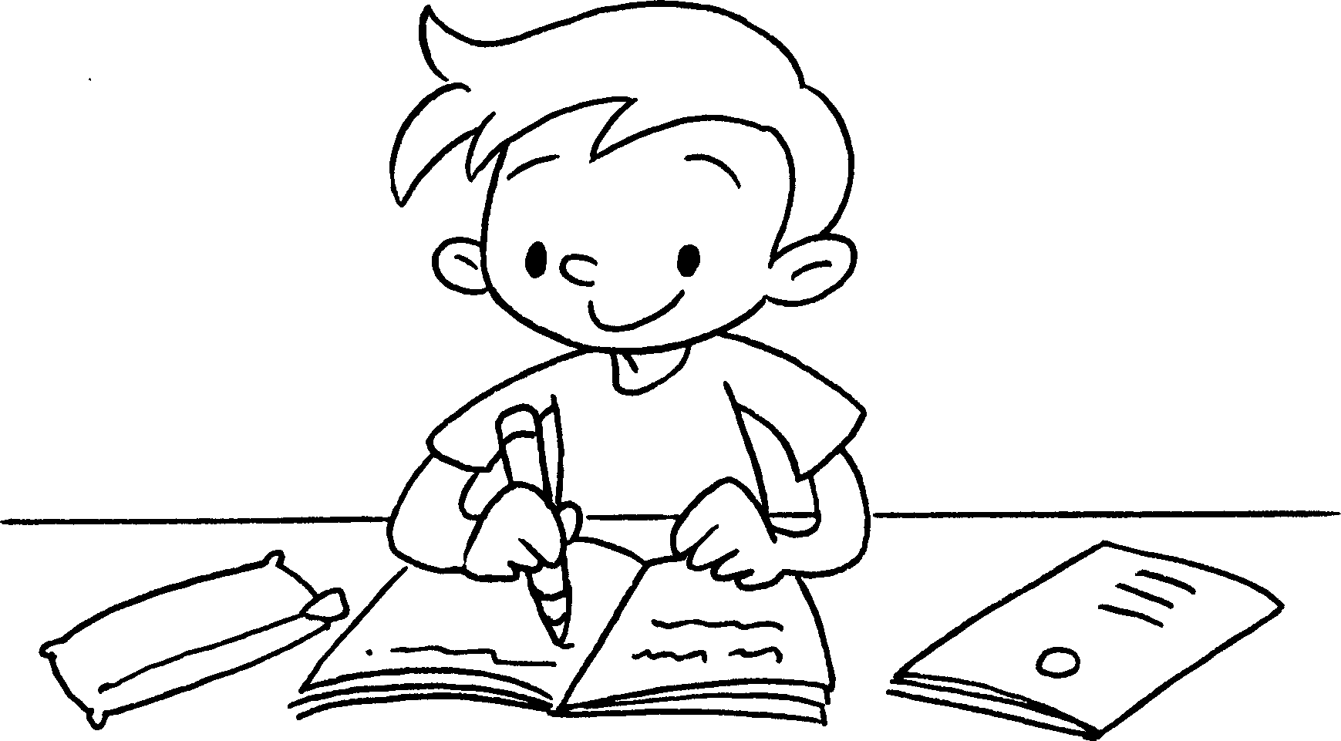 | do | did
3 | 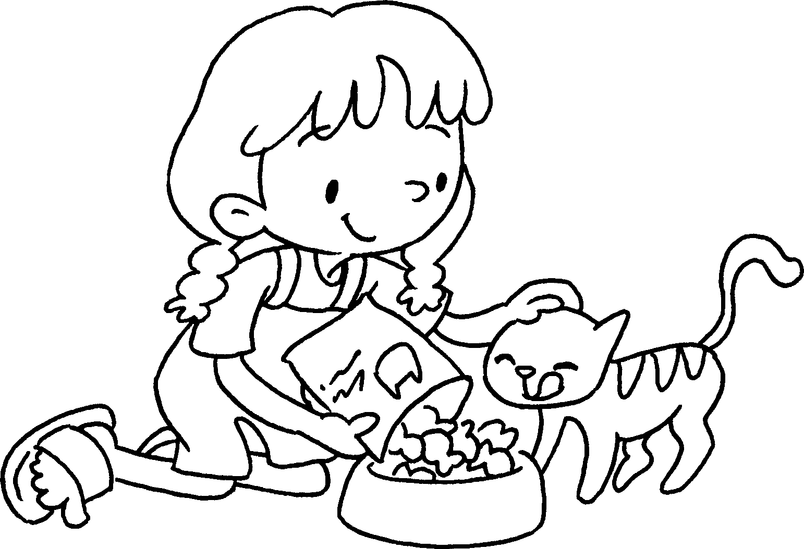 | feed | fed
4 | 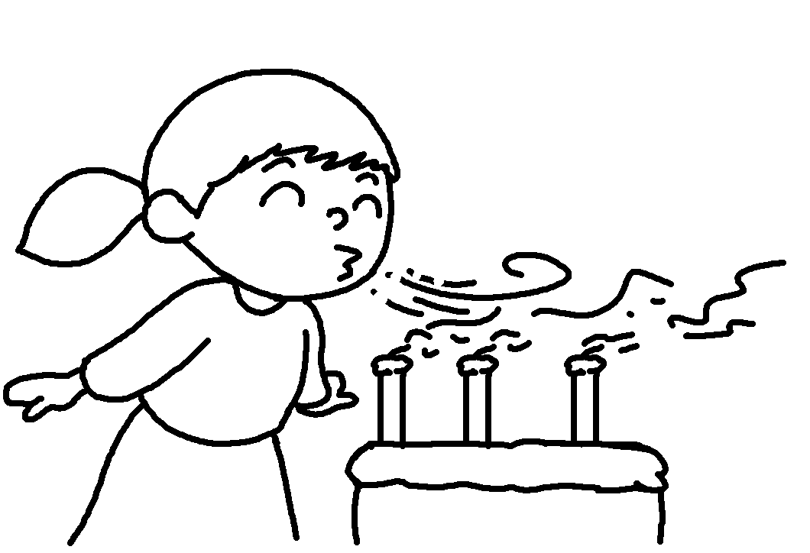 | blow | blew
5 | 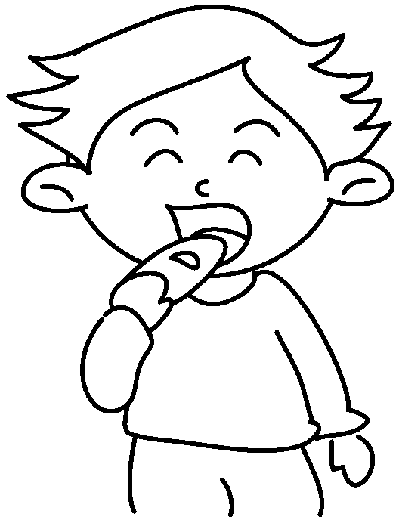 | eat | ate


Book 5A Chapter 5 Graded Worksheets
Worksheet 1⬇
- finished
- done
- fed
- blown
- eaten

