Complete the table.
RP no: Century Gothic 15pt
(所有圈號用15pt)

 |  | Present | Past | Past participle
1 | 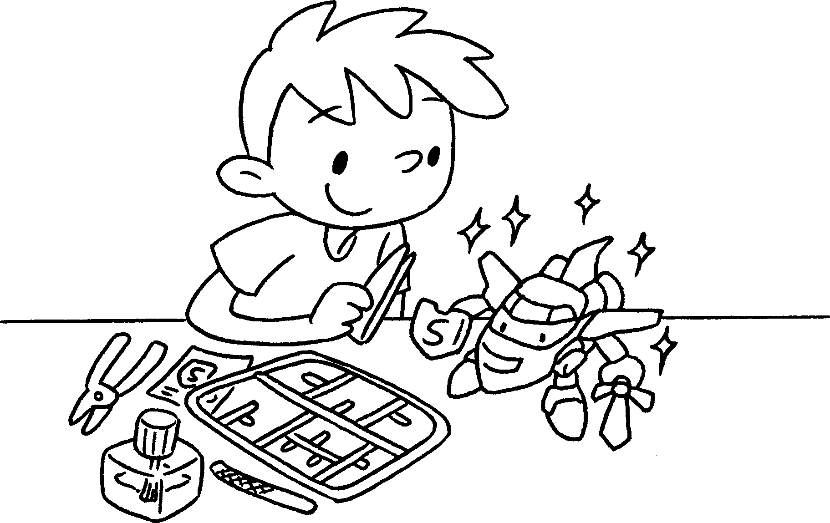 | finish
2 | 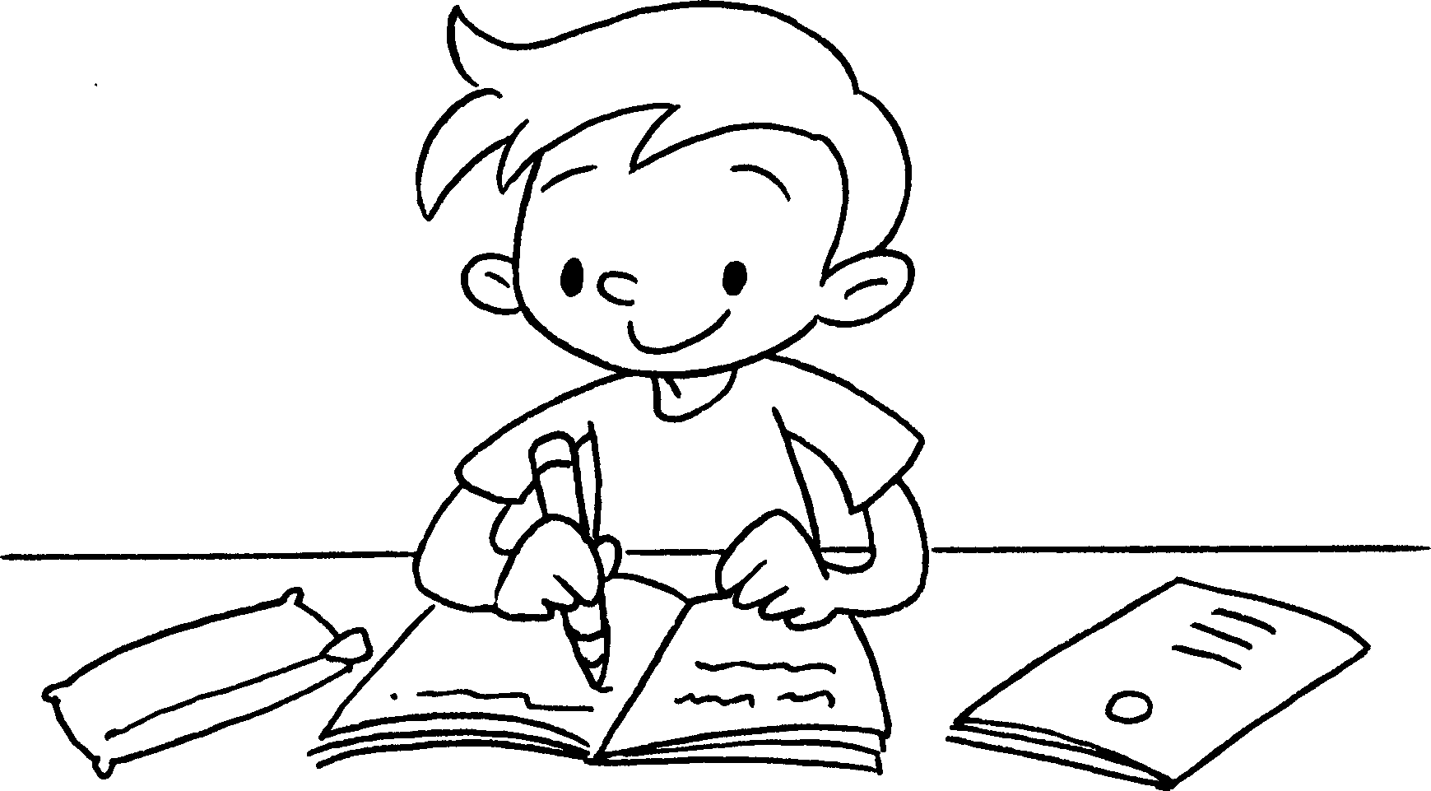 | do
3 | 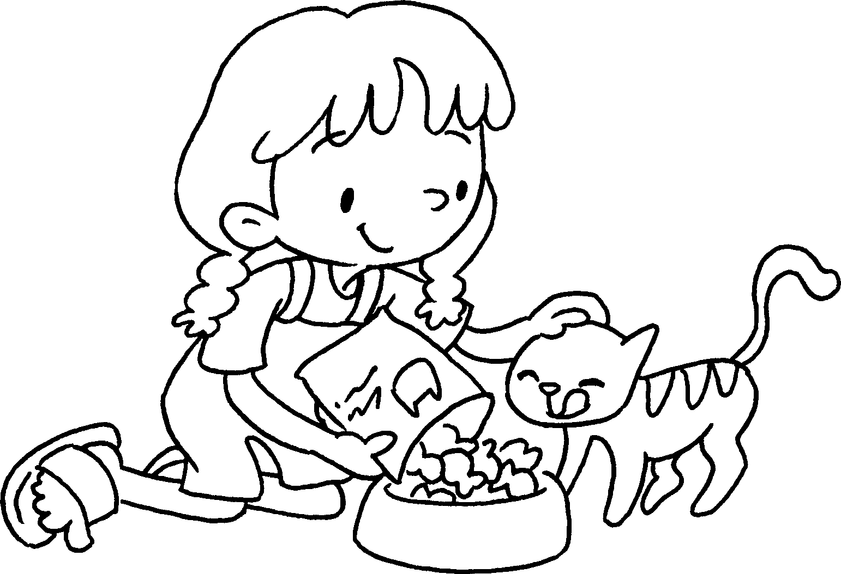 | feed
4 | 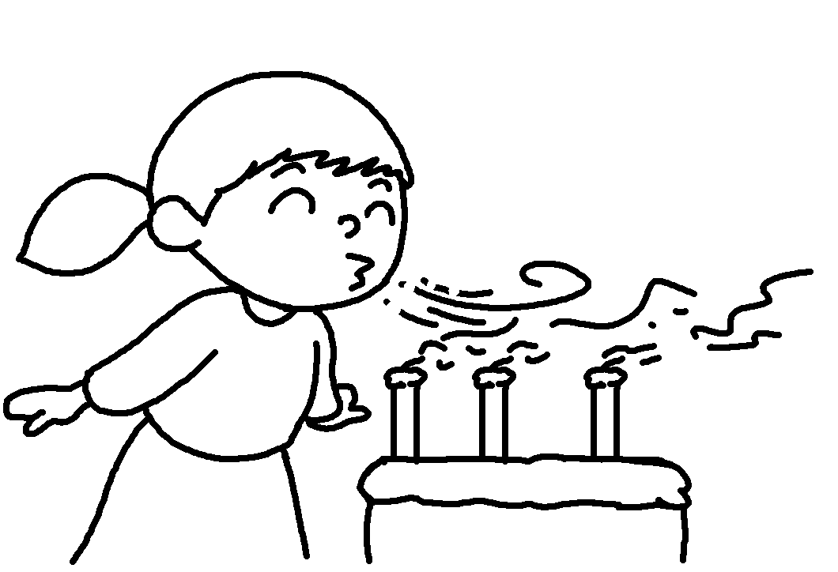 | blow
5 | 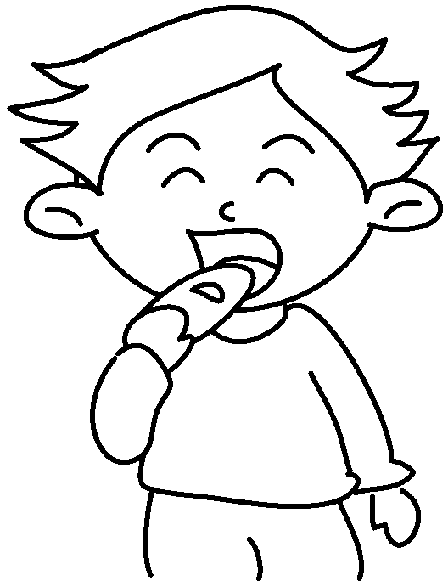 | eat


Book 5A Chapter 5 Graded Worksheets
Worksheet 1⬇⬇
1 finished finished
2 did done
3 fed fed
4 blew blown
5 ate eaten

