Complete the table.
RP no: Century Gothic 15pt
(所有圈號用15pt)

 |  | Present | Past | Past participle
1 | 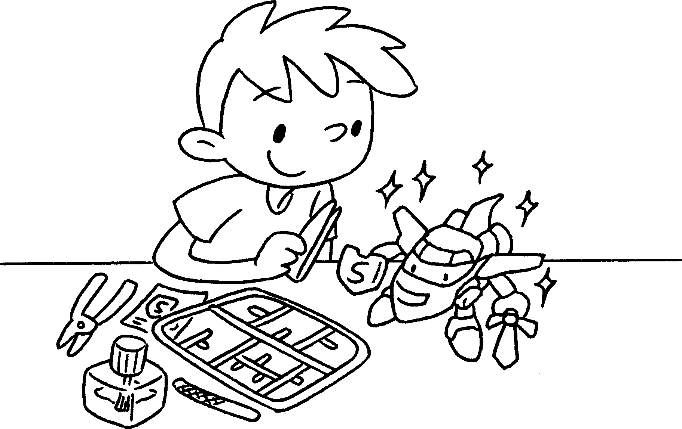 | finish
2 | 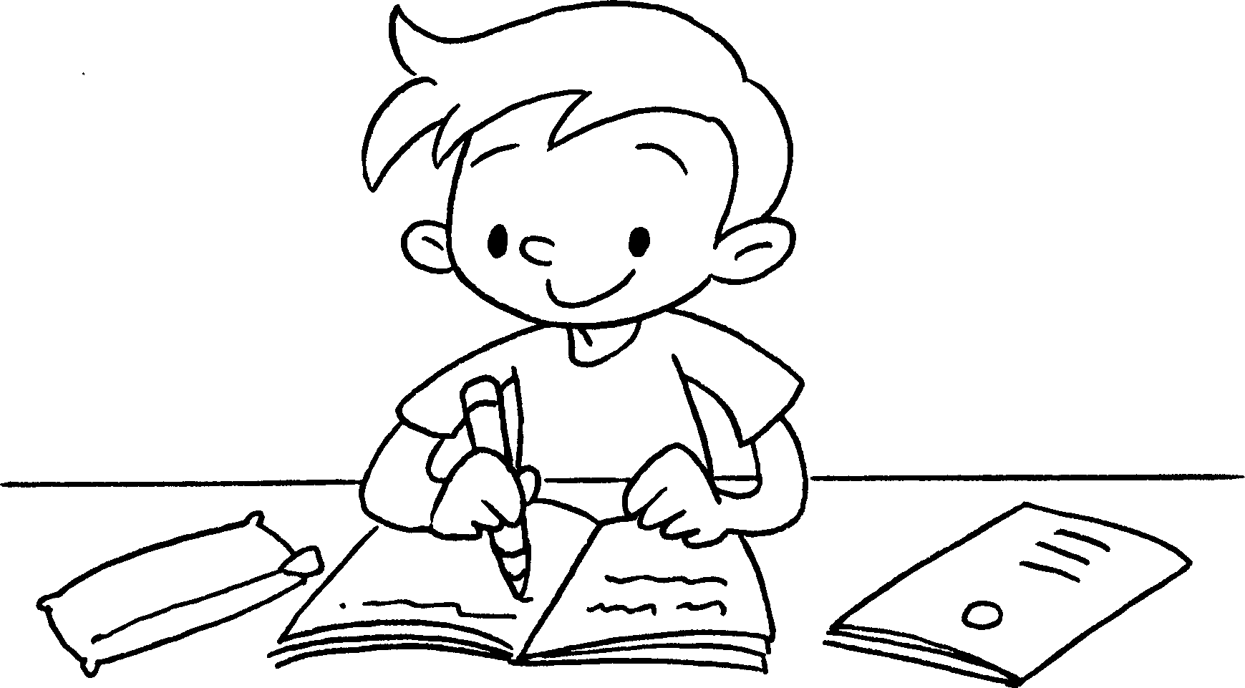 | do
3 | 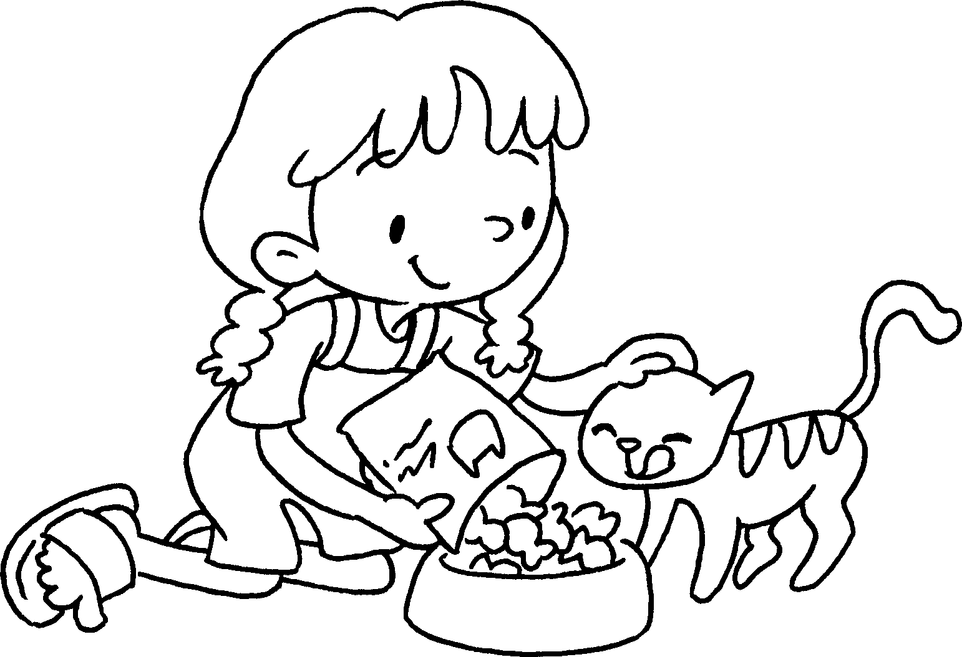 | feed
4 | 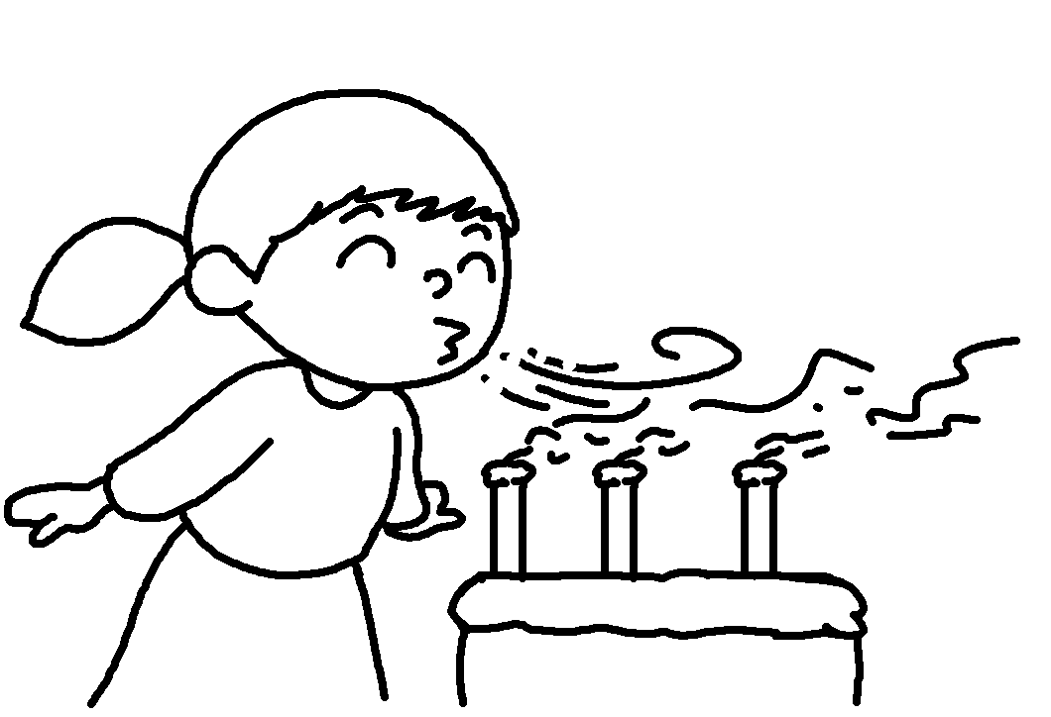
5 | 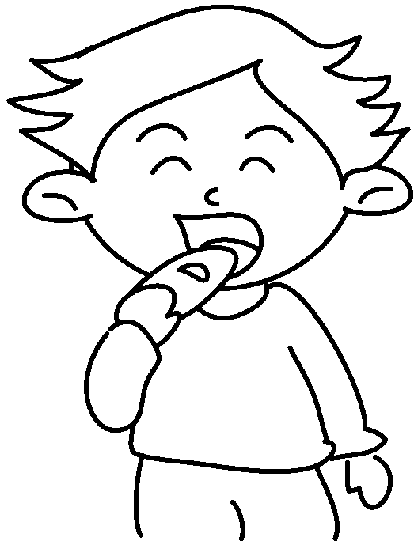


Book 5A Chapter 5 Graded Worksheets
Worksheet 1⬇⬇⬇
- finished finished
- did done
- fed fed
- blow blew blown
- eat ate eaten

