Fill in the blanks with the correct form of the verbs.
has | have
hasn’t | haven’t
A
B
1 | 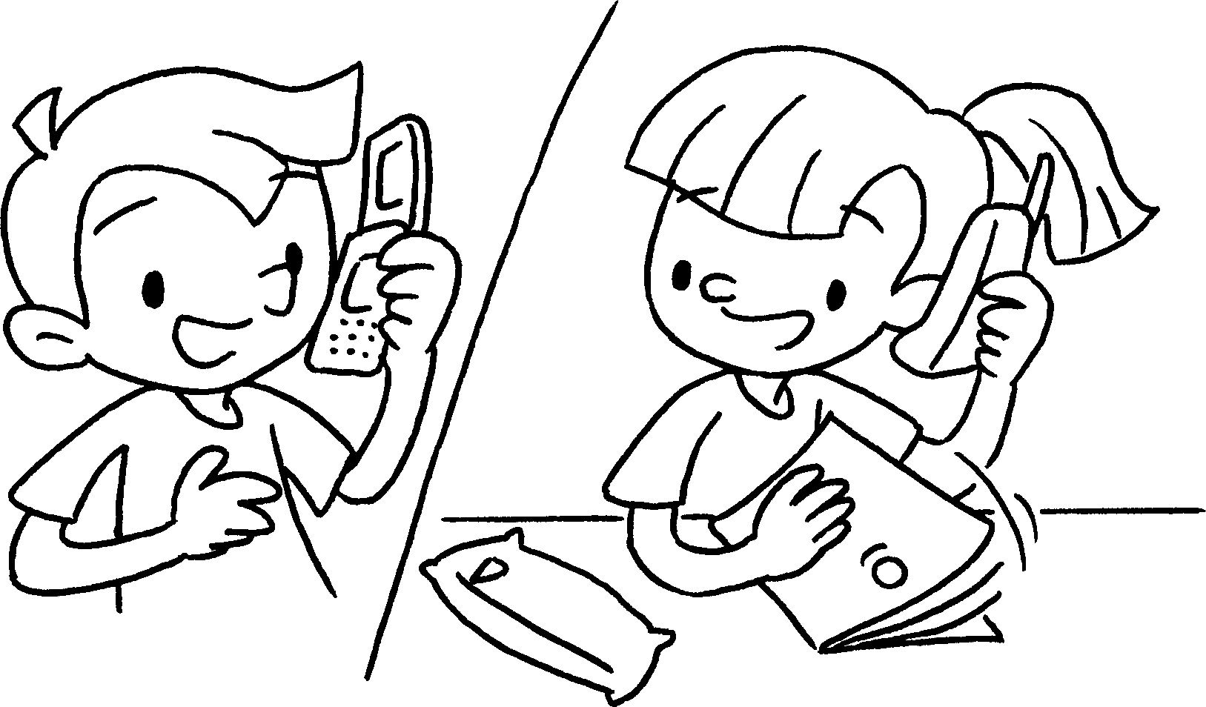 |  | A : you ( do )  your homework yet?  B : Yes, I just ( do ) my homework.
2 | 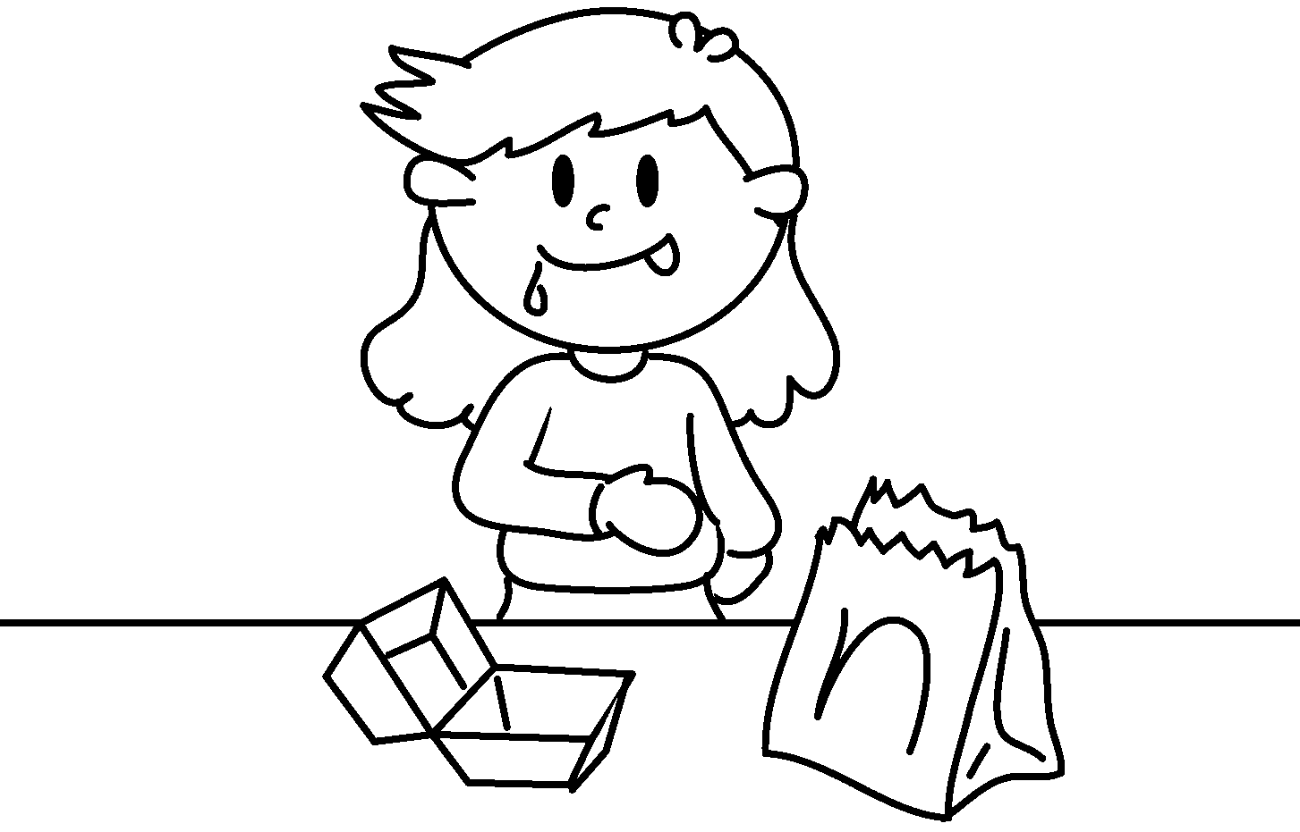 |  | A : Kat ( eat ) the hamburger yet?  B : Yes, she already  ( eat ) the hamburger.
3 | 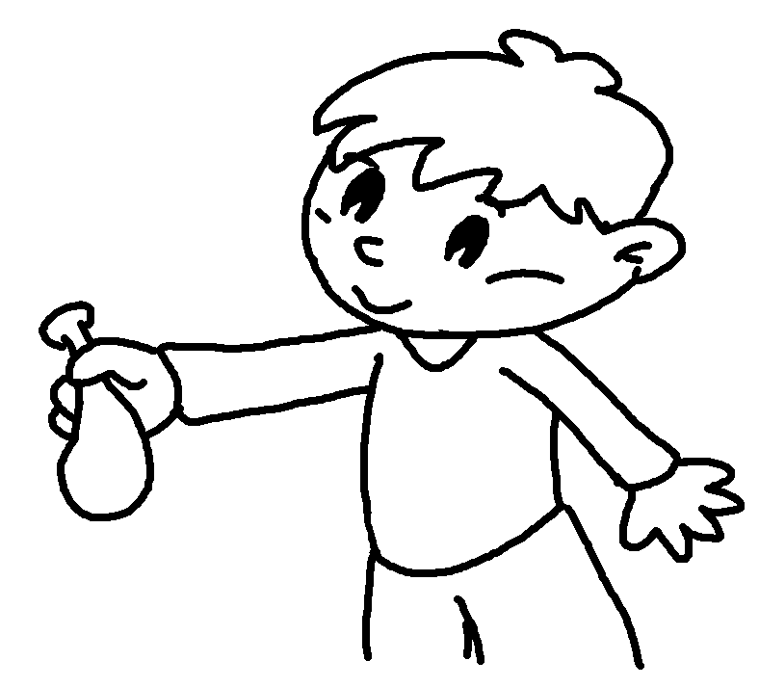 |  | A : Billy  ( blow ) up the balloon yet?  B : No, he  ( blow ) up the balloon yet.
4 | 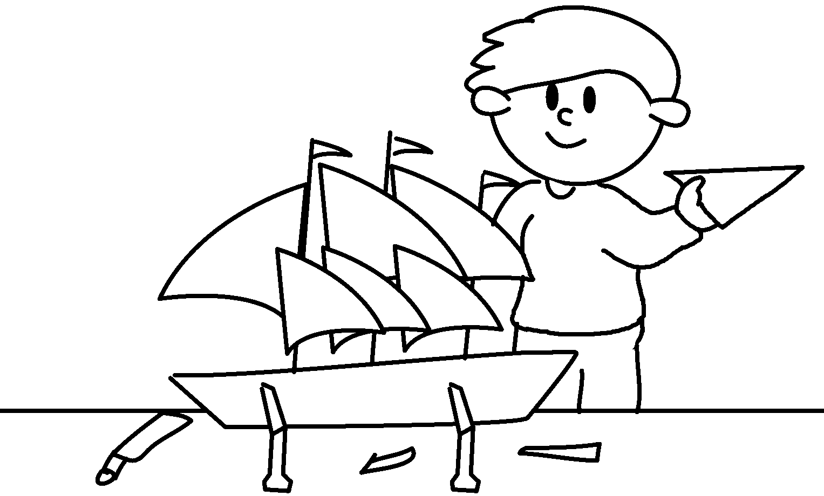 |  | A : Mike  ( finish ) his model yet?  B : Yes, he just  ( finish ) his model.
5  A  B | 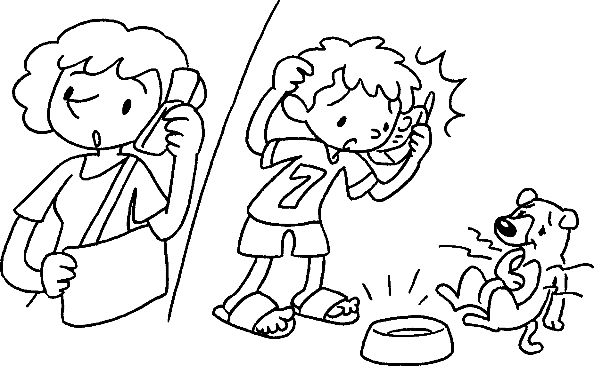 |  | A : you  ( feed ) the dog yet?  B : No, I  ( feed ) the dog yet.


Book 5A Chapter 5 Graded Worksheets
Worksheet 2⬇
1 Have done
have done
2 Has eaten
has eaten
3 Has blown
hasn’t blown
4 Has finished
has finished
5 Have fed
haven’t fed

