What have / haven’t they done? Finish the questions and answers with the correct form of the verbs.

blow do eat feed finish
A
B
1 | 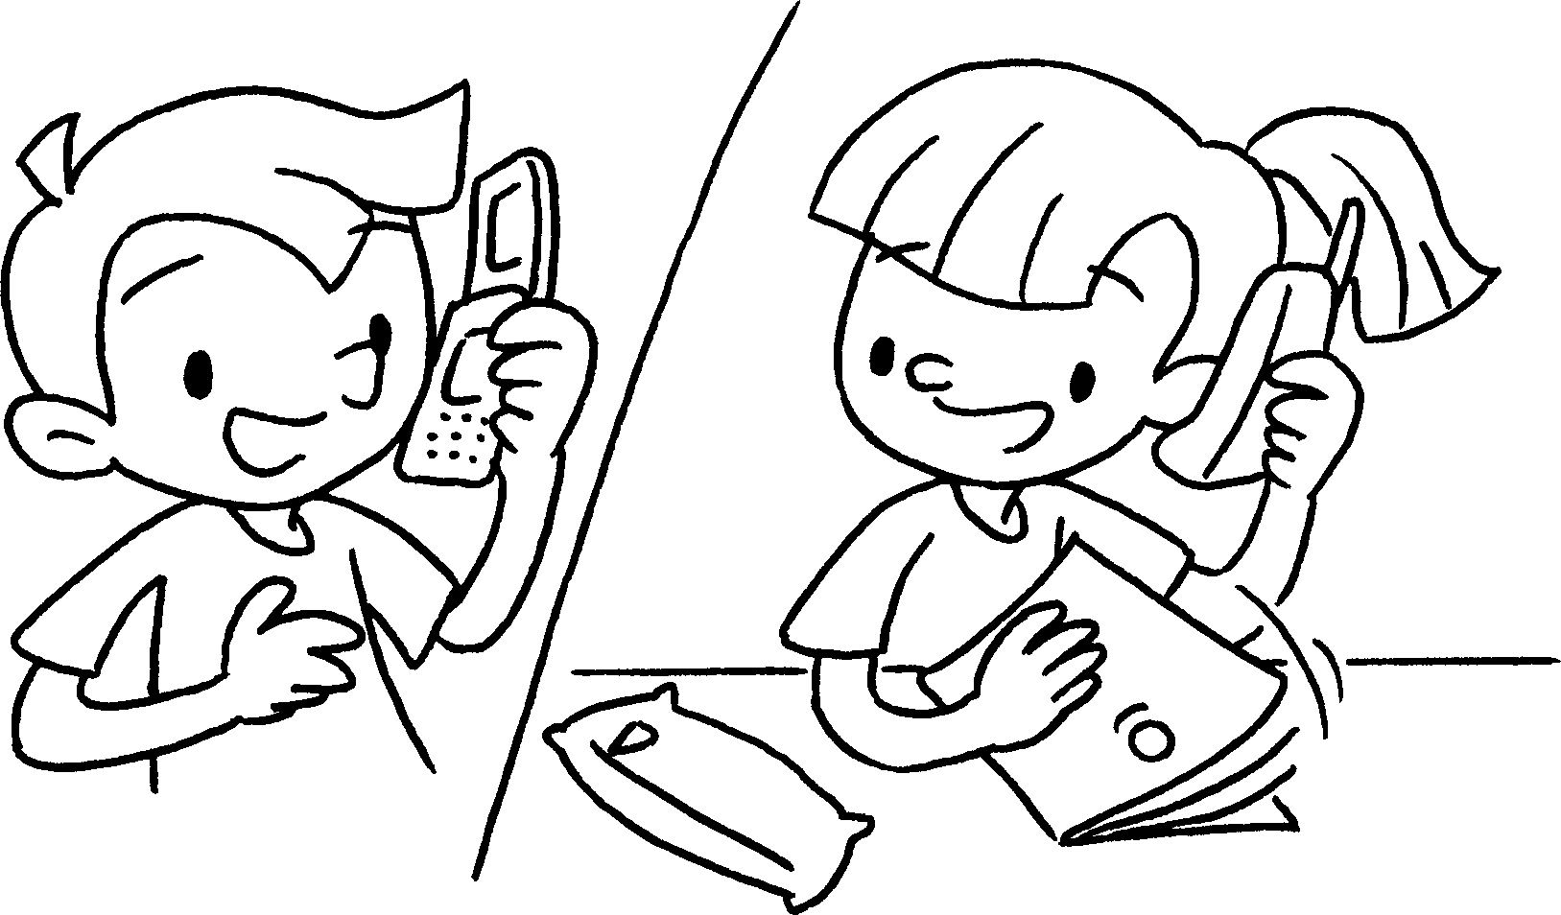 |  | A : Have you your homework yet?  B : Yes, I just my homework.
2 | 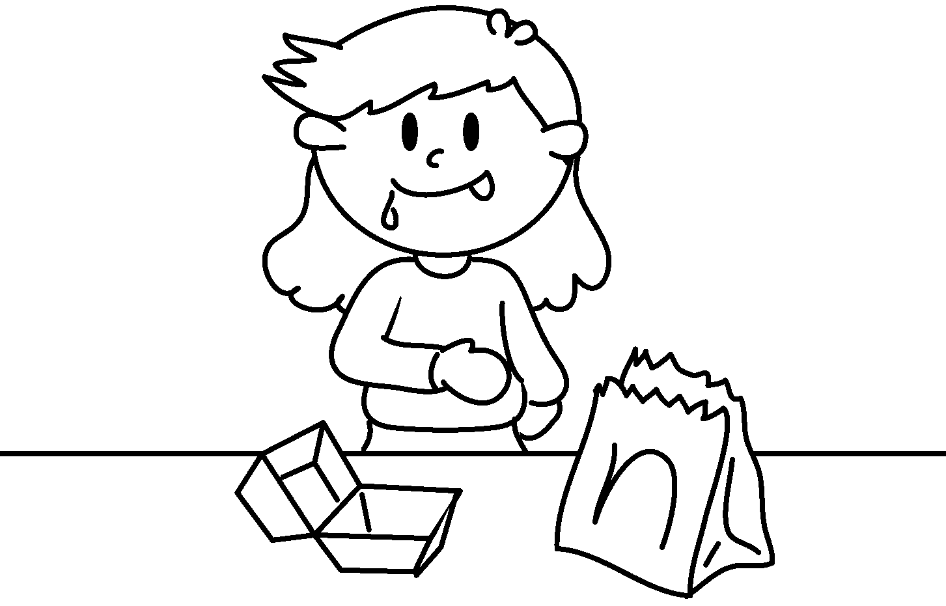 |  | A : Kat the hamburger yet?  B : Yes, she already  the hamburger.
3 | 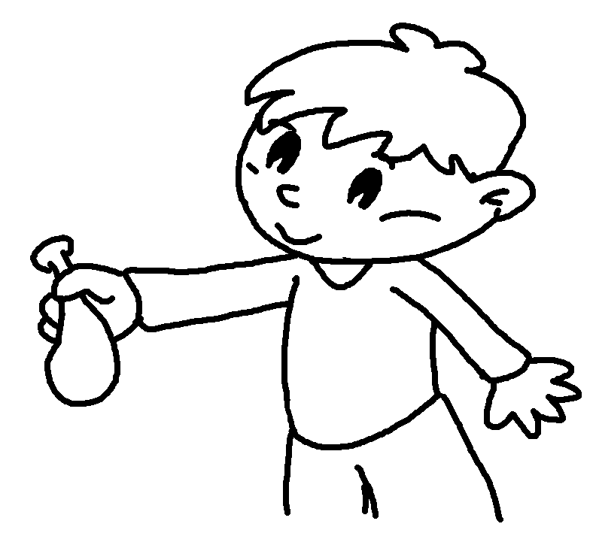 |  | A : Billy  up the balloon yet?  B : No, he  up the balloon yet.
4 | 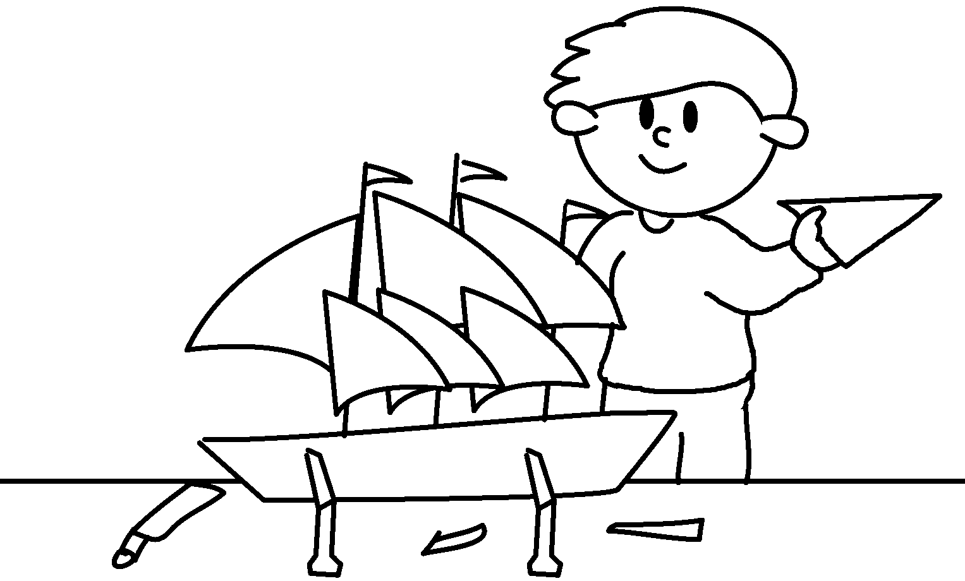 |  | A : Mike  his model yet?  B : Yes, just  .
5  A  B | 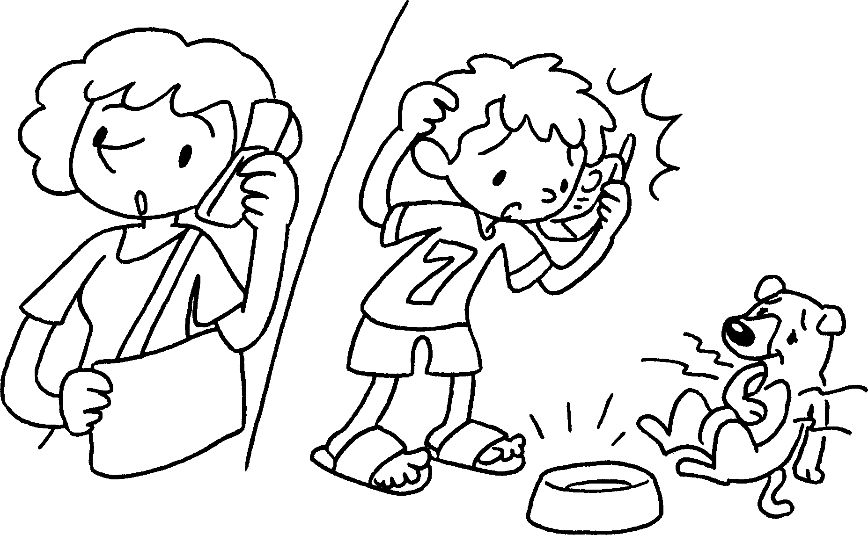 |  | A : you  the dog yet?  B : No,  yet.


Book 5A Chapter 5 Graded Worksheets
Worksheet 2⬇⬇⬇
1 done
have done
2 Has eaten
has eaten
3 Has blown
hasn’t blown
4 Has finished
he has finished his model / it
5 Have fed
I haven’t fed the dog / it

