Choose and write.

already | just | yet
A
1 | 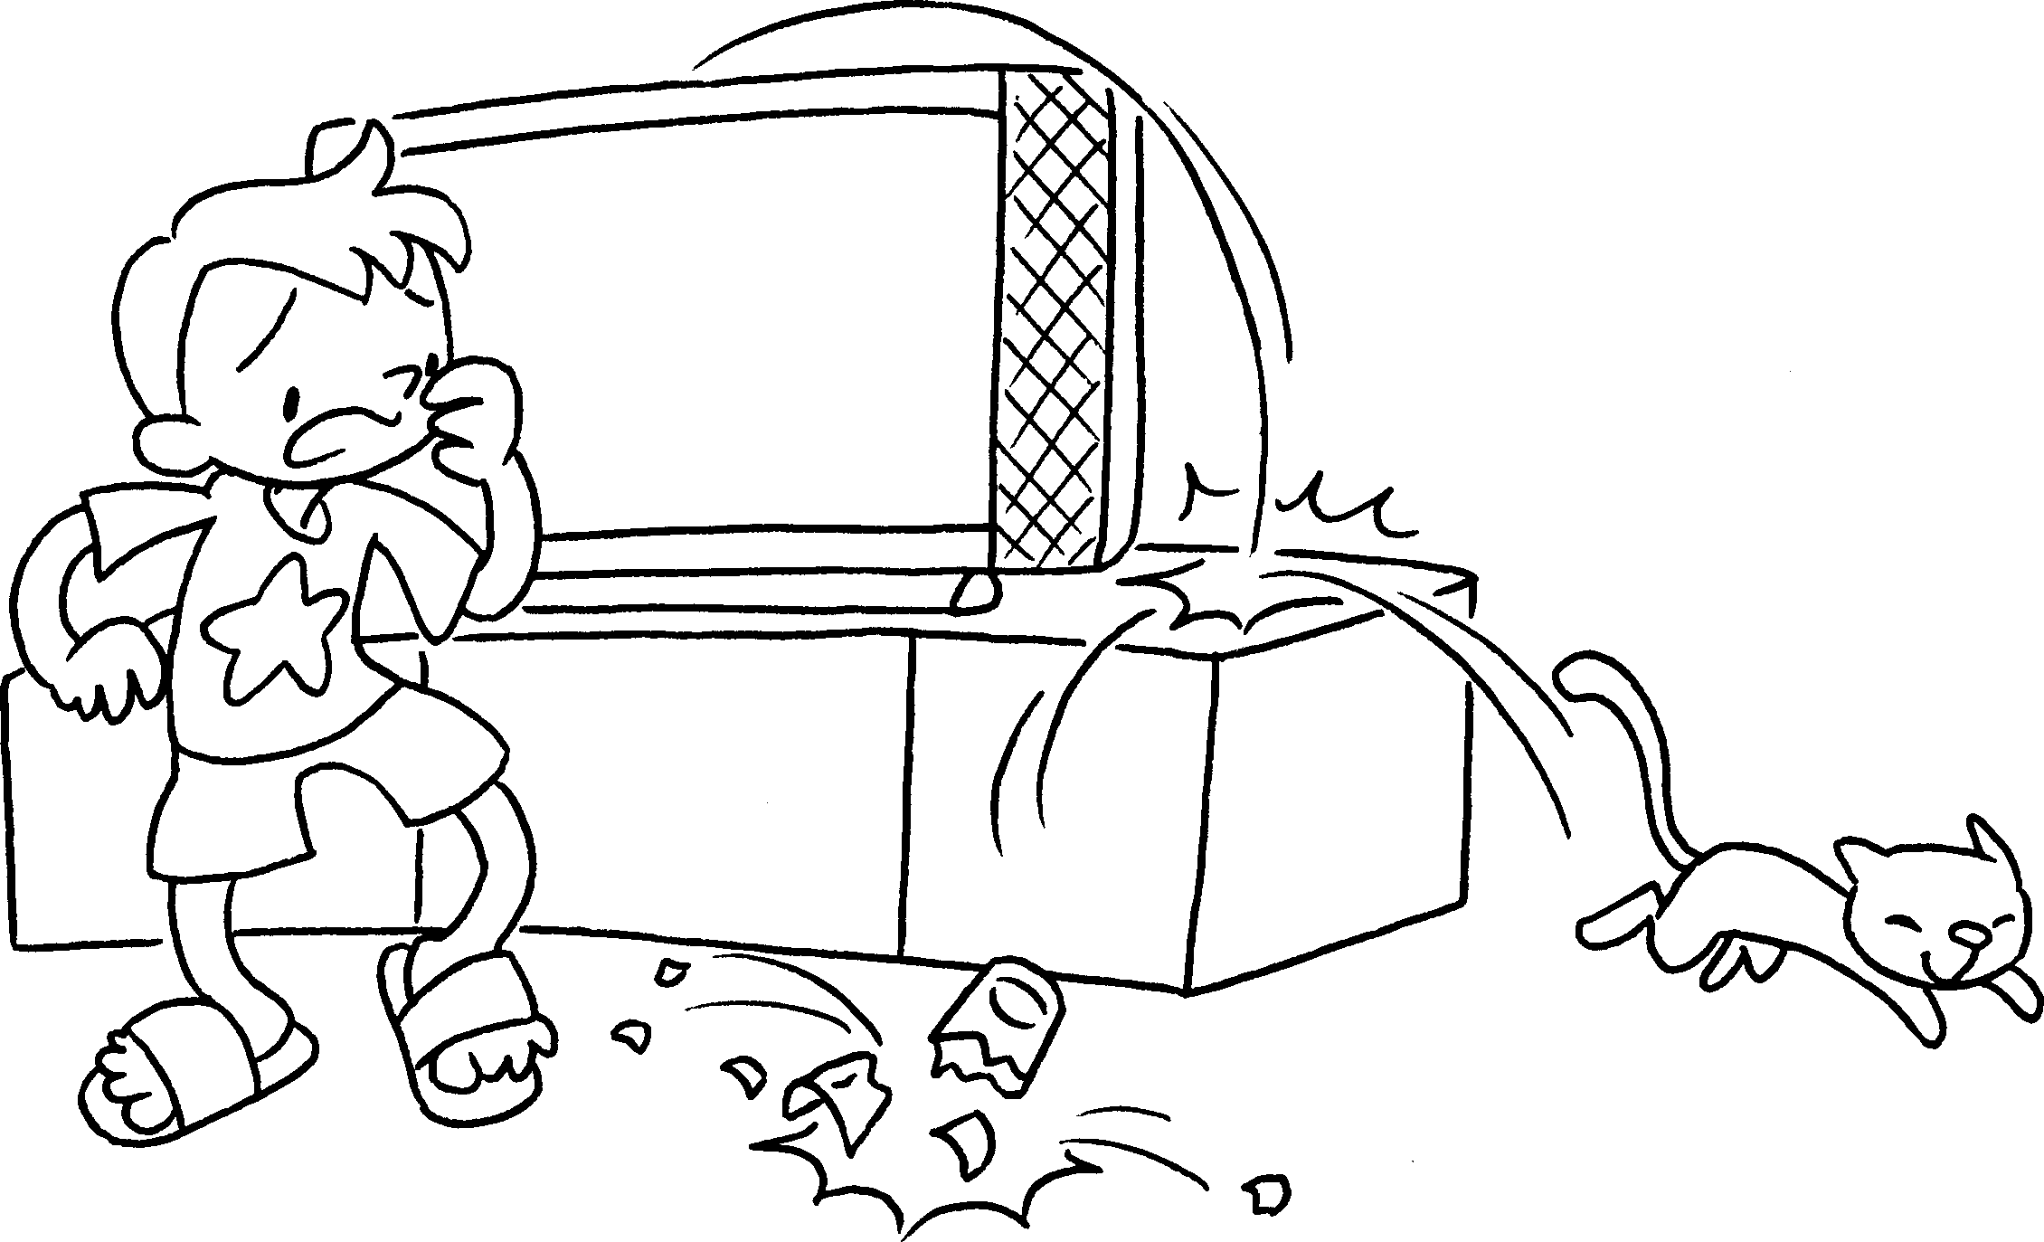 |  | A : Oh no! Momo has  broken the glass.
2  A | 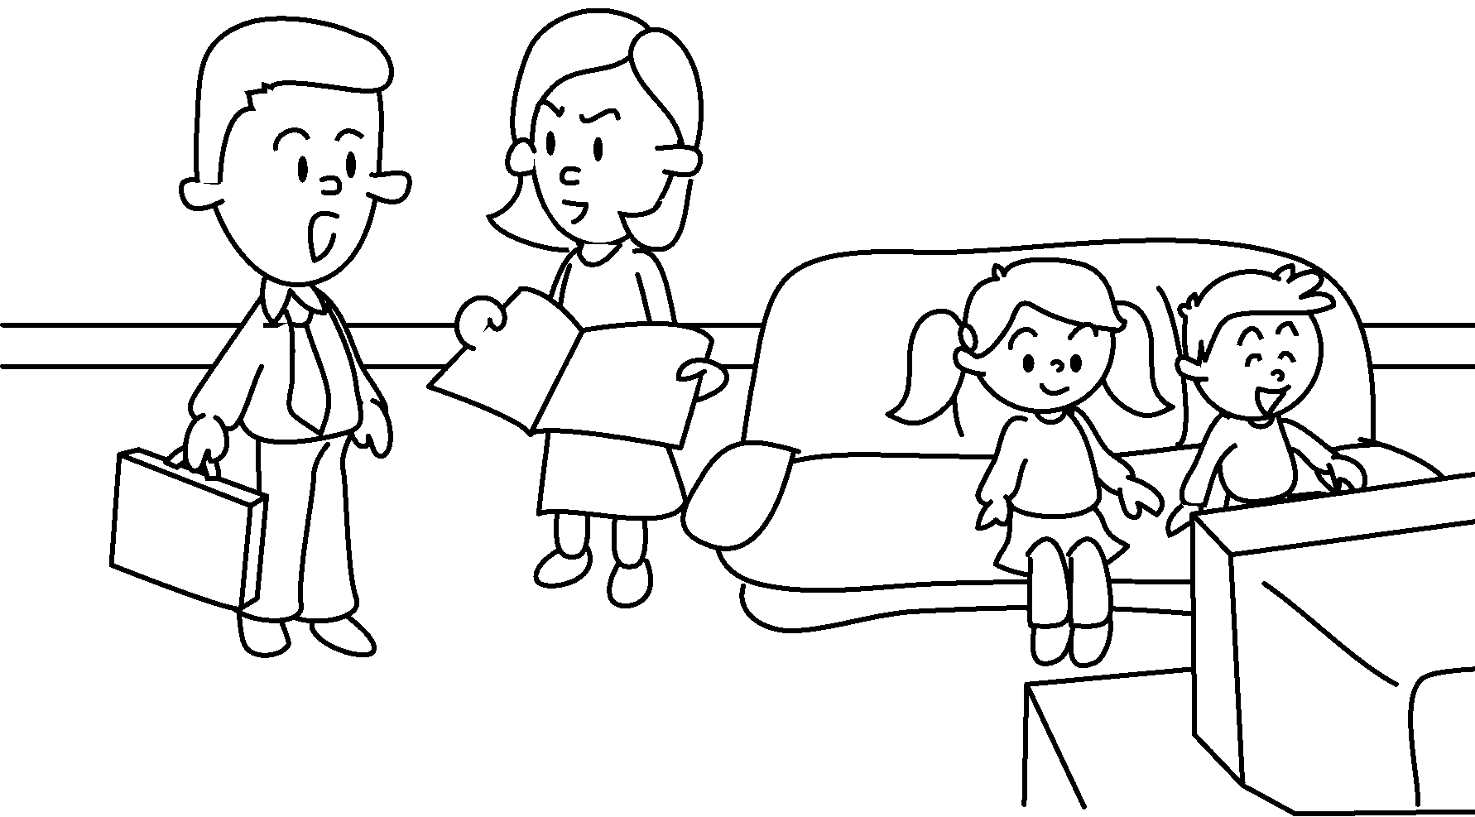 |  | A : Kate and Sam haven’t done their  homework .
3 | 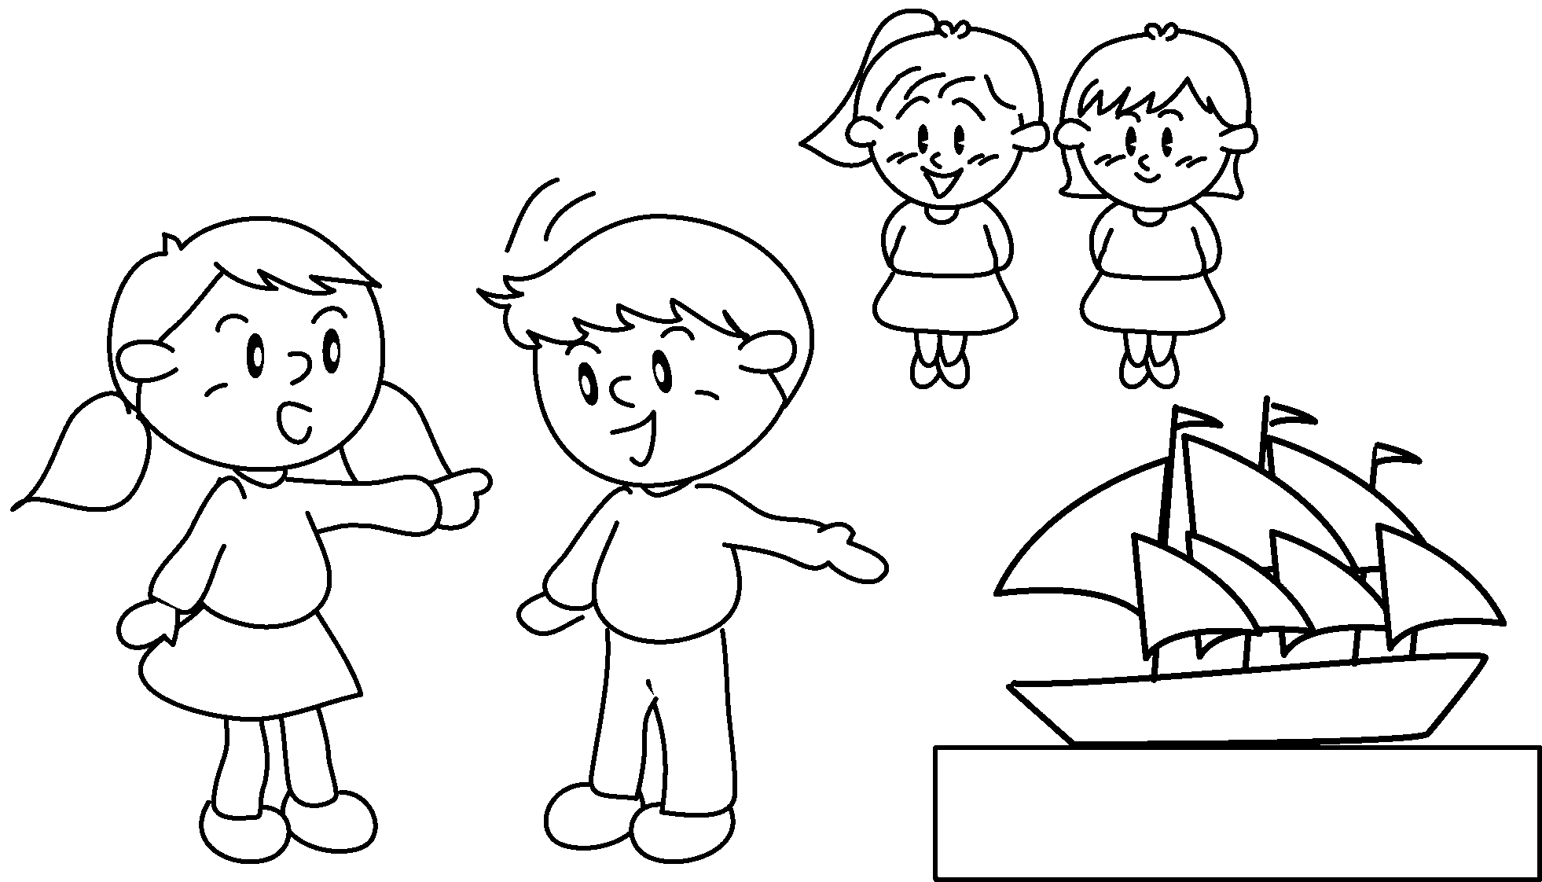  A |  | A : Look! Lily and Katie have  made the model.
4  A  B | 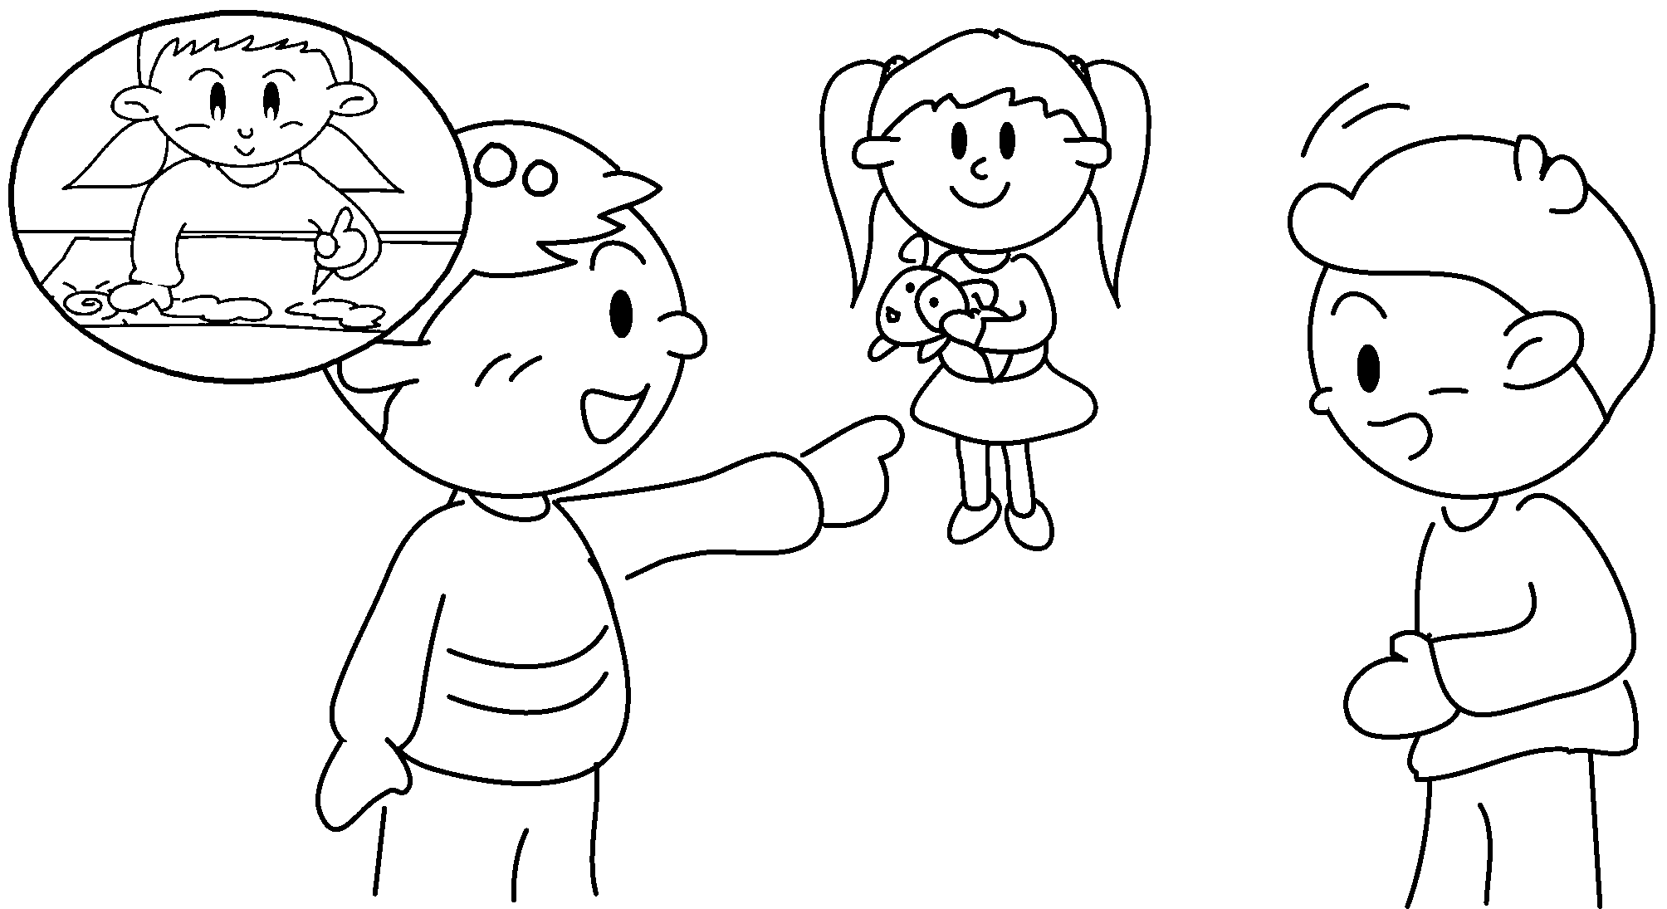 |  | A : Has Emma drawn the picture  ?  B : Yes, she has drawn the picture.
5  A  B | 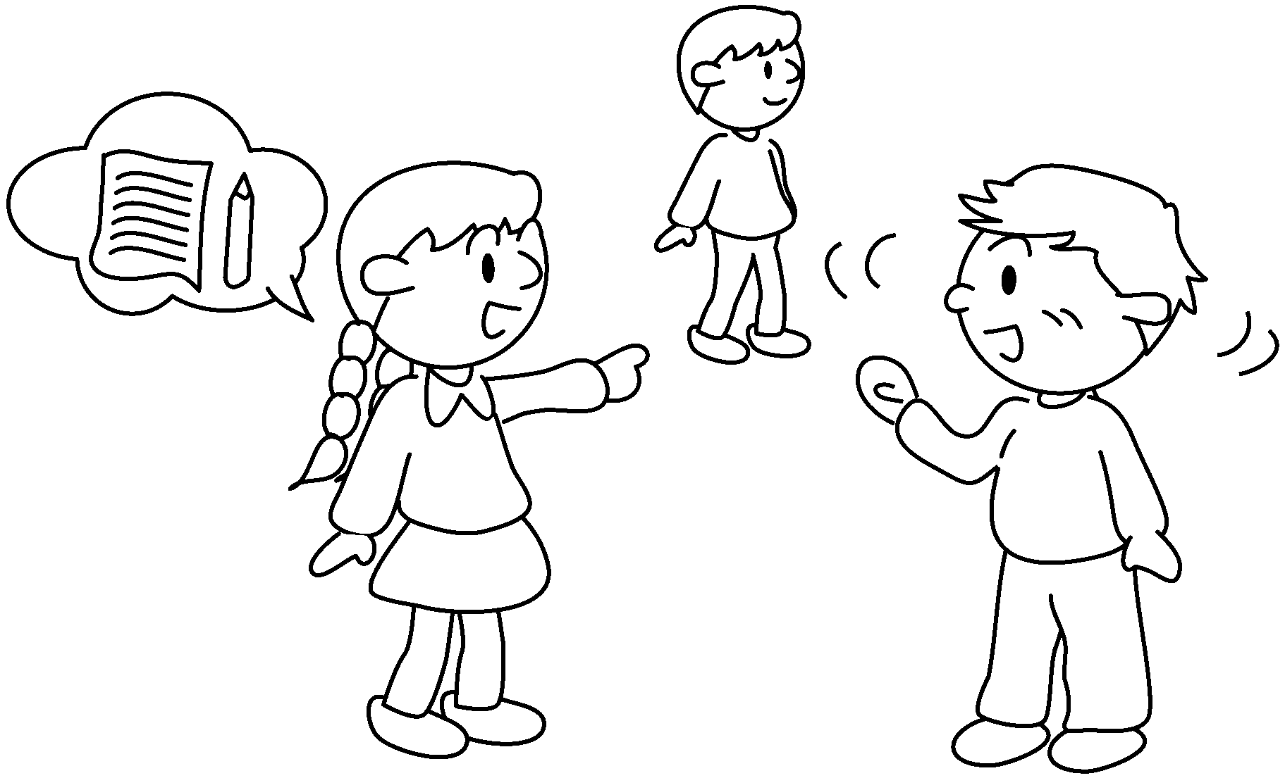 |  | A : Has Henry written the letter  ?  B : No, he hasn’t written the letter  .


Book 5A Chapter 5 Graded Worksheets
Worksheet 3⬇
- just
- yet
- already
- yet
already
- yet
yet

