Finish the sentences using the present perfect tense and ‘already’, ‘just’ or ‘yet’.
A
1 | 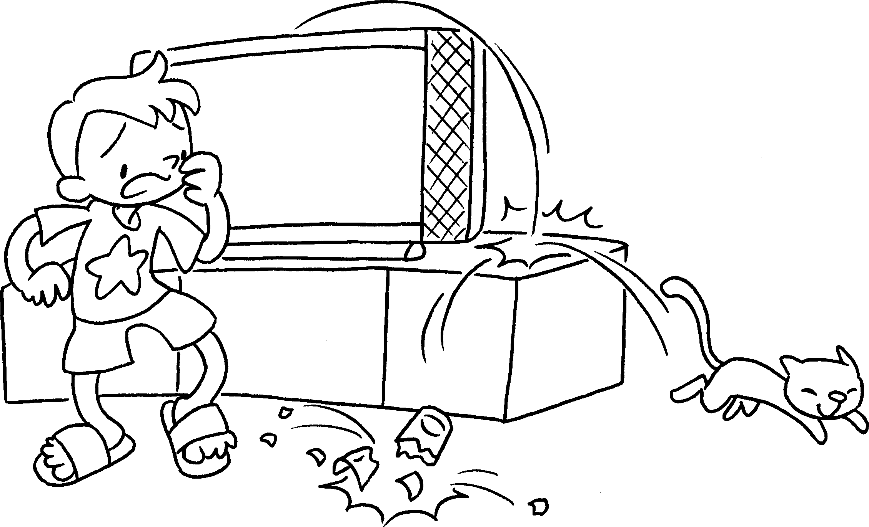  ( break ) |  | A : Oh no! Momo has just  the glass.
2  A | 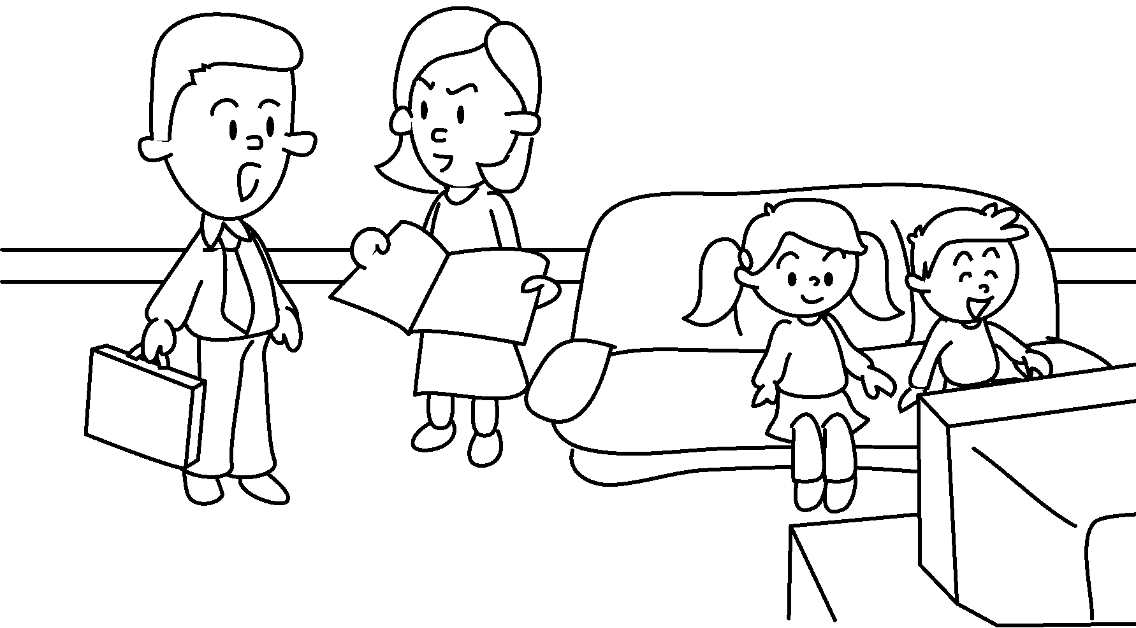  ( do ) |  | A : Kate and Sam haven’t ___________ their homework .
3  A | 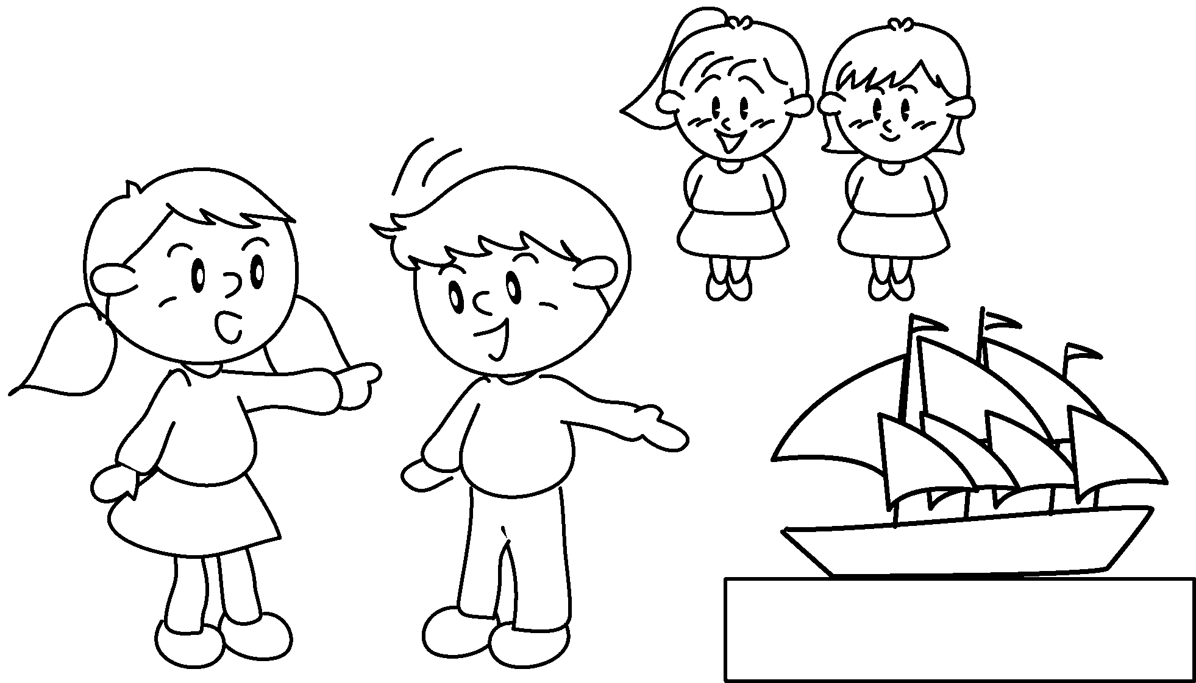  ( make ) |  | A : Look! Lily and Katie _____________  the model.
4 | 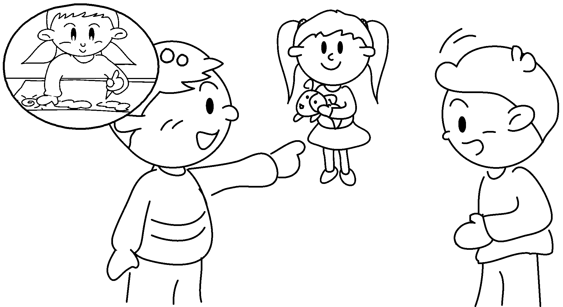  ( draw )  A  B |  | A : ___________ Emma _____________ the picture ?  B : Yes, she ____________ the picture.
5 | 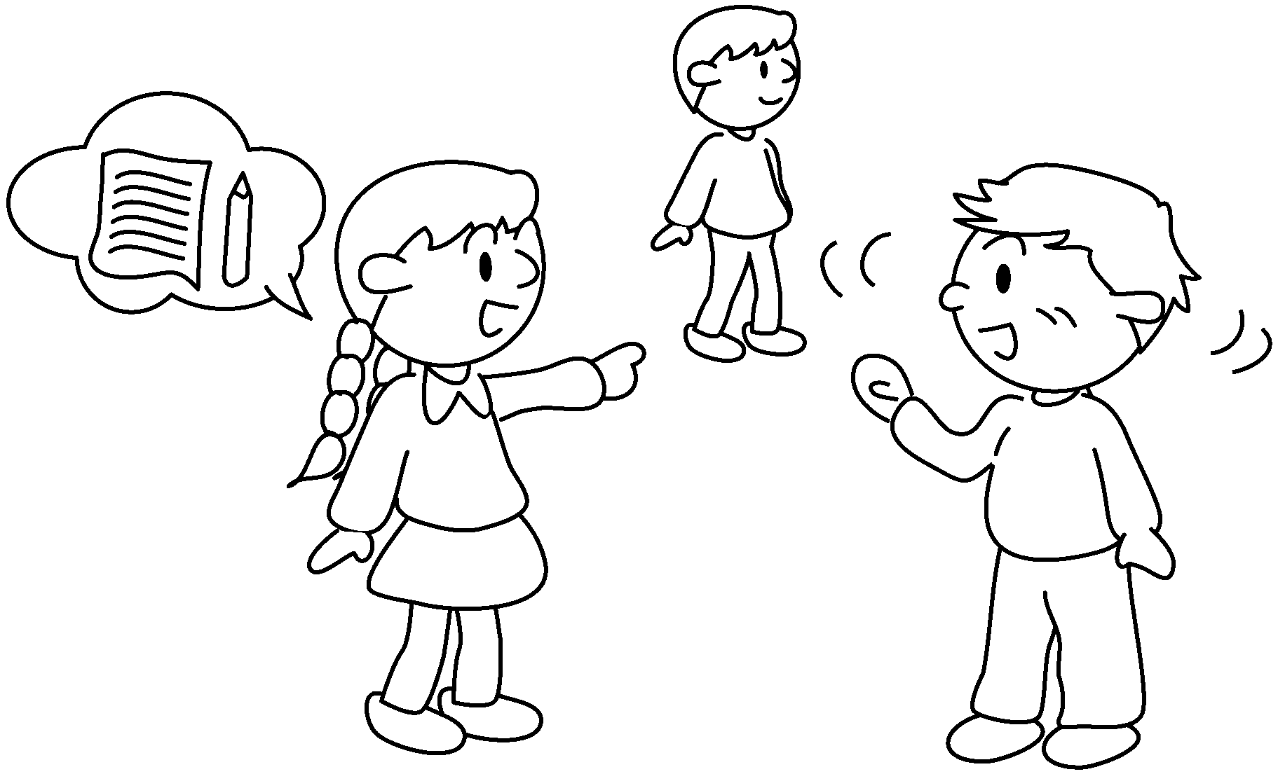  ( write )  A  B |  | A : ___________ Henry _____________ the letter ?  B : No, he the letter .


Book 5A Chapter 5 Graded Worksheets
Worksheet 3⬇⬇
- broken
- done yet
- have already made
- Has drawn yet
has already drawn
- Has written yet
hasn’t written yet

