- Have you done it yet?
The Johnsons live on a farm in Australia. They are going on holiday to Hong Kong tonight. What do they need to do before they leave? Read the story and find out.
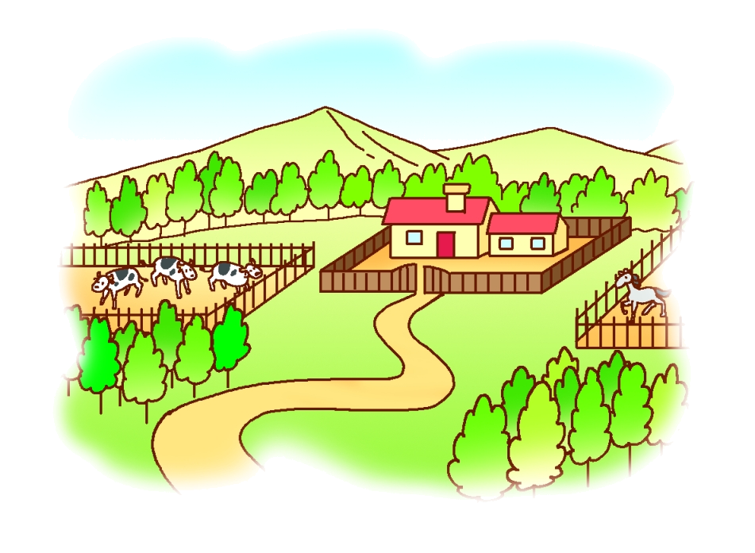

‘Oh dear,’ said Mrs Johnson. ‘There are so many things to do before we leave.
‘Look!’ said Mr Johnson. ‘I’ve just written a list.’


Things to do
• Take Tiger to the vet
• Give keys to Uncle Ted
• Throw away the rubbish
• Do the washing and ironing
• Feed the pigs
• Pack

‘Can I use the computer?’ asked Alex.
‘Have you thrown away the rubbish yet?’ asked his mum.
‘Not yet,’ said Alex.
‘Do your jobs before you play computer games,’ said his dad.
Alex went out with the rubbish.
‘I’ll go to the vet,’ said Mr Johnson.
Two hours later, Mr Johnson returned.
‘I’ve already done the washing but I haven’t done the ironing yet,’ said his wife. ‘Anna has just gone to Uncle Ted’s house with the keys.’
Book 5A Chapter 5
Simplified reading passage
After a while Anna came back.
‘I’ve given the keys to Uncle Ted,’ said Anna. ‘Can we use the computer, please?’
‘Have you packed the suitcases yet?’ asked Mr Johnson.
‘No yet,’ said Alex, ‘but …’
‘Hurry up! Do it now!’
An hour later Mr Johnson said, ‘I’ve fed the pigs.’
‘I’ve just finished the ironing,’ said his wife.
‘We’ve packed the suitcases,’ said the children.

‘Good!’ said Mrs Johnson. ‘I’m looking forward to relaxing on the beach.’
‘Beach?’ said Alex. ‘We’ve packed jumpers and coats. It’s August now. Isn’t it winter in Hong Kong?’
‘No, it’s summer in Hong Kong. Why didn’t you check the weather?’ asked Mr Johnson.
‘We wanted to use the computer but …’ started Alex.

