Choose and write.
Cultural Centre | Disneyland | Hong Kong Wetland Park
Ocean Park | Science Museum | Space Museum
1
 | 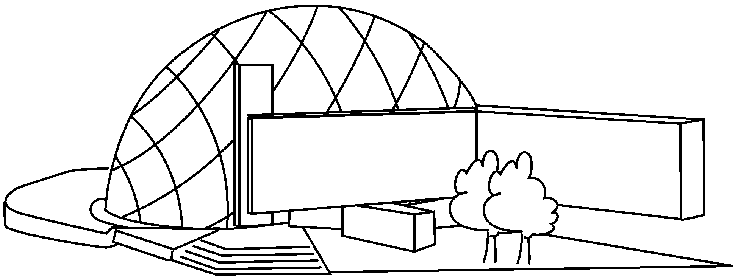 | 2 | 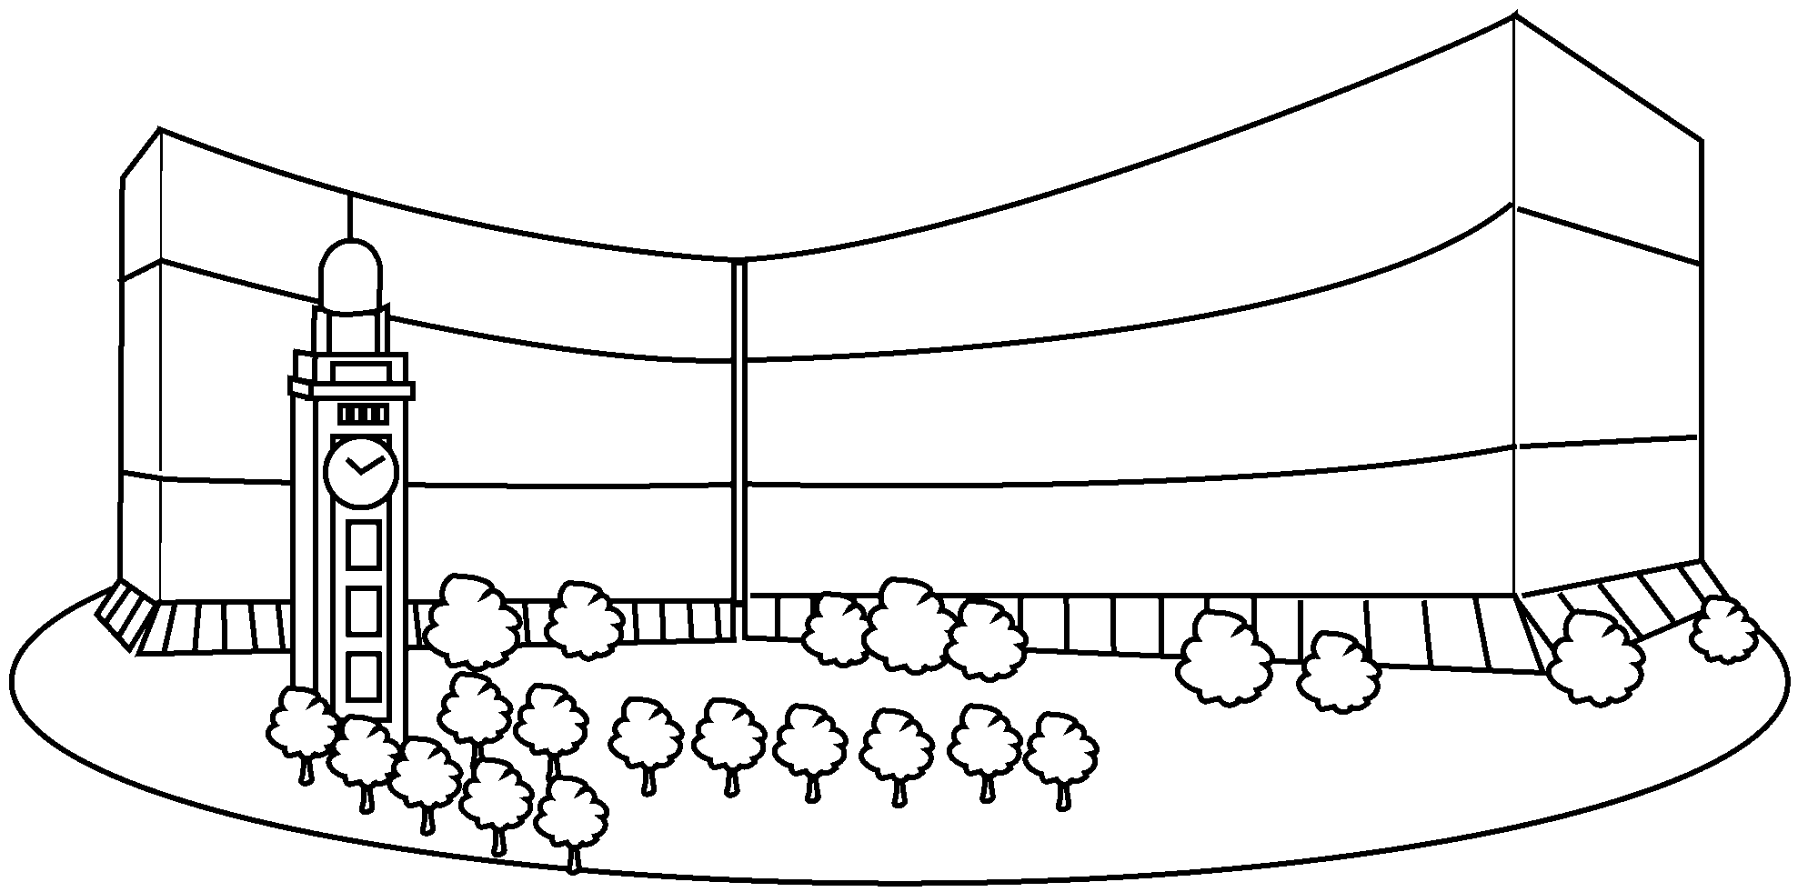
3 | 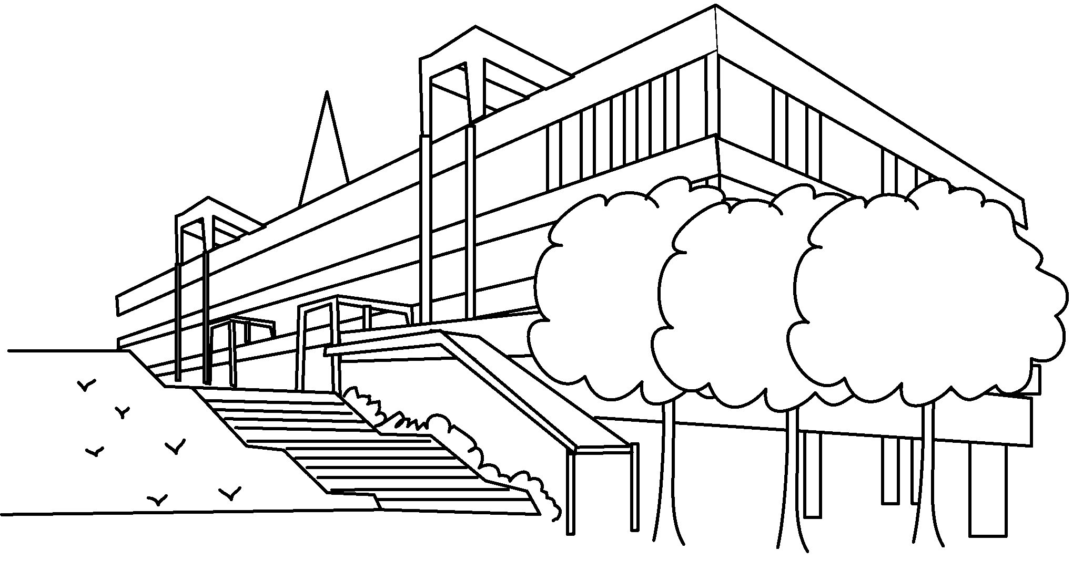 | 4 | 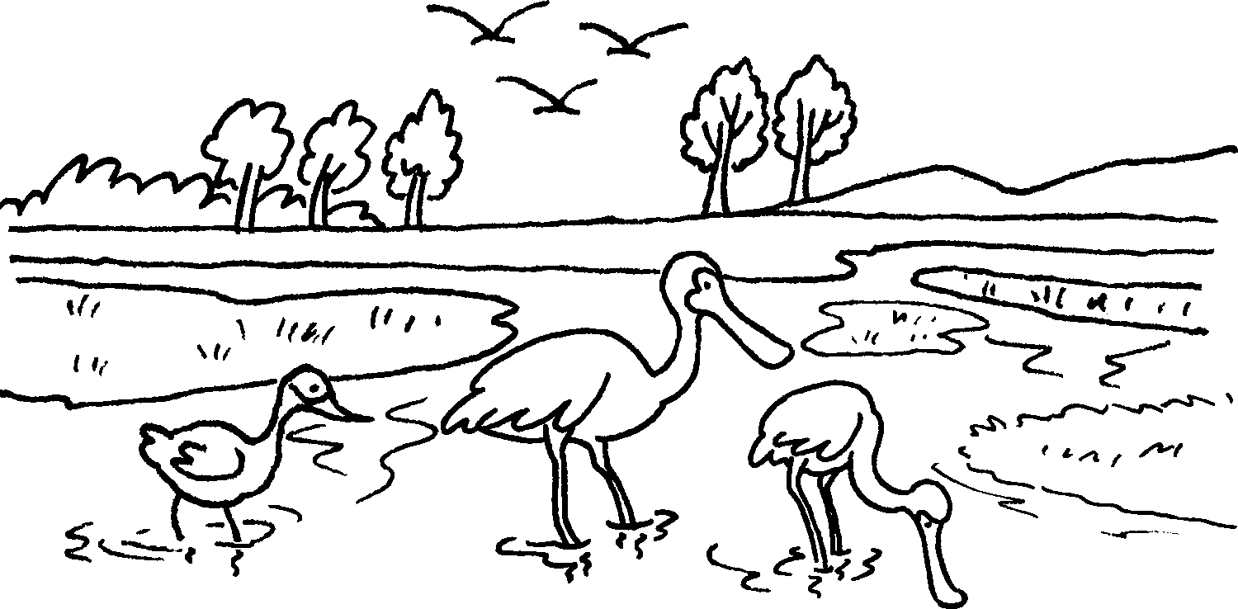
5 | 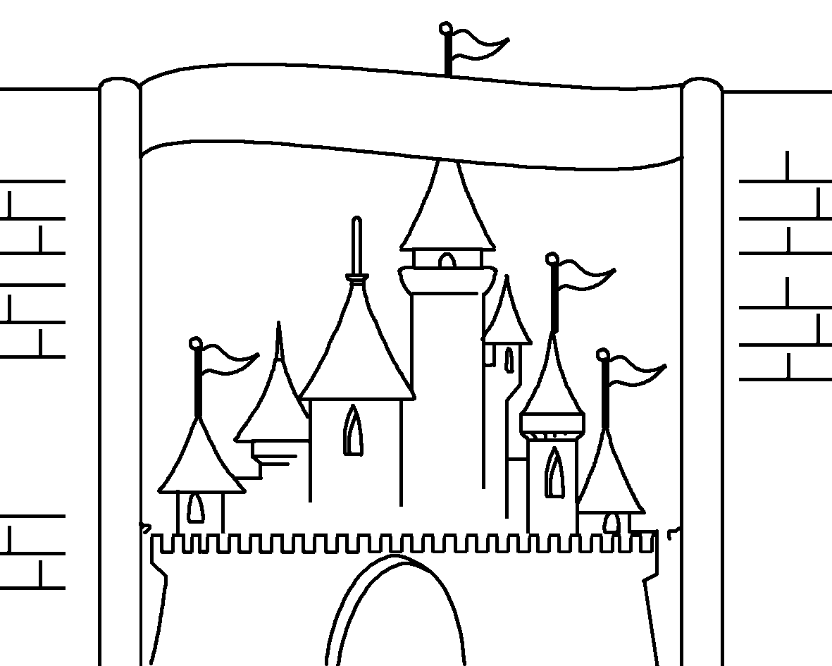 | 6 | 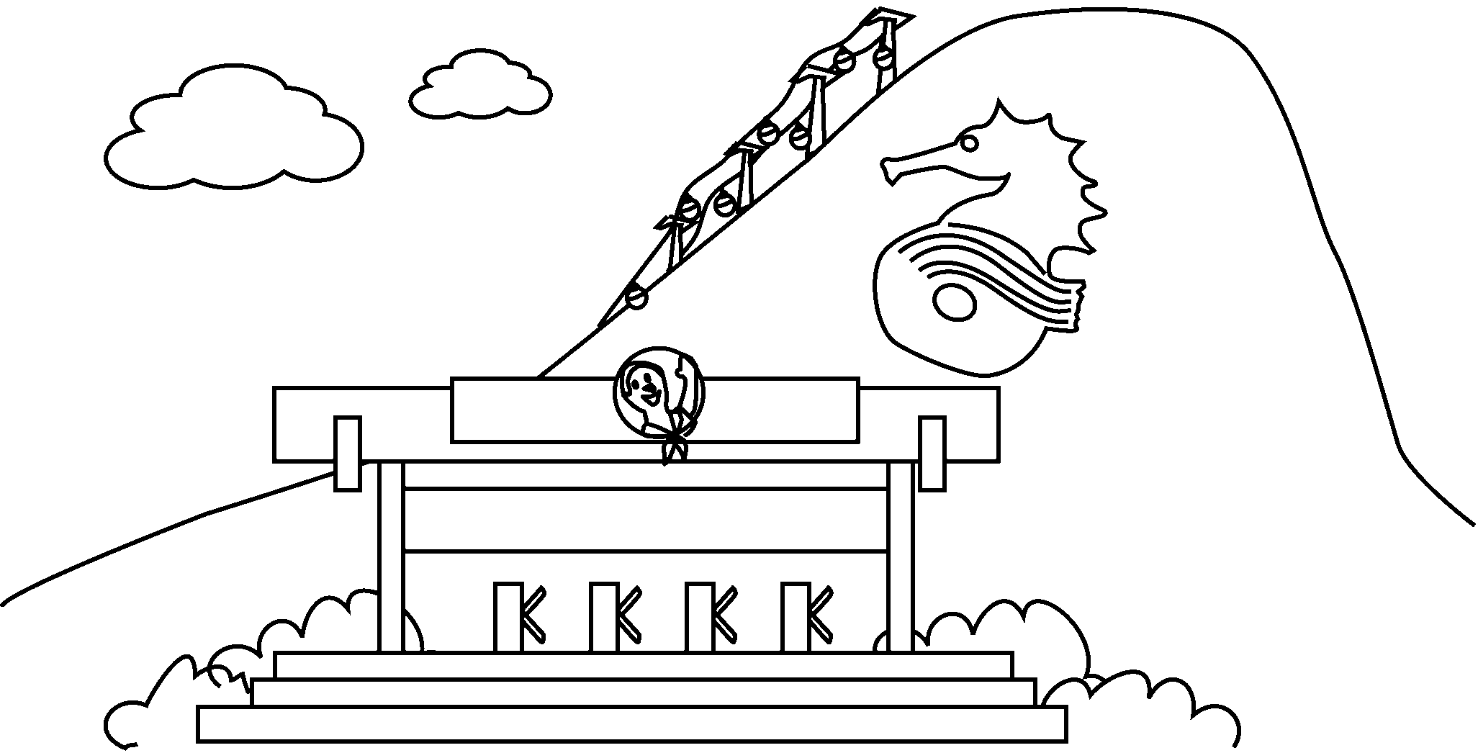

1 | the
2 | the
3 | the
4
5
6


Book 5A Chapter 6 Graded Worksheets
Worksheet 1⬇
- Space Museum
- Cultural Centre
- Science Museum
- Hong Kong Wetland Park
- Disneyland
- Ocean Park

