What are these places in Hong Kong? Write.
1
 | 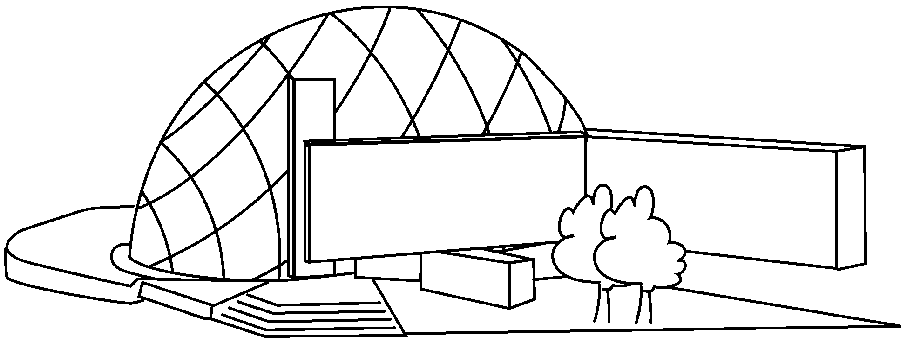 | 2 | 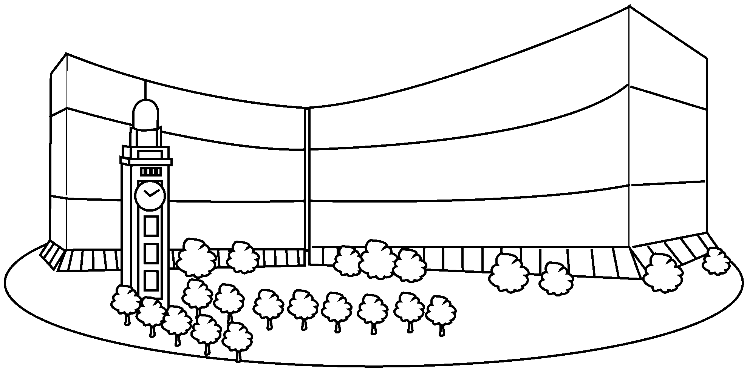
3 | 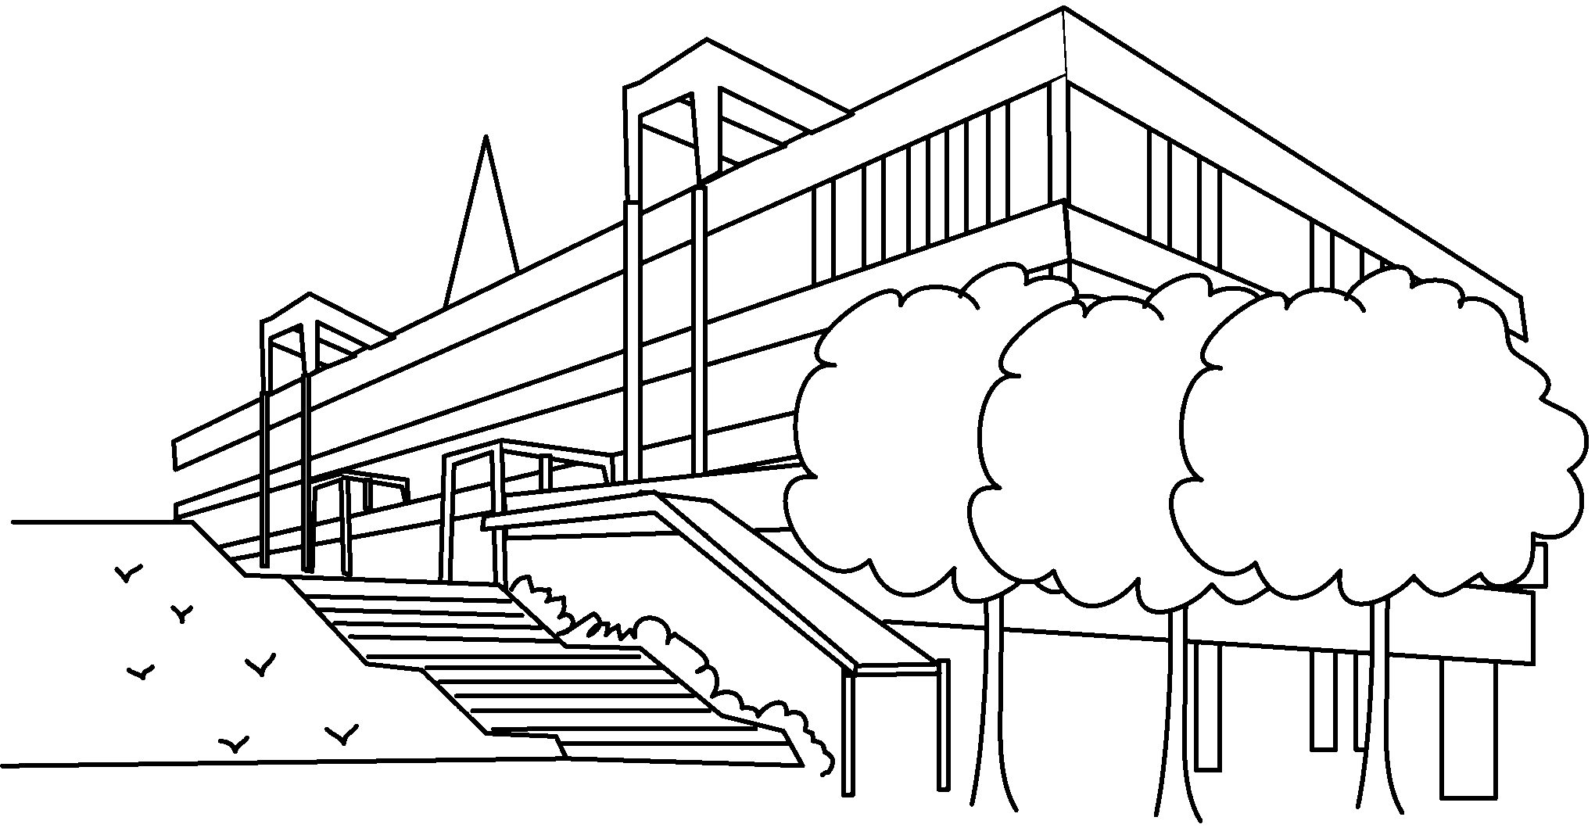 | 4 | 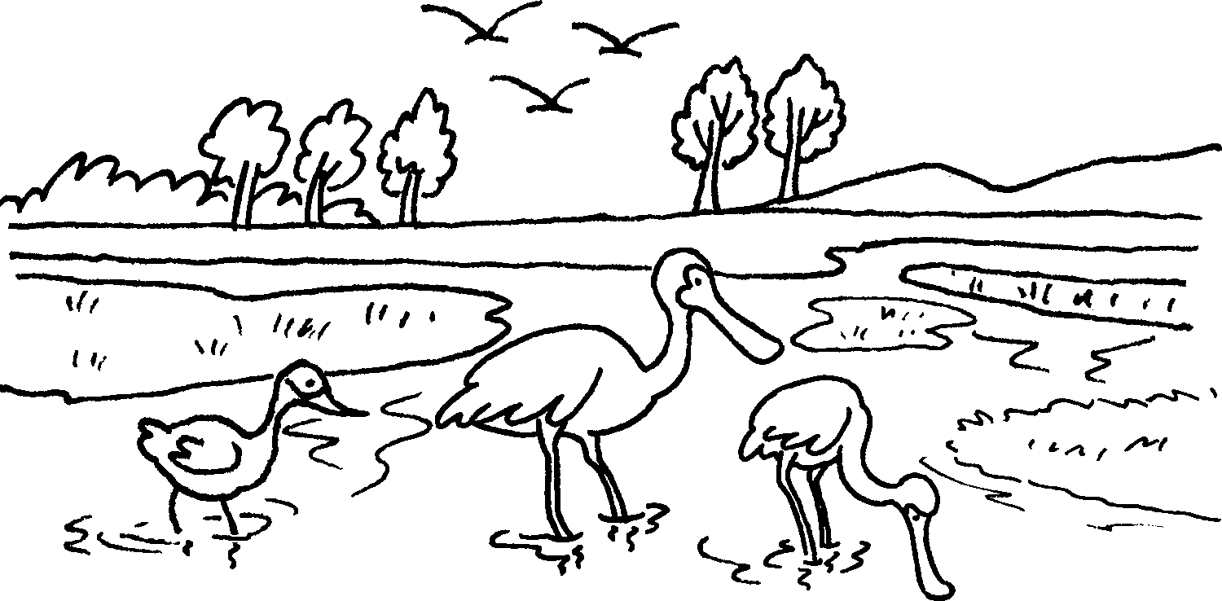
5 | 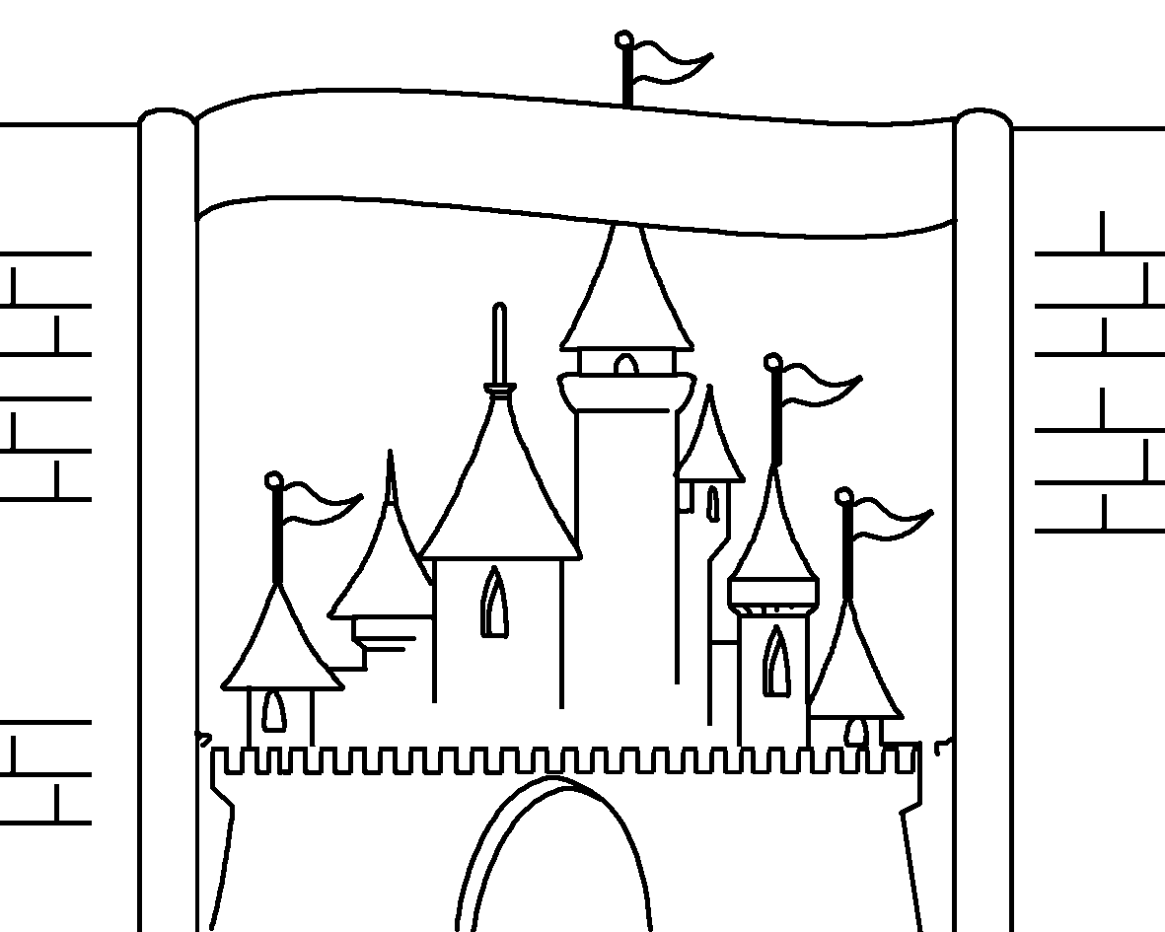 | 6 | 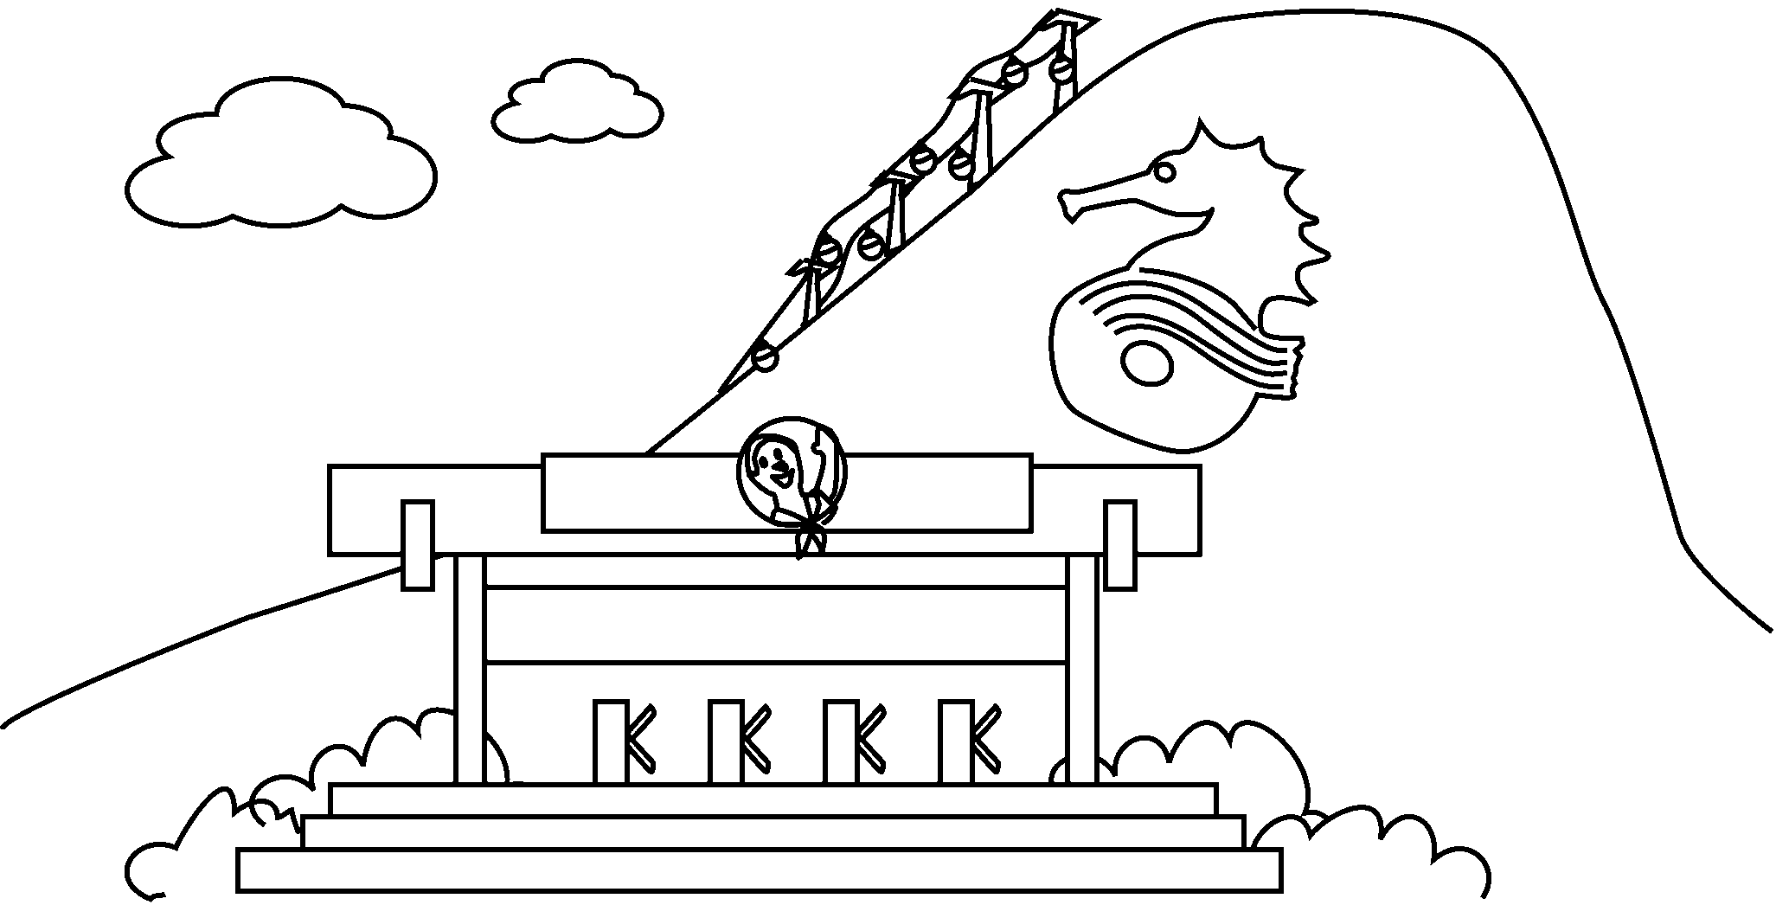

1 | the
2
3
4 | Hong Kong
5
6


Book 5A Chapter 6 Graded Worksheets
Worksheet 1⬇⬇⬇
- Space Museum
- the Cultural Centre
- the Science Museum
- Wetland Park
- Disneyland
- Ocean Park

