Finish the questions and answers.

1  ✓  A  B | 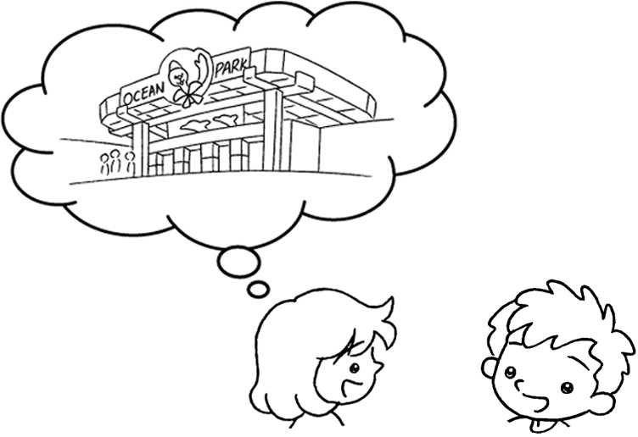 |  | ever  A : Have you been  to Ocean Park?  B : Yes, I .
2  ✗  B  A | 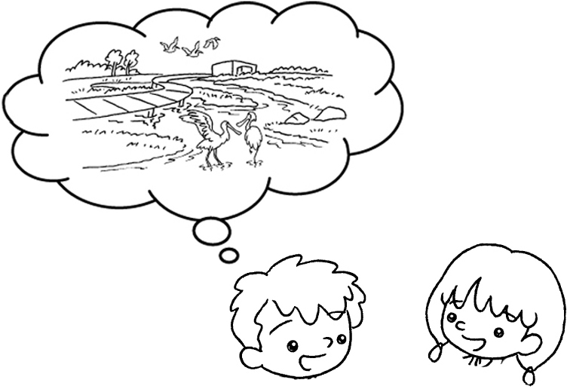 |  | A : you ever  to Hong Kong  Wetland Park?  B : No, I haven’t.
3  ✓  A  B | 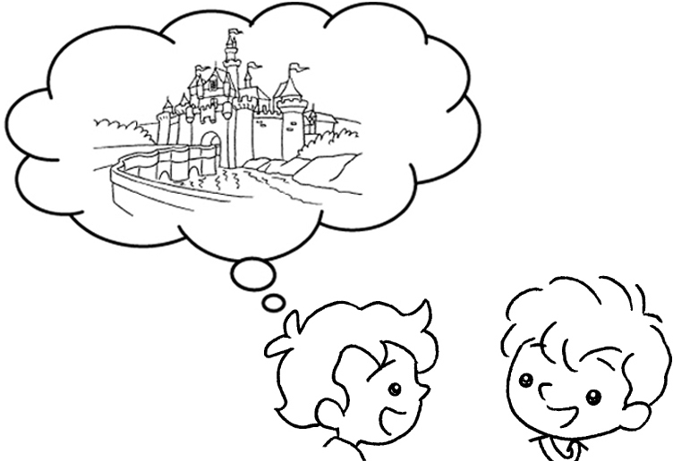 |  | A : you  to Disneyland?  B : Yes, I .
4  ✗  A  B | 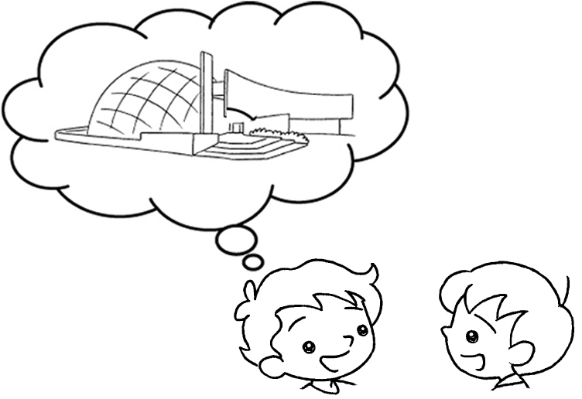  ( Space Museum ) |  | A : you  ?  B : No, I .
5  ✗  A  B | 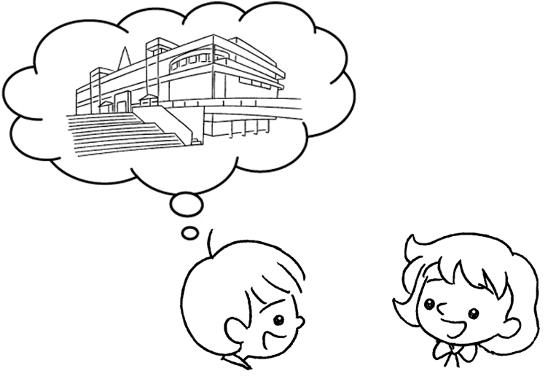  ( Science Museum ) |  | A :  B : No, I .


Book 5A Chapter 6 Graded Worksheets
Worksheet 2⬇⬇
- have
- Have been
- Have ever been
have
4 Have ever been to the Space Museum
haven’t
5 Have you ever been to the Science Museum?
haven’t

