Finish the sentences.
never |  | once |  | twice |  | three times

1 | 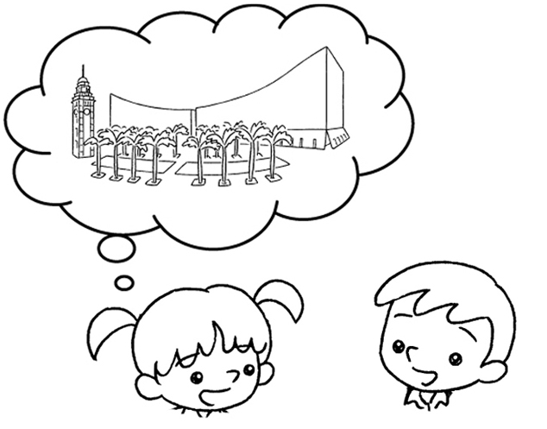  1  A  B |  | A : How many times have you been to the Cultural Centre?  B : I’ve been to the Cultural Centre  .
2 | 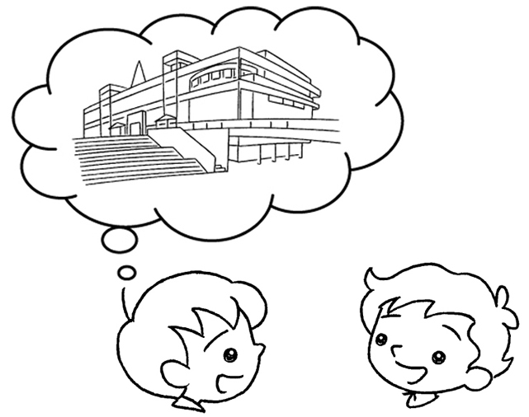  0  A  B |  | A : How many times have you been to the Science Museum?  B : I’ve been to  the Science Museum.
3 | 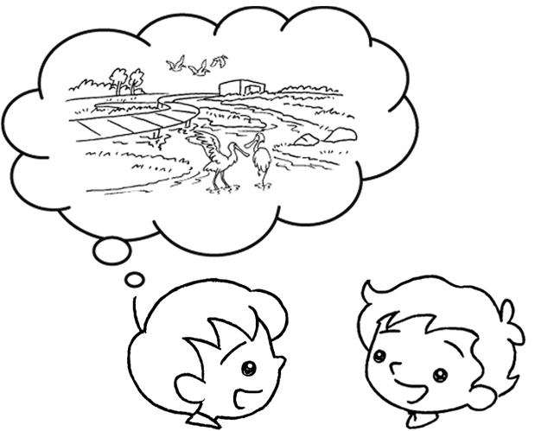  1  A  B |  | A : How many times have you been to Hong Kong Wetland Park?  B : I’ve Hong Kong  Wetland Park .
4 | 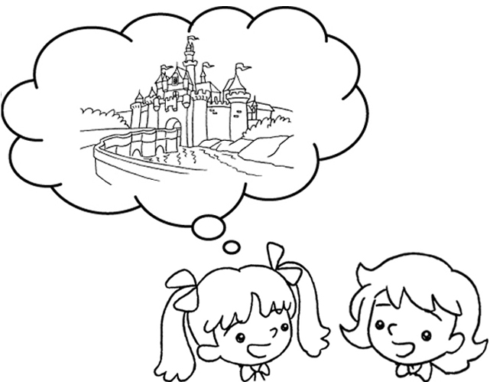  2  A  B |  | A : How many times have you been to Disneyland?  B : I’ve Disneyland  .
5 | 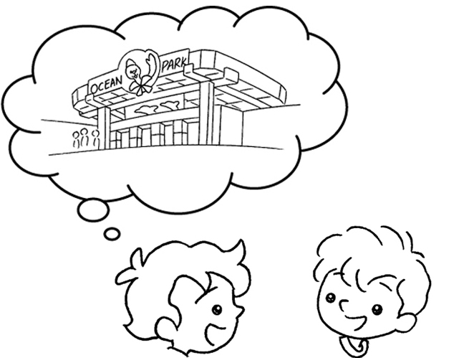  3  A  B |  | A : How many times have you been to Ocean Park?  B : Ocean Park  .



Book 5A Chapter 6 Graded Worksheets
Worksheet 3⬇
- once
- never
- been to once
- been to twice
- I’ve been to three times

