RP no: Century Gothic 15pt
(所有圈號用15pt)
Choose and write.

animator | athlete | film director | musician
painter | scientist | singer | writer
1
2
3
 | 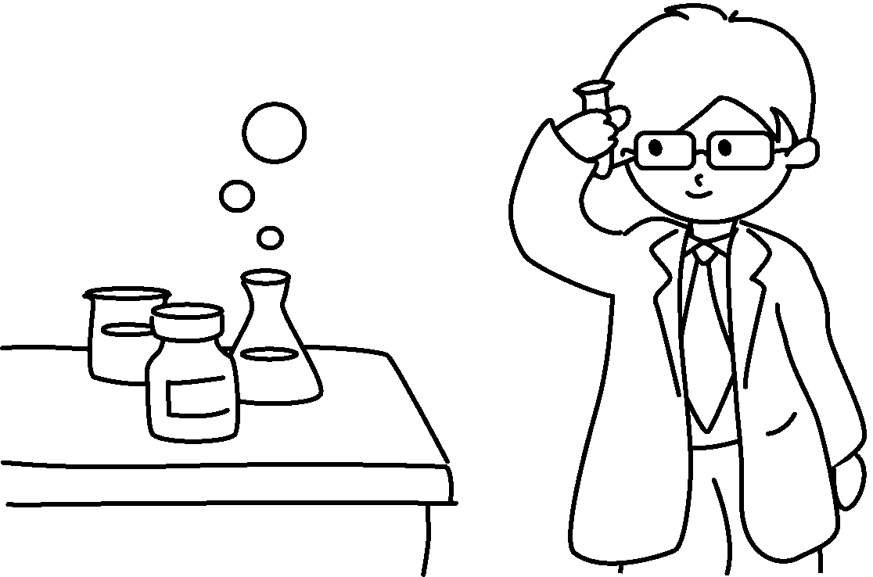 |  |  |  |  |  | 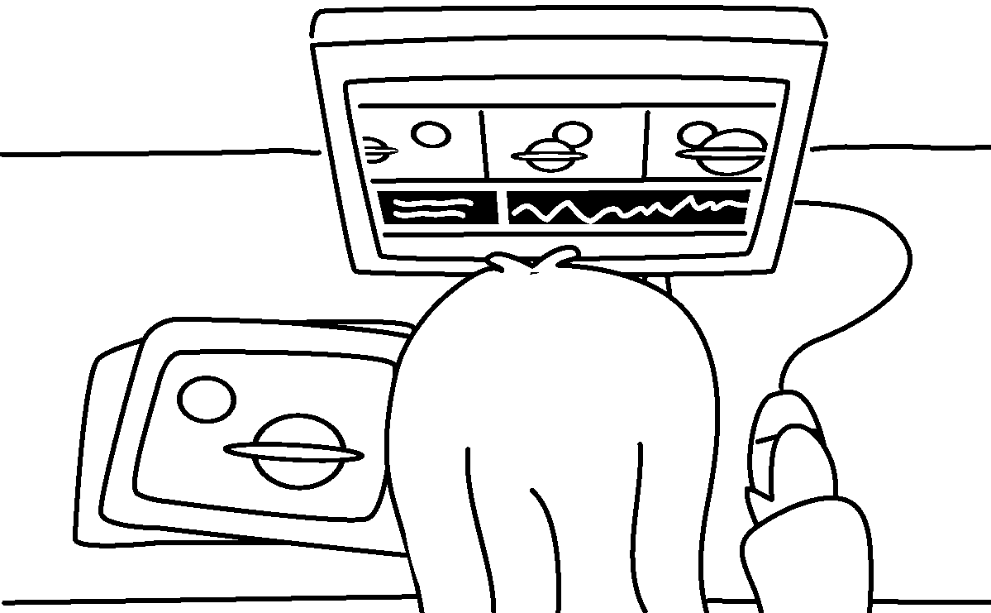
4  5 | 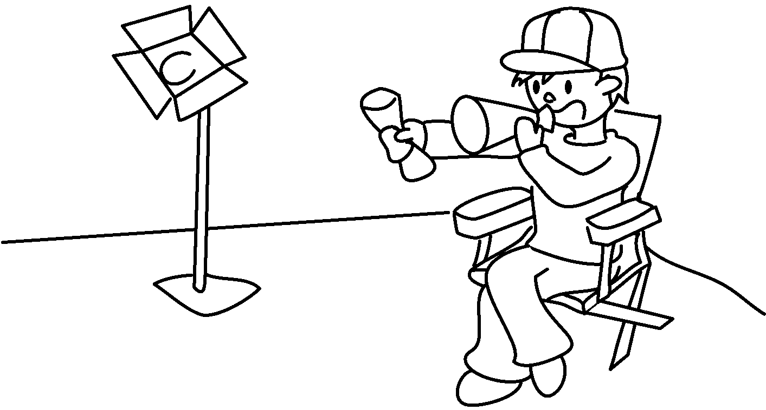 |  |  |  | 
 |   6  7  8 |  | 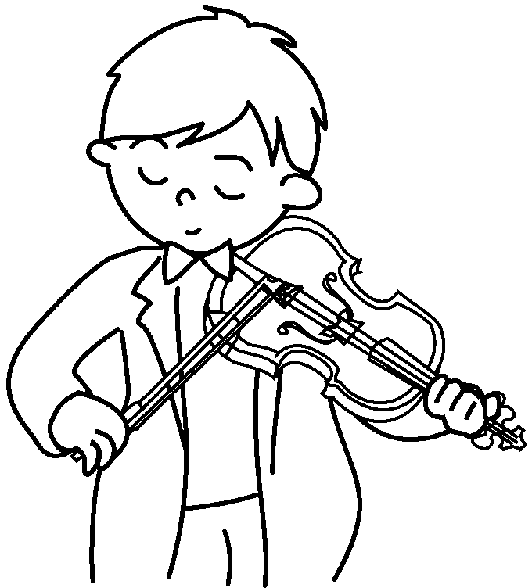 |  |  |  | 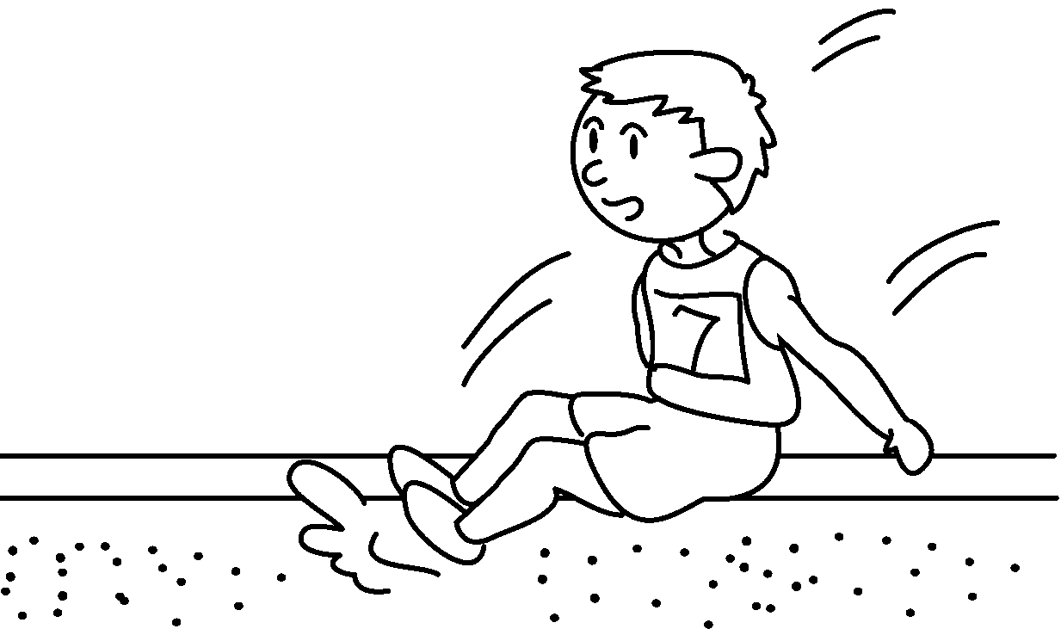

1 | a |  | 2 | a
3 | an |  | 4 | a
5 | a |  | 6 | a
7 | a |  | 8 | an

RP no: Century Gothic 15pt
(所有圈號用15pt)


Book 5A Chapter 7 Graded Worksheets
Worksheet 1⬇
- scientist 2 painter
3 animator 4 film director
5 writer 6 singer
7 musician 8 athlete

