RP no: Century Gothic 15pt
(所有圈號用15pt)
Who are they? Write.
1
2
3
 | 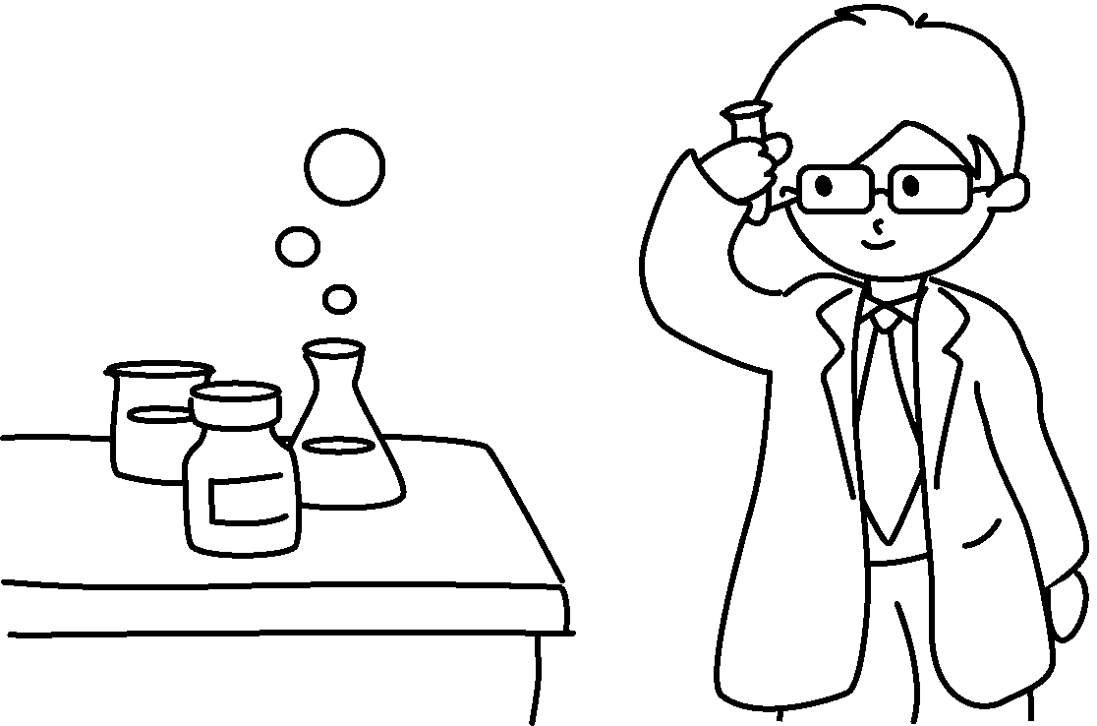 |  |  |  |  |  | 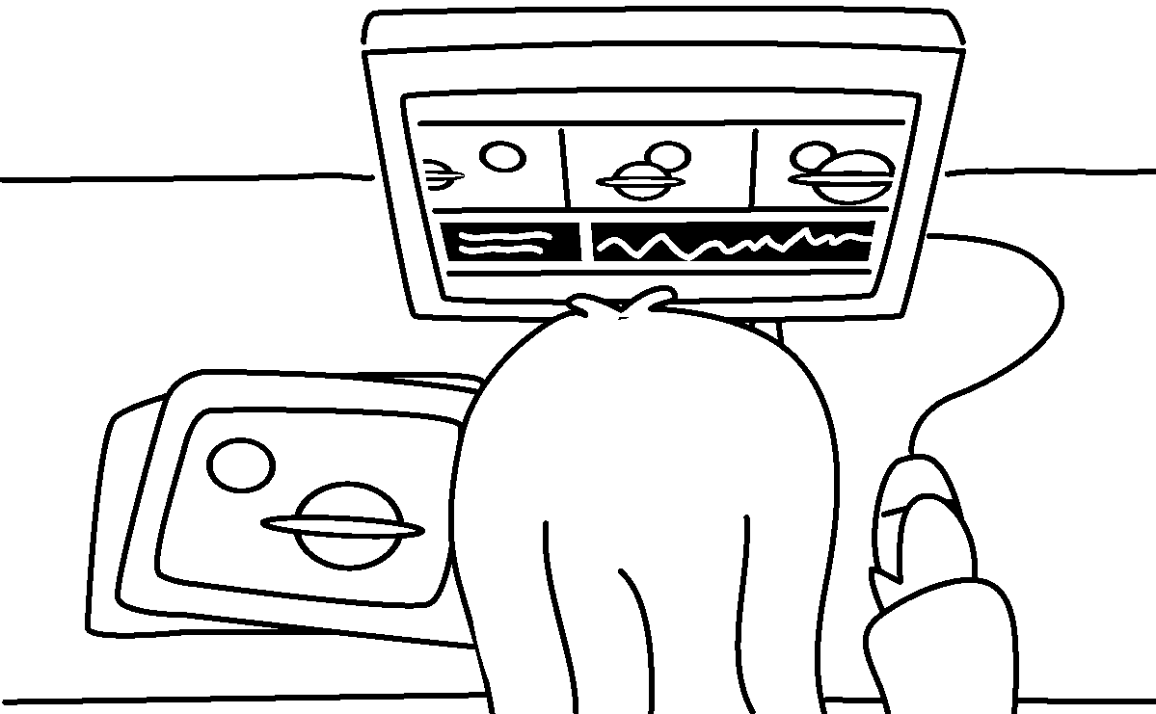
4  5 | 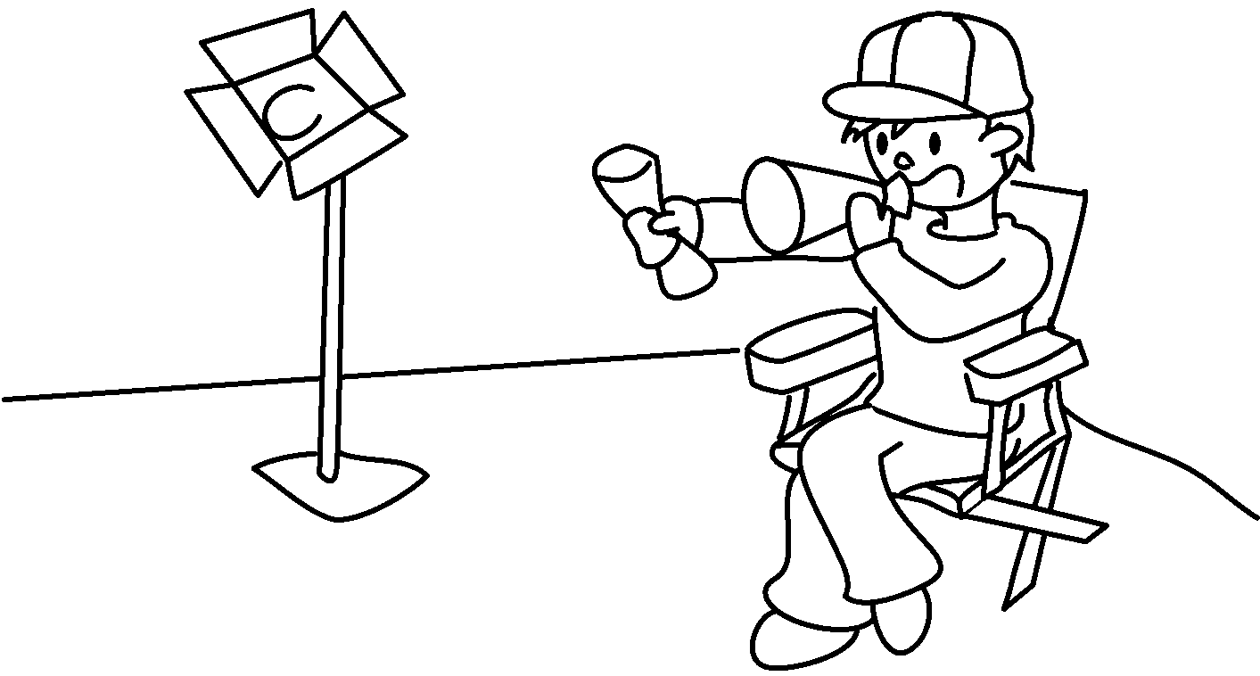 |  |  |  | 
 |   6  7  8 |  |  |  |  |  | 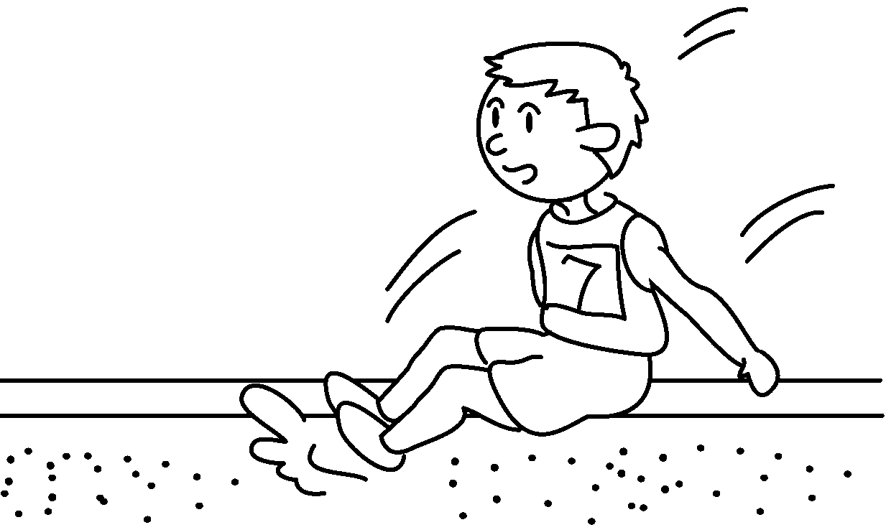

1 | a s |  | 2 | a p
3 | an a |  | 4 | a f d
5 | a w |  | 6 | a s
7 | a m |  | 8 | an a

RP no: Century Gothic 15pt
(所有圈號用15pt)


Book 5A Chapter 7 Graded Worksheets
Worksheet 1⬇⬇
- scientist 2 painter
3 animator 4 film director
5 writer 6 singer
7 musician 8 athlete

