RP no: Century Gothic 15pt
(所有圈號用15pt)
Who are they? Write.
1
2
3
 | 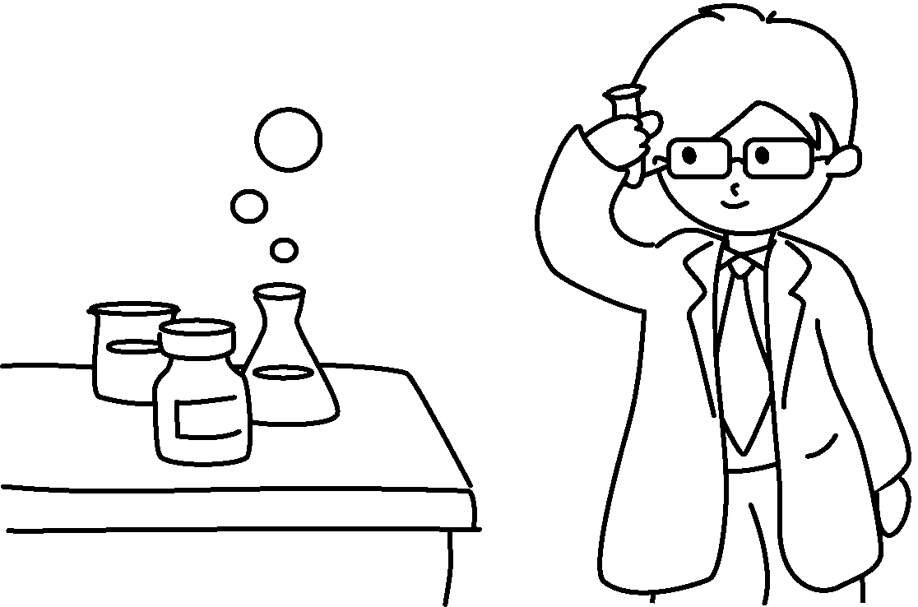 |  |  |  |  |  | 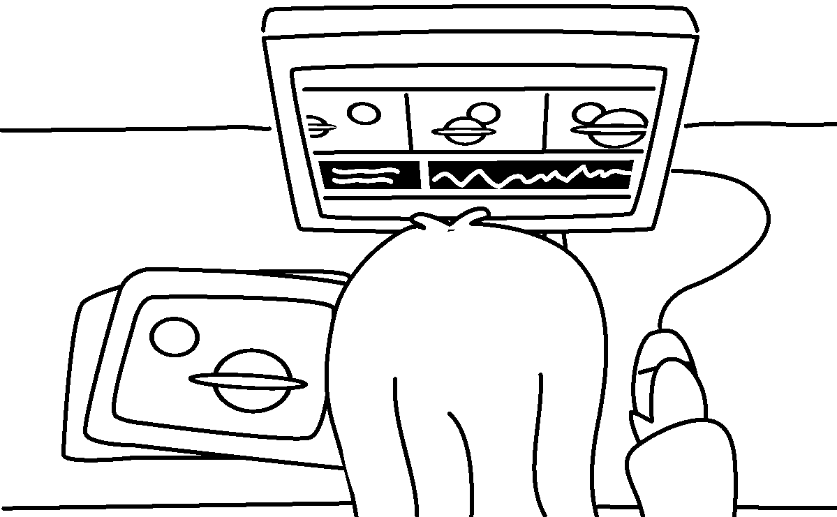
4  5 | 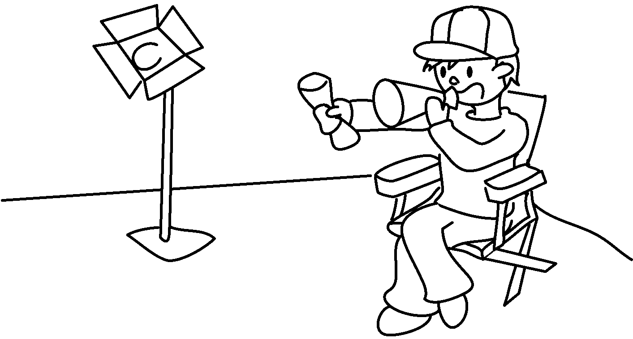 |  |  |  | 
 |   6  7  8 |  |  |  |  |  | 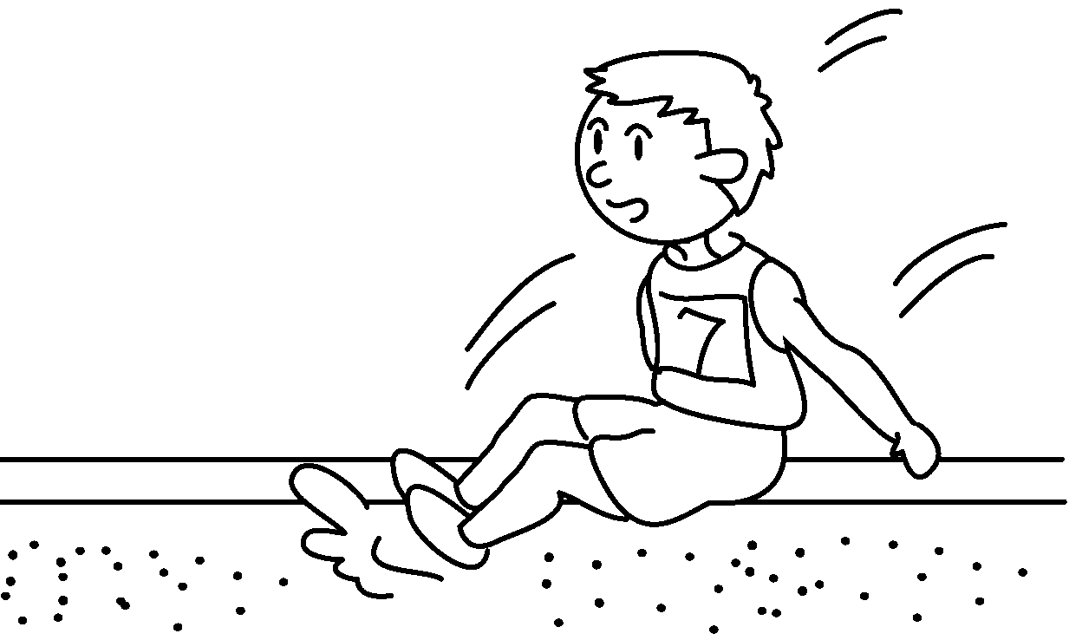

1 | a |  | 2 | a
3 |  |  | 4
5 |  |  | 6
7 |  |  | 8


Book 5A Chapter 7 Graded Worksheets
Worksheet 1⬇⬇⬇
- scientist 2 painter
3 an animator 4 a film director
5 a writer 6 a singer
7 a musician 8 an athlete
(Accept any reasonable answers.)

