Circle and write the correct answers.

 |  | ago |  | in

1 | 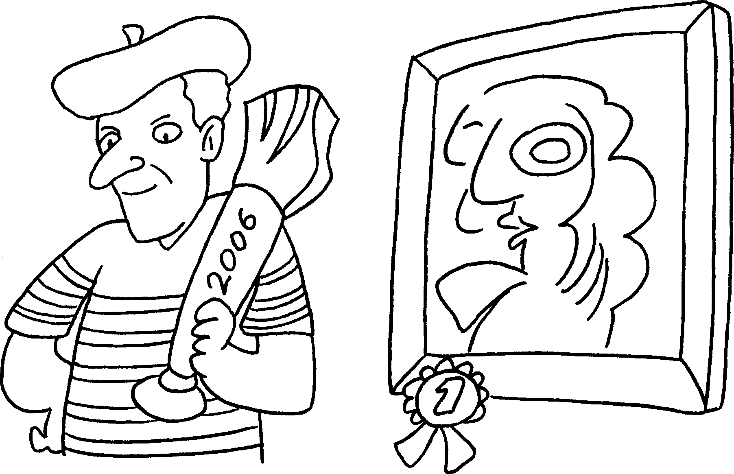 |  | Mr Wong ( won / has won ) the painting competition 2006.
2 | 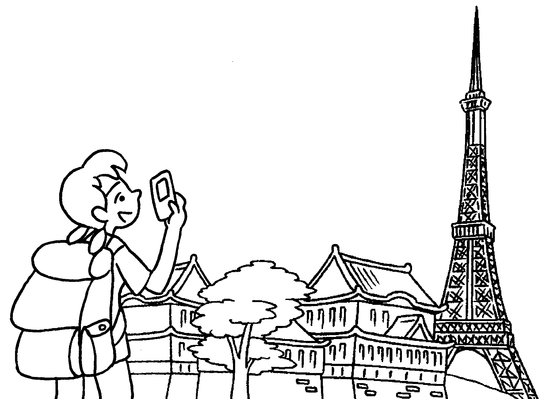 |  | Helen ( has visited / visited ) Japan five years .
3 |  |  | Mr Chan ( has written / wrote ) his first book ten years .
4 | 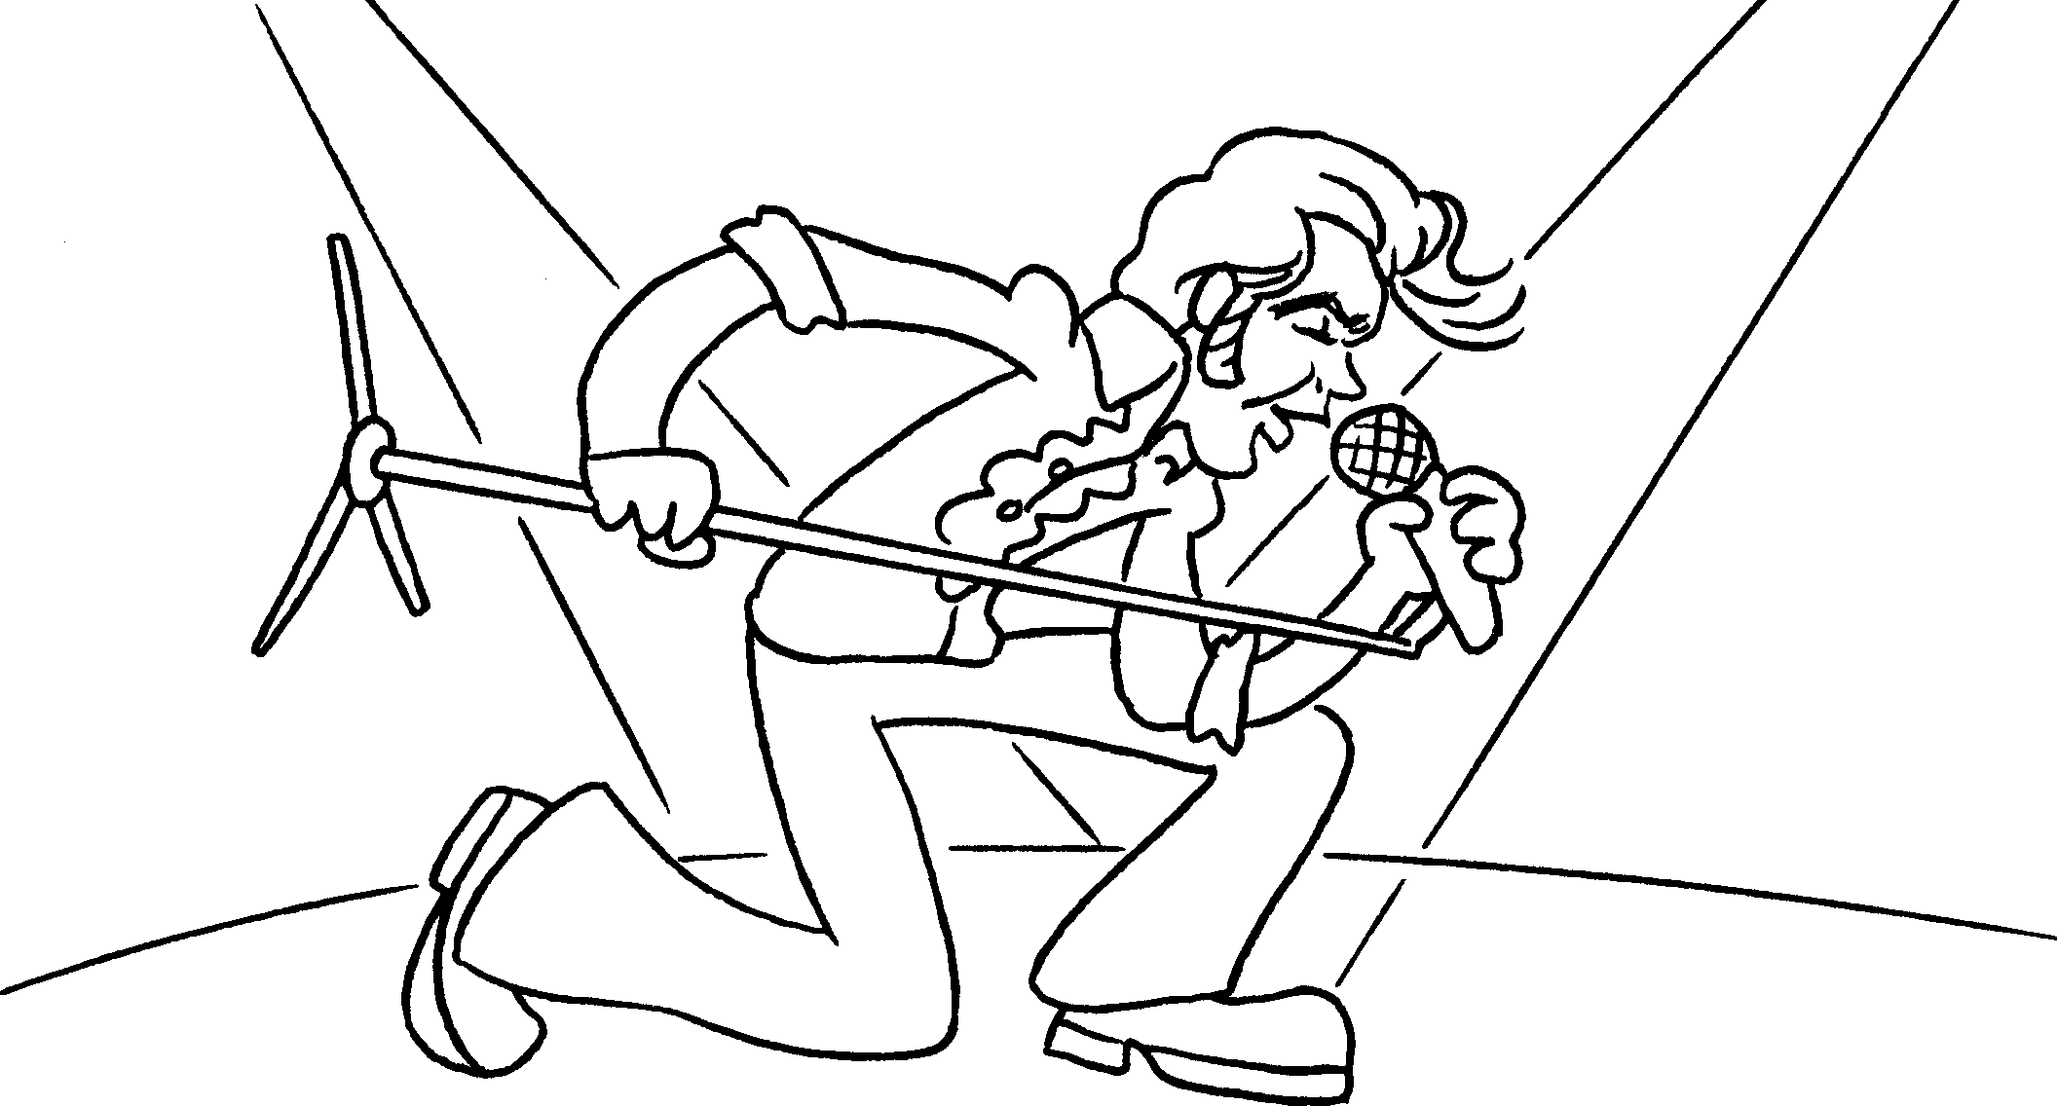 |  | Andy ( becomes / has become / became ) a singer 2003.
5 | 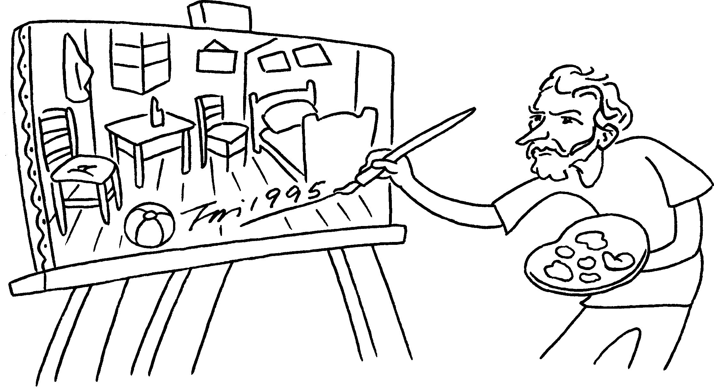 |  | The painter ( has painted / painted / paints ) this picture 1995.


Book 5A Chapter 7 Graded Worksheets
Worksheet 2⬇
1 ( won / has won ) in
2 ( has visited / visited ) ago
3 ( has written / wrote ) ago
4 ( becomes / has become / became ) in
5 ( has painted / painted / paints ) in

