Finish the sentences. Use the simple past tense.

 |  | ago |  | in

become paint visit win write

1 | 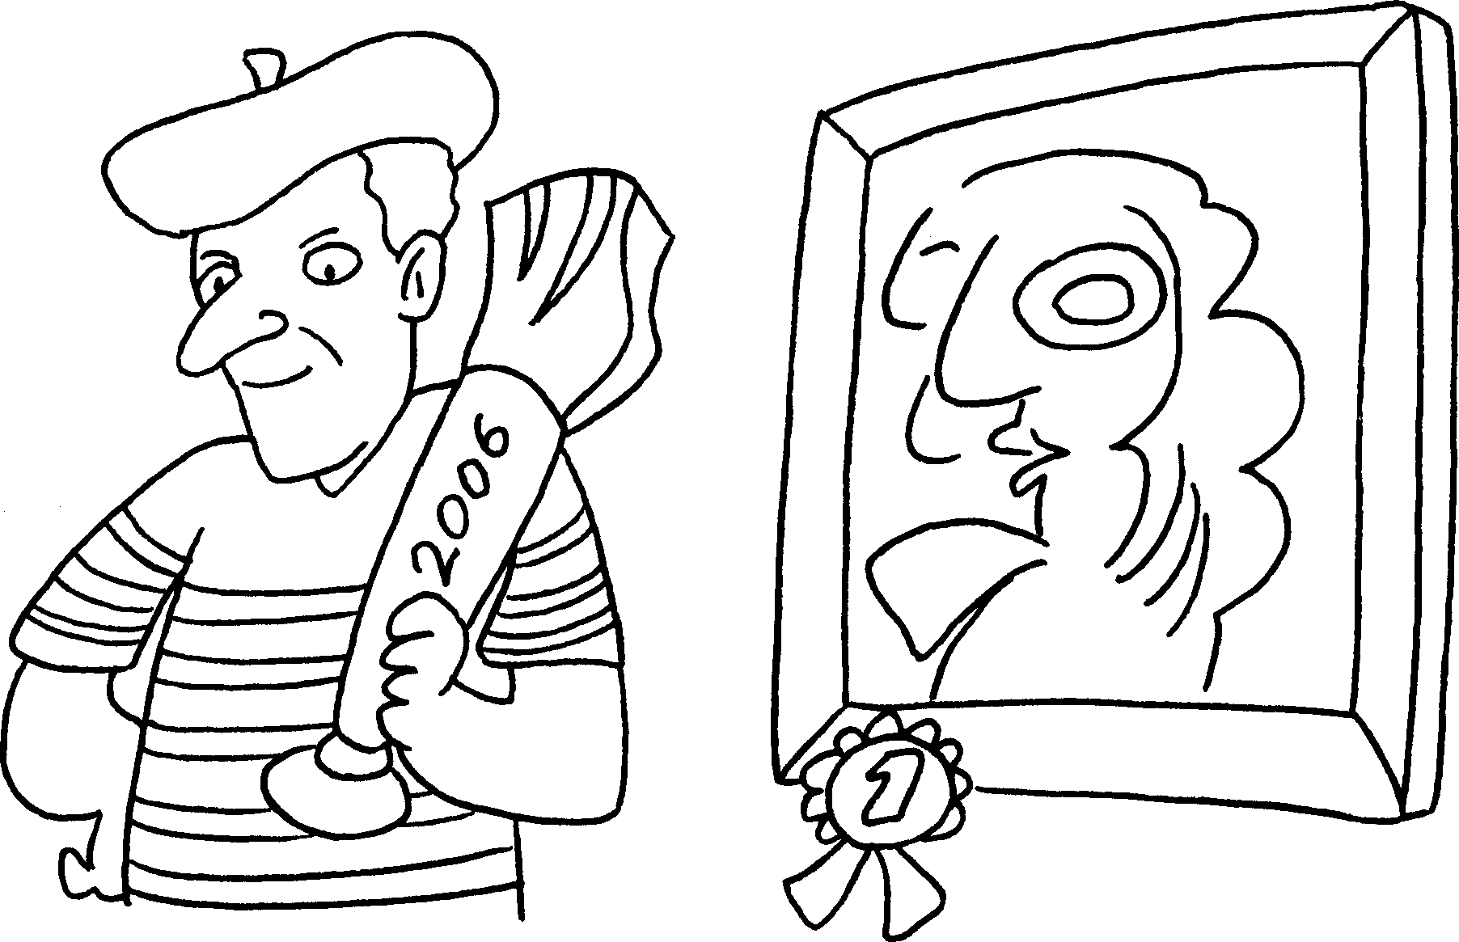 |  | Mr Wong the painting competition 2006.
2 | 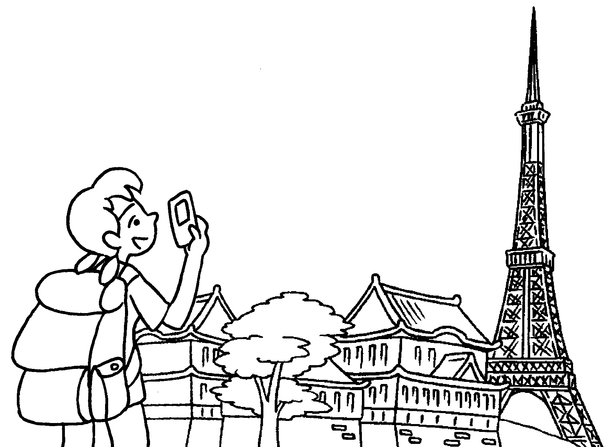 |  | Helen Japan five years .
3 | 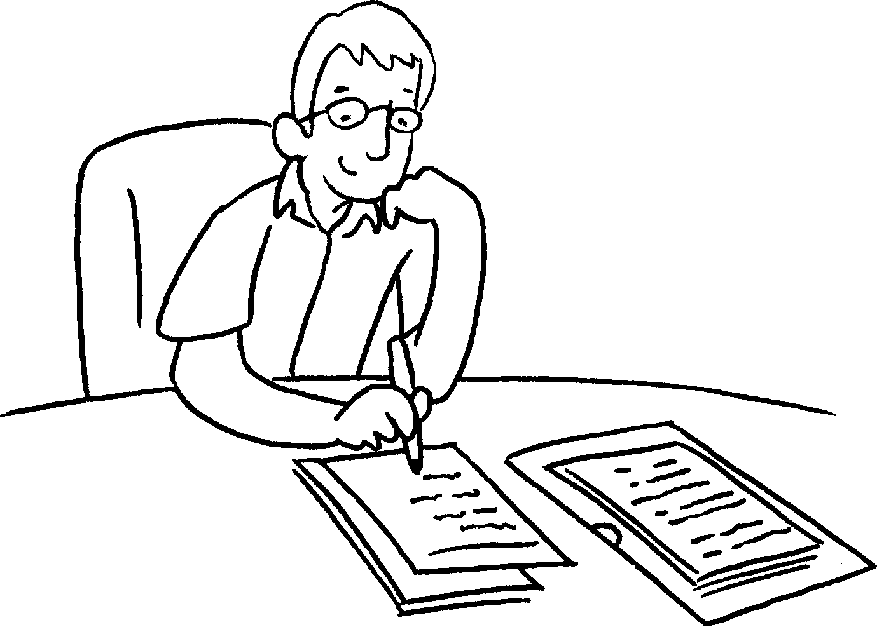 |  | Mr Chan his first book ten years .
4 | 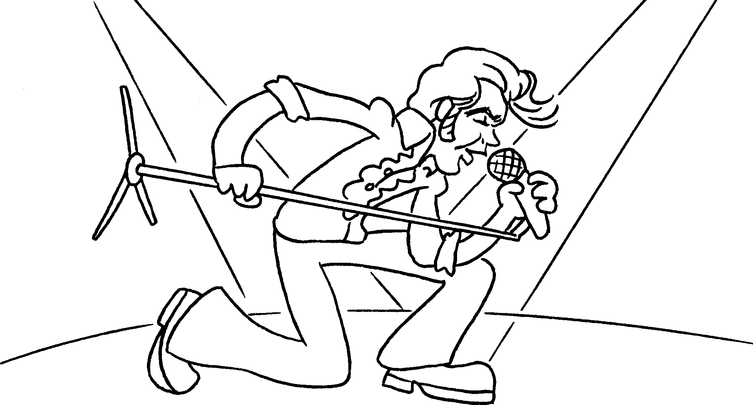 |  | Andy a singer  2003.
5 | 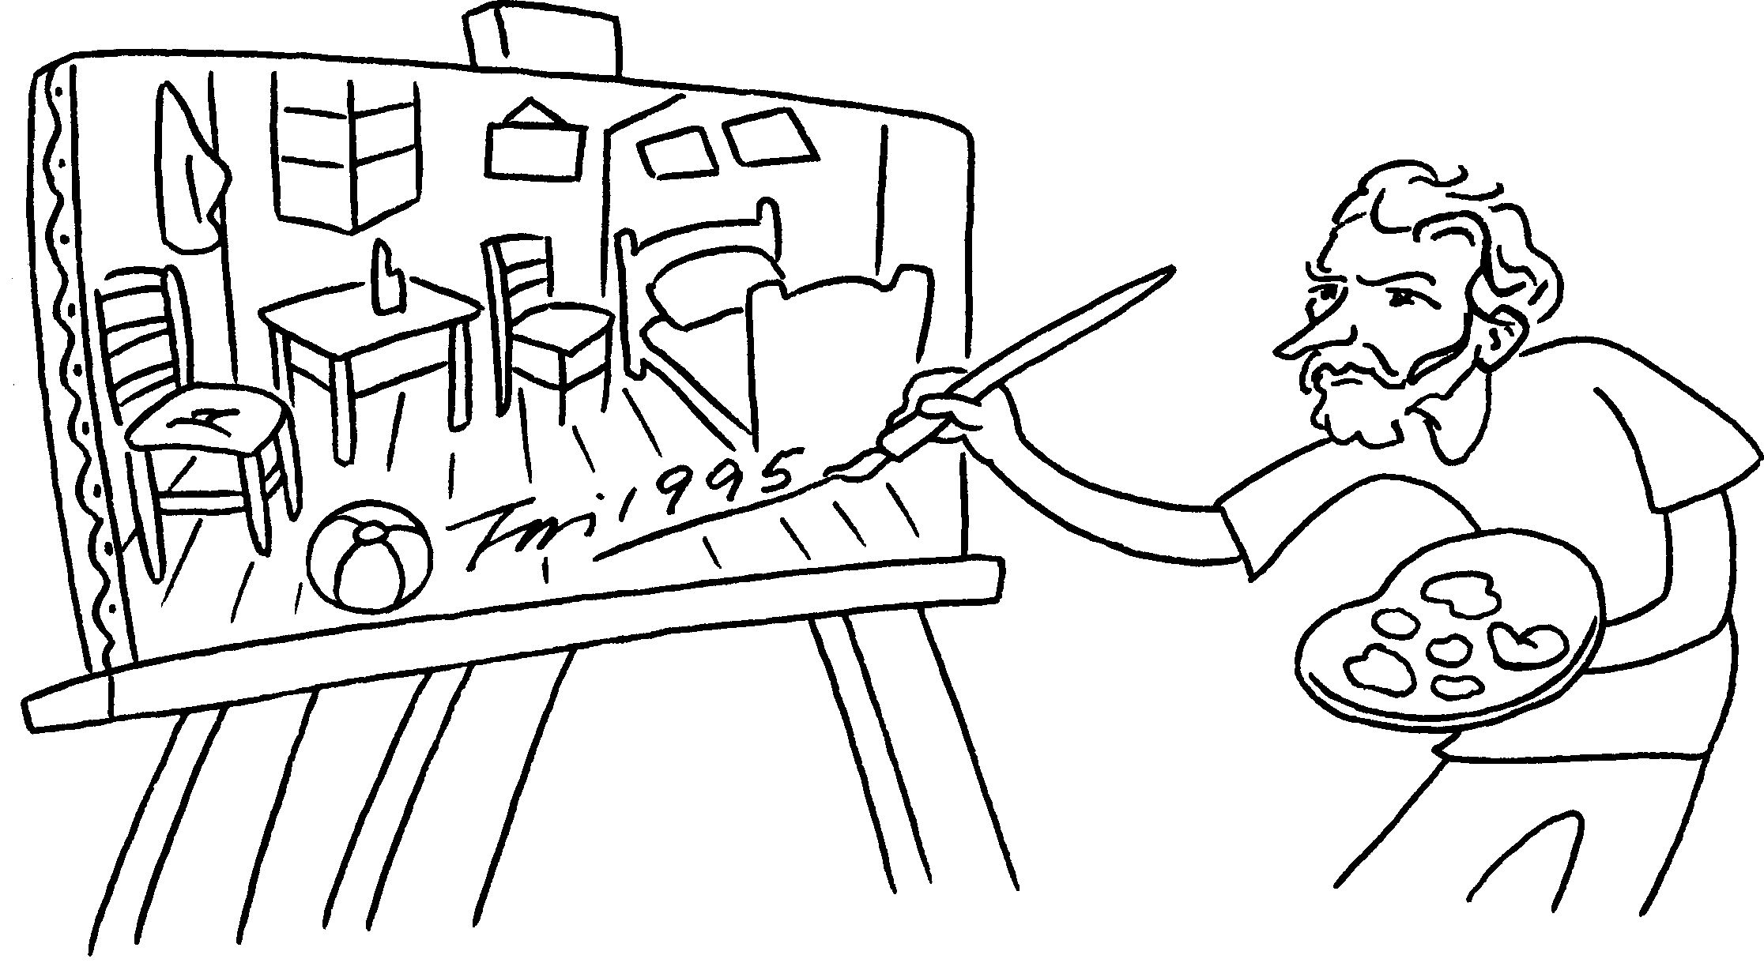 |  | The painter this picture 1995.


Book 5A Chapter 7 Graded Worksheets
Worksheet 2⬇⬇⬇
1 won in
2 visited ago
3 wrote ago
4 became in
5 painted in

