B
Finish the sentences. Use the present perfect tense.

 | for |  | since
A
A
A
A
A
B
B
B
B
1  1980 → now | 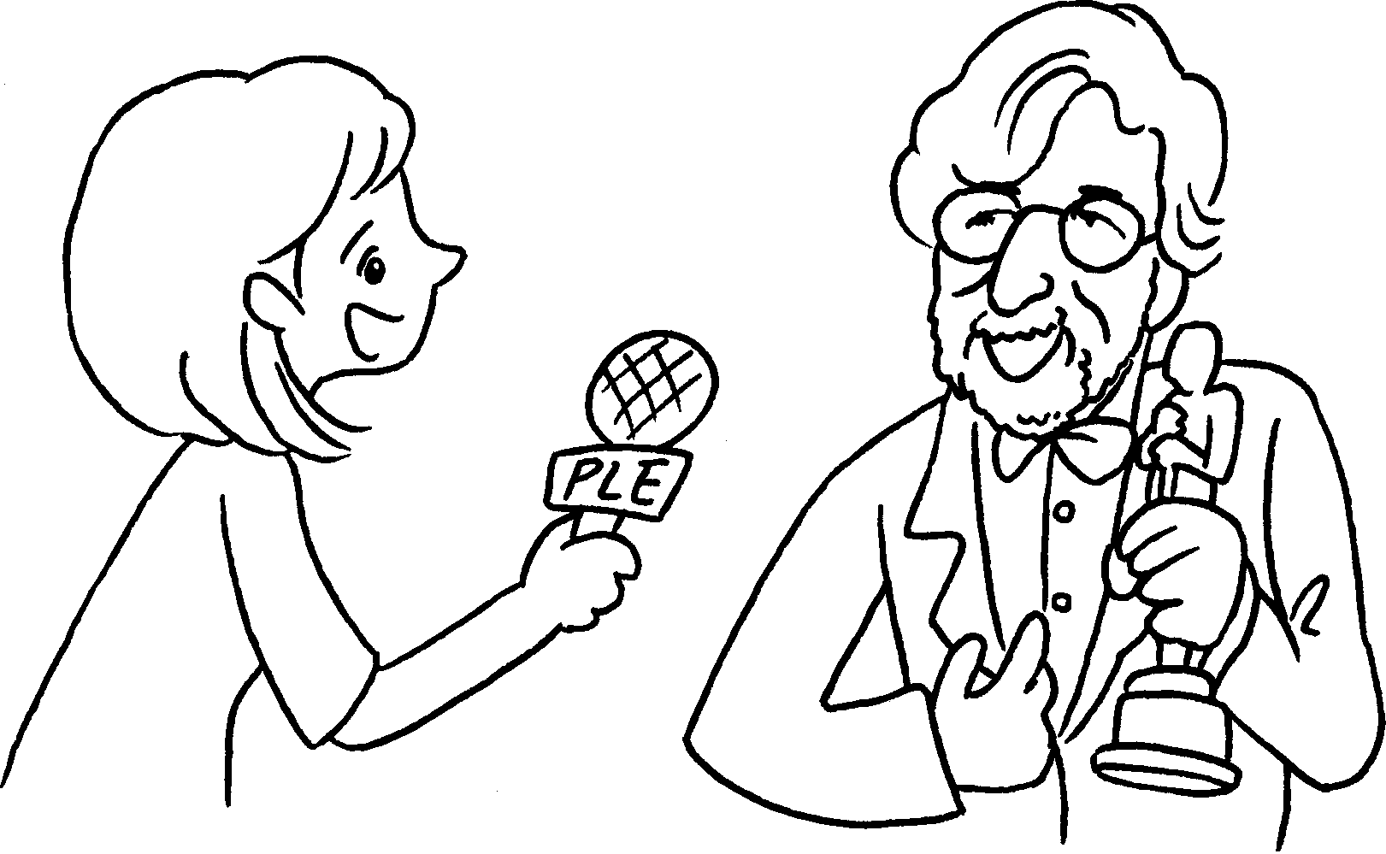 | A : How long have you been a film director?  B : I’ve been a film director  1980.
2  7 years | 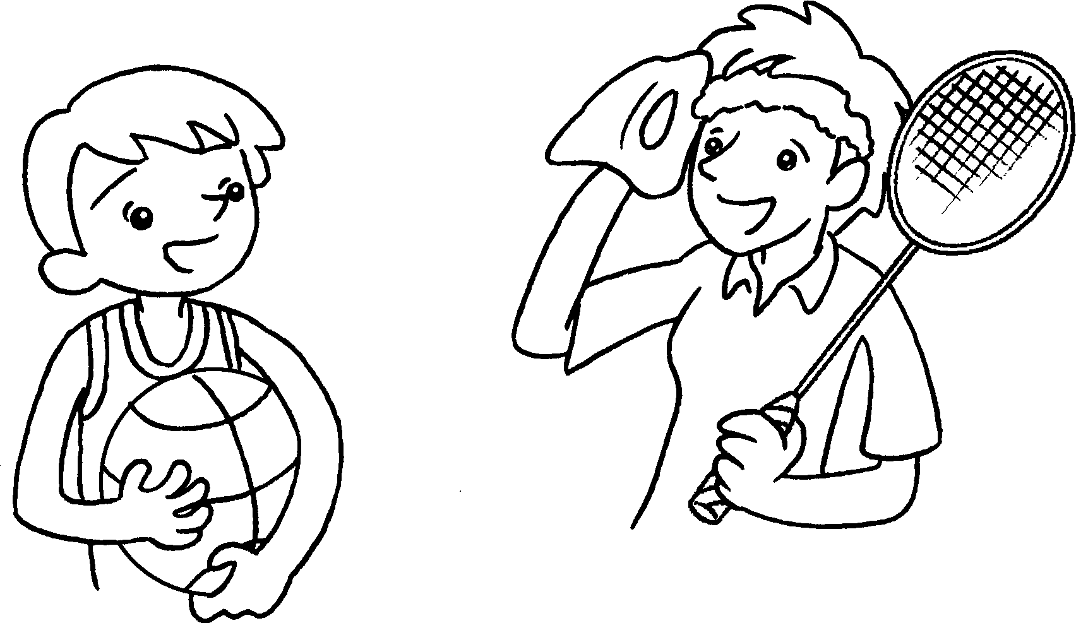 | A : How long have you played  badminton?  B : I ( play )  badminton 7 years.
3  1999 → now | 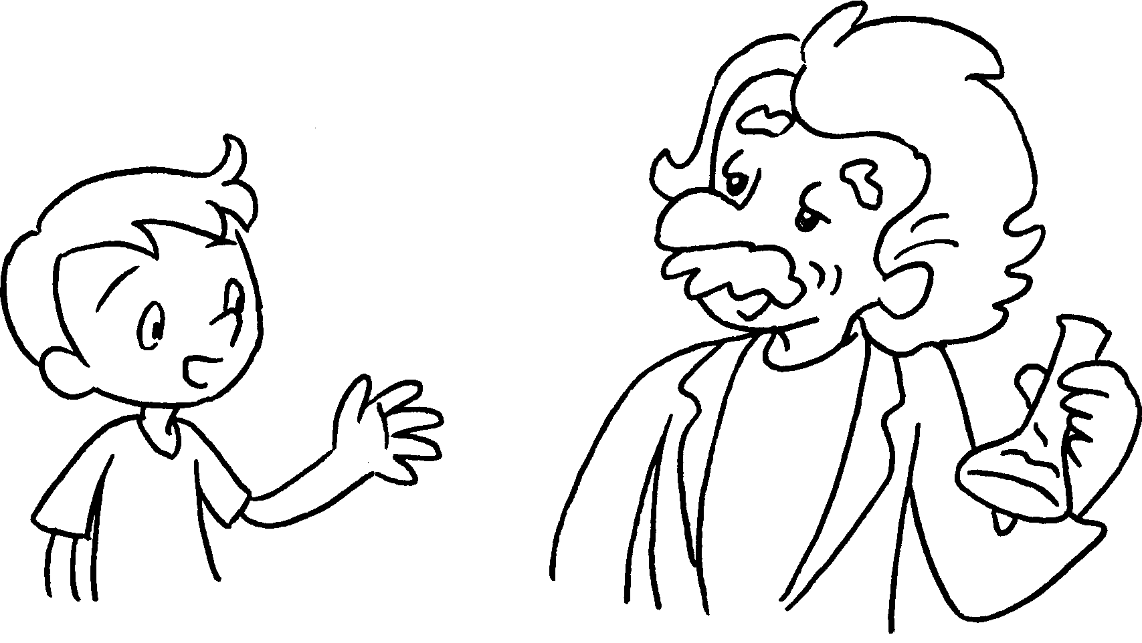 | A : How long have you been a scientist?  B : I ( be ) a scientist 1999.
4  5 years |  | A : How long have you been an athlete?  B : I ( be )  an athlete 5 years.
5  4 years | 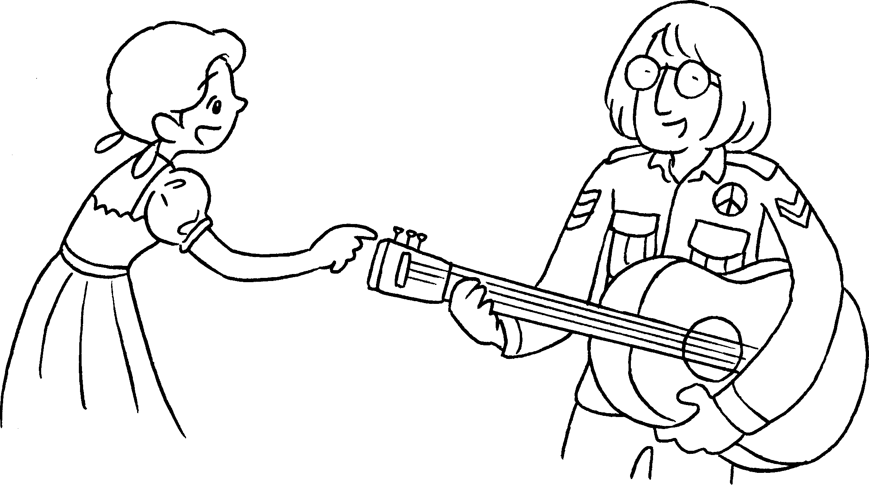 | A : How long have you played the guitar?  B : I ( play )  the guitar 4 years.


Book 5A Chapter 7 Graded Worksheets
Worksheet 3⬇
- since
- ’ve / have played for
- ’ve / have been since
- ’ve / have been for
- ’ve / have played for

