Finish the questions and answers. Use the present perfect tense.

 | be |  | play
B
A
A
B
B
1  1980 → now  A  A  A  B  B | 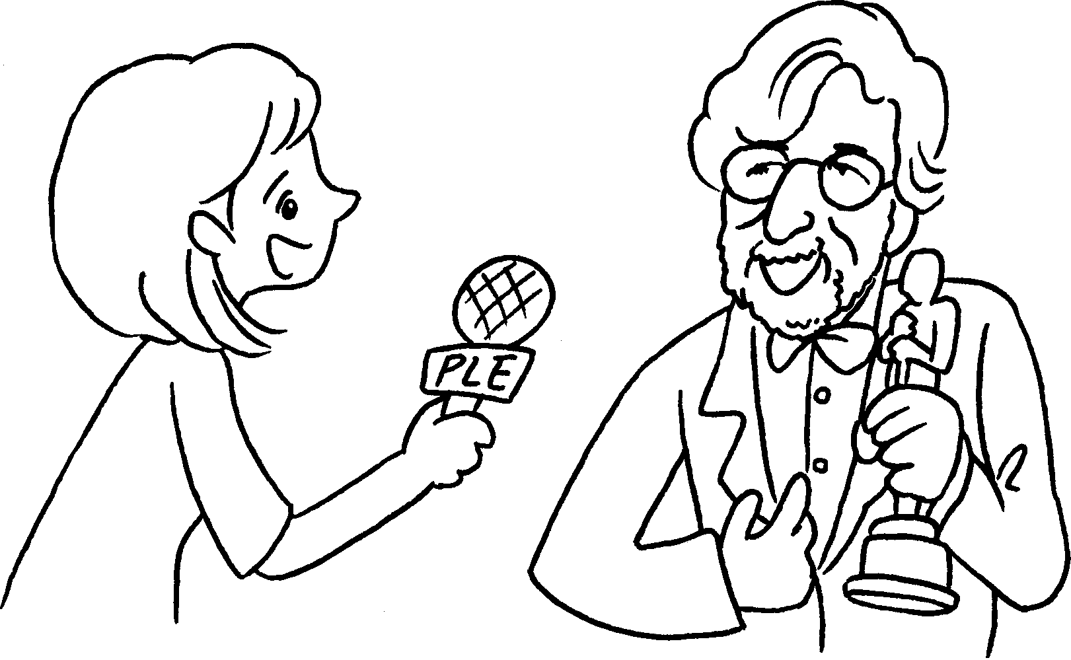 | A : How long have you been a film director?  B : I’ve a film director  1980.  since
2  7 years | 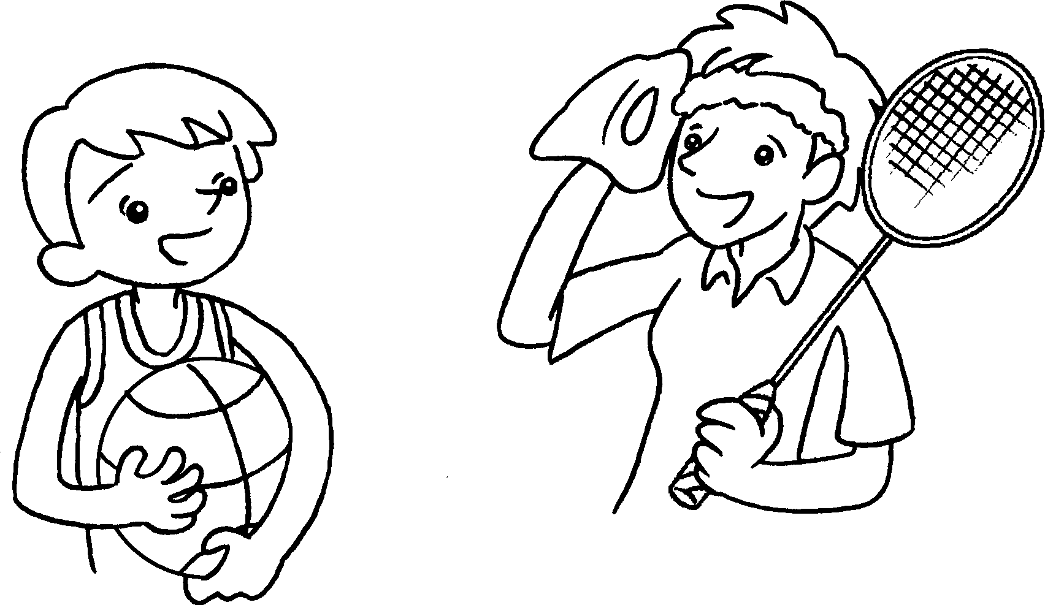 | A : How long have you  badminton?  B : I  badminton 7 years.
3  1999 → now | 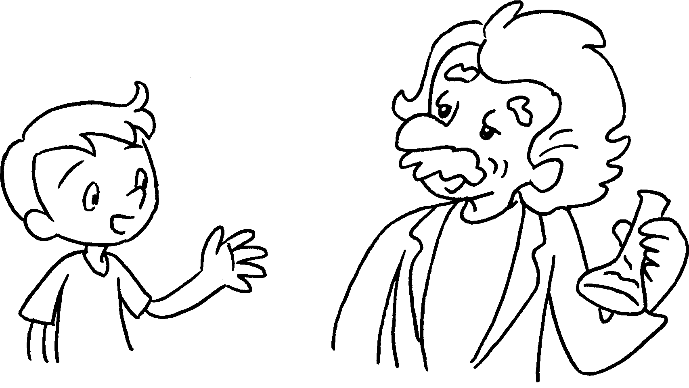 | A : How long have you  a scientist?  B : I a scientist  1999.
4  5 years | 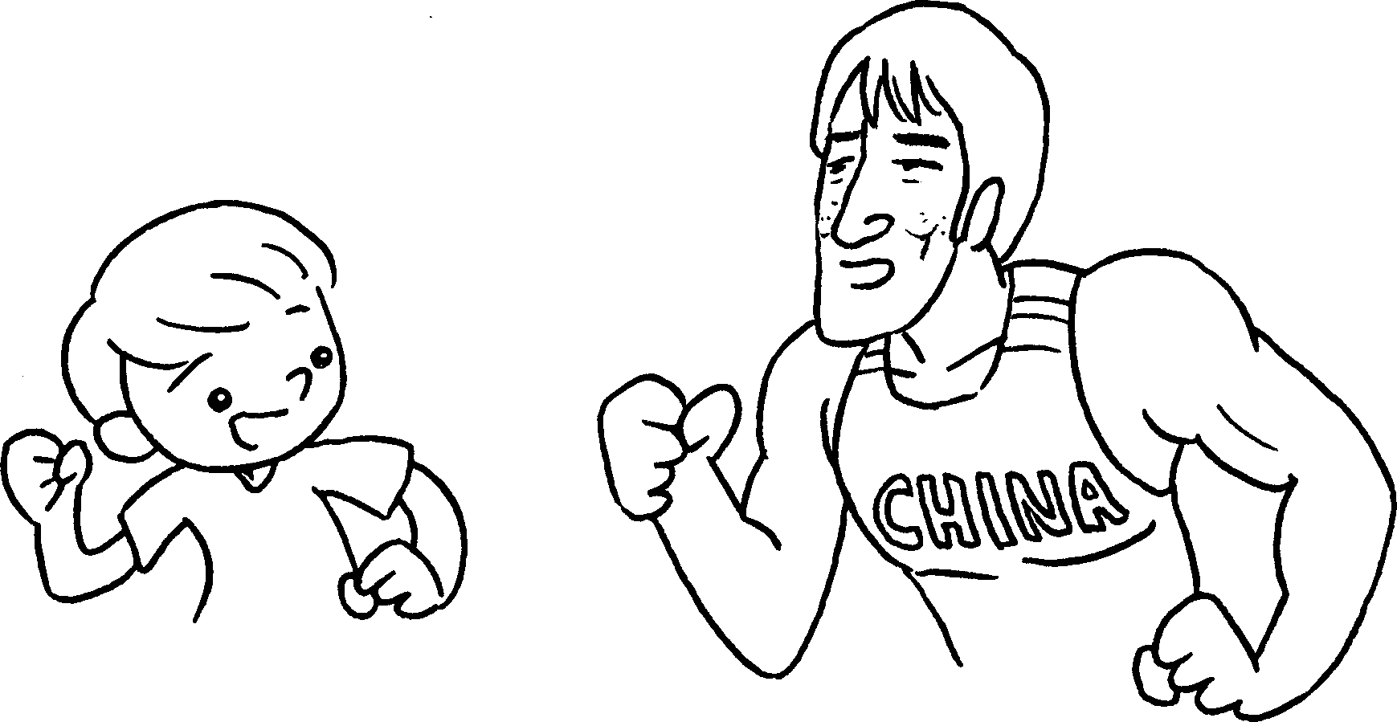 | A : How long  an athlete?  B : I  5 years.
5  4 years | 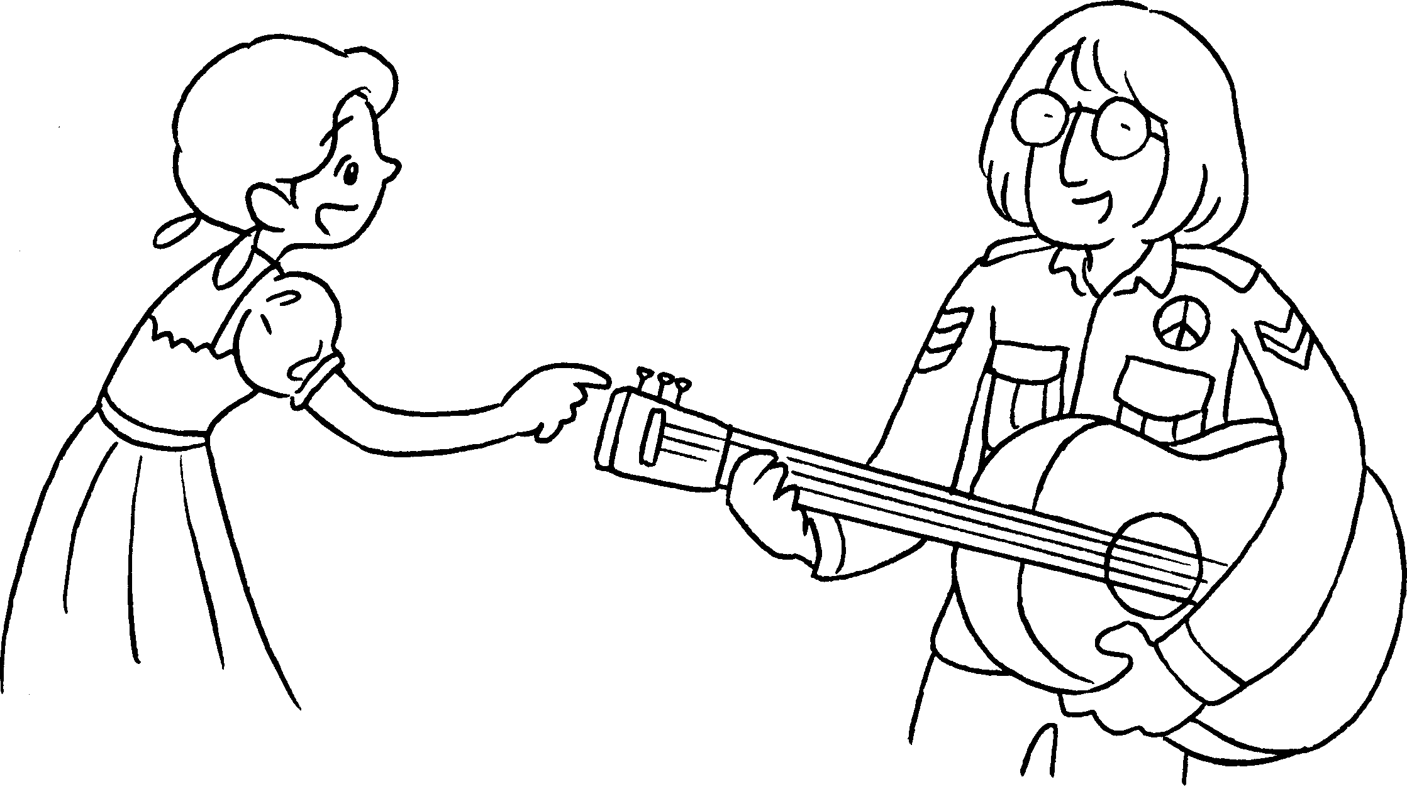 | A : How long  the guitar?  B : I  4 years.


Book 5A Chapter 7 Graded Worksheets
Worksheet 3⬇⬇
- been
- played
’ve / have played for
- been
’ve / have been since
- have you been
’ve / have been an athlete for
- have you played
’ve / have played the guitar for

