B
Finish the questions and answers. Use the present perfect tense.
A
A
A
A
A
B
B
B
B
1  1980 → now | 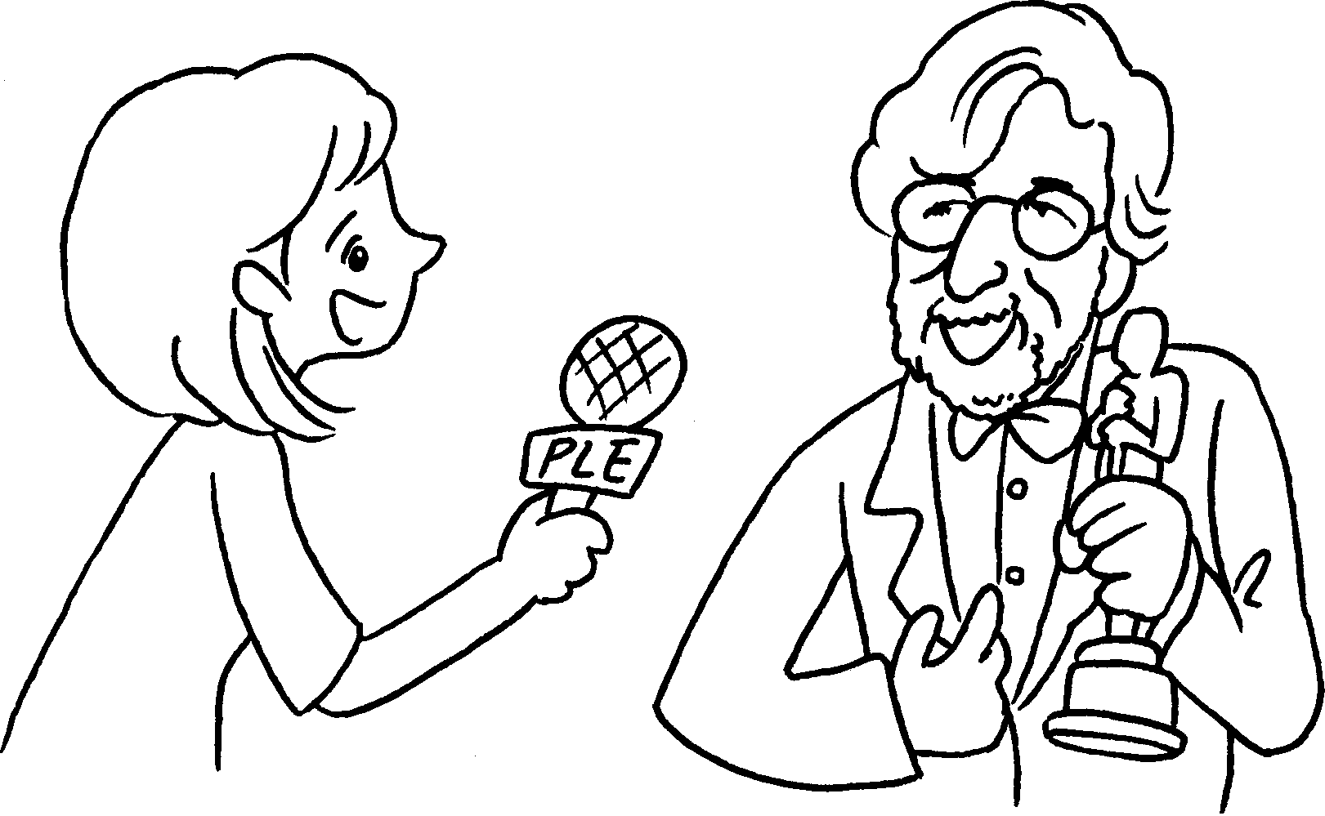 | A : How long have you been a film director?  B : I’ve a film director  1980.  since
2  7 years | 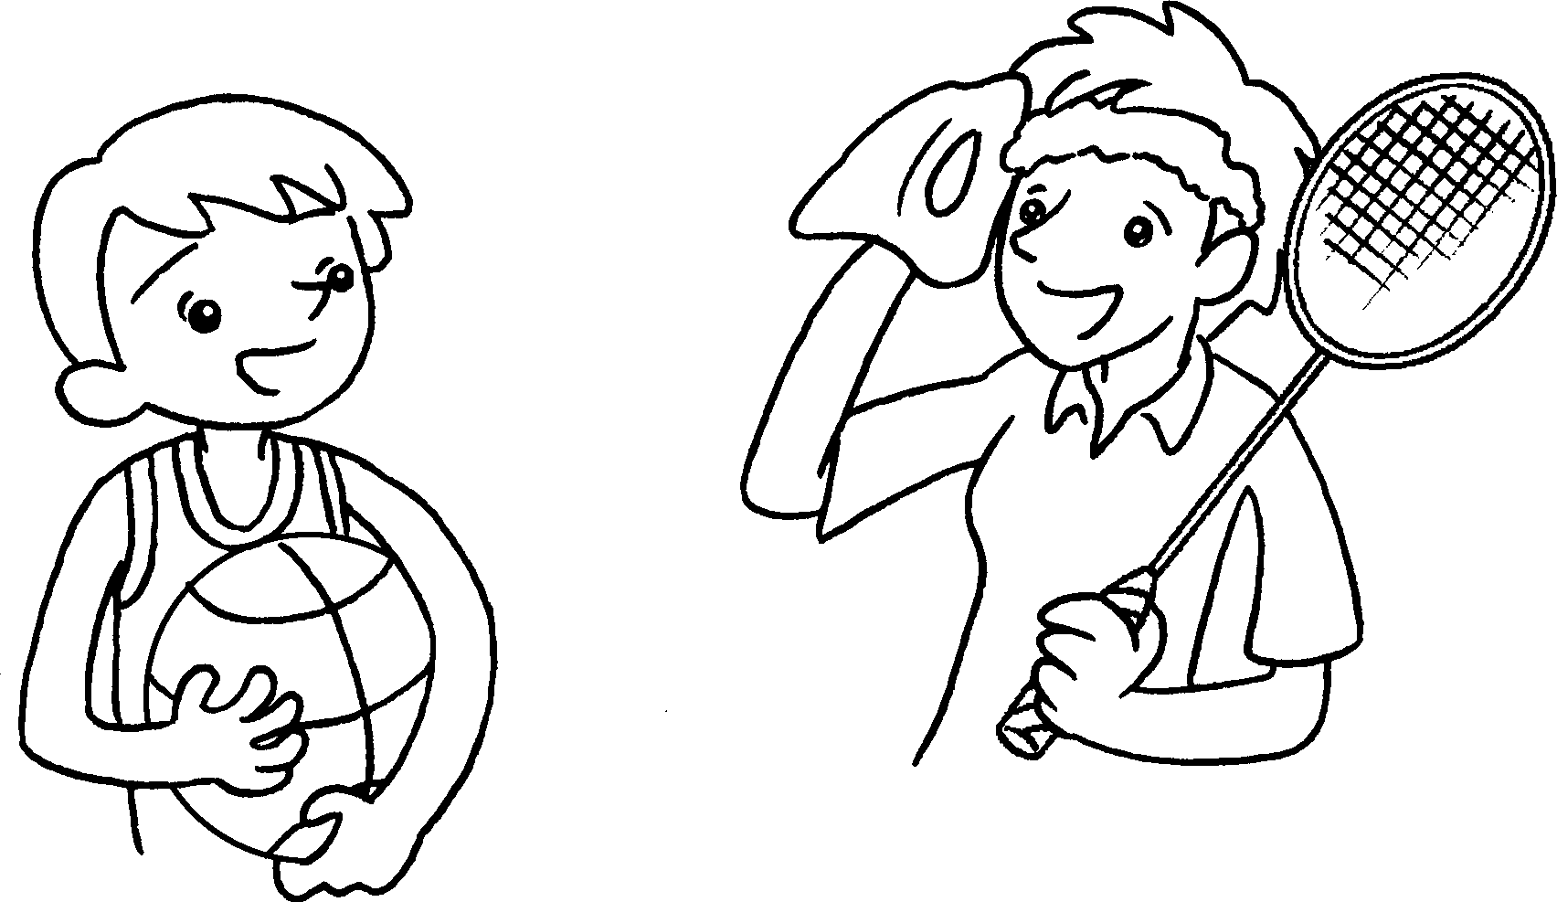 | A : How long have you  badminton?  B : I  badminton 7 years.
3  1999 → now | 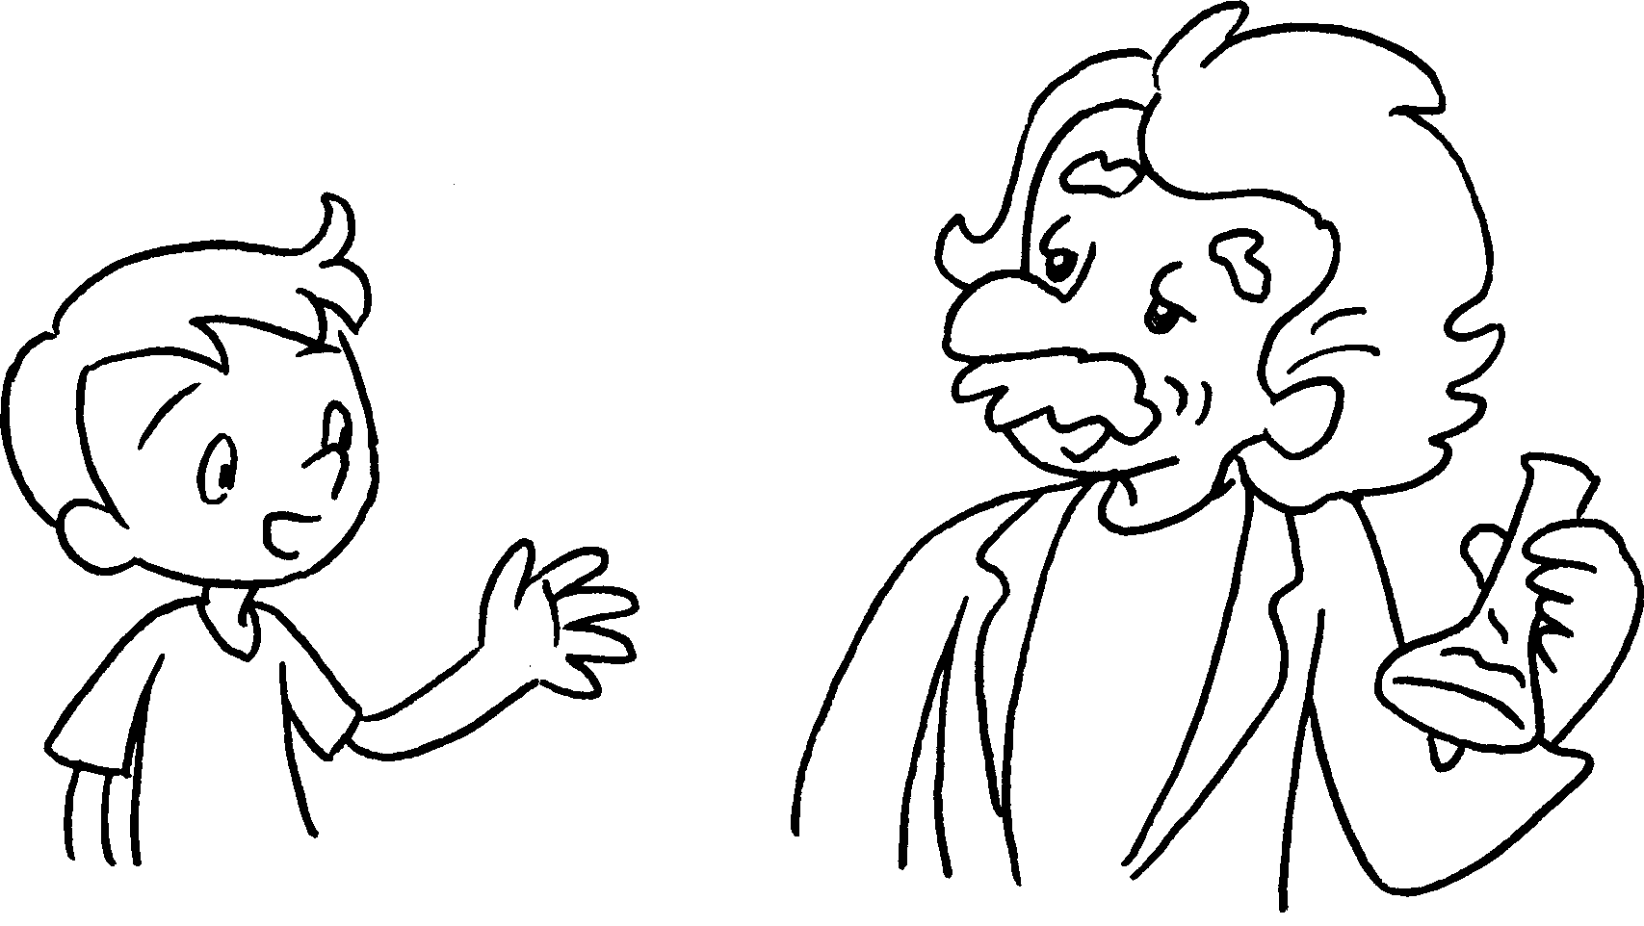 | A : have you  a scientist?  B : I a scientist  1999.
4  5 years | 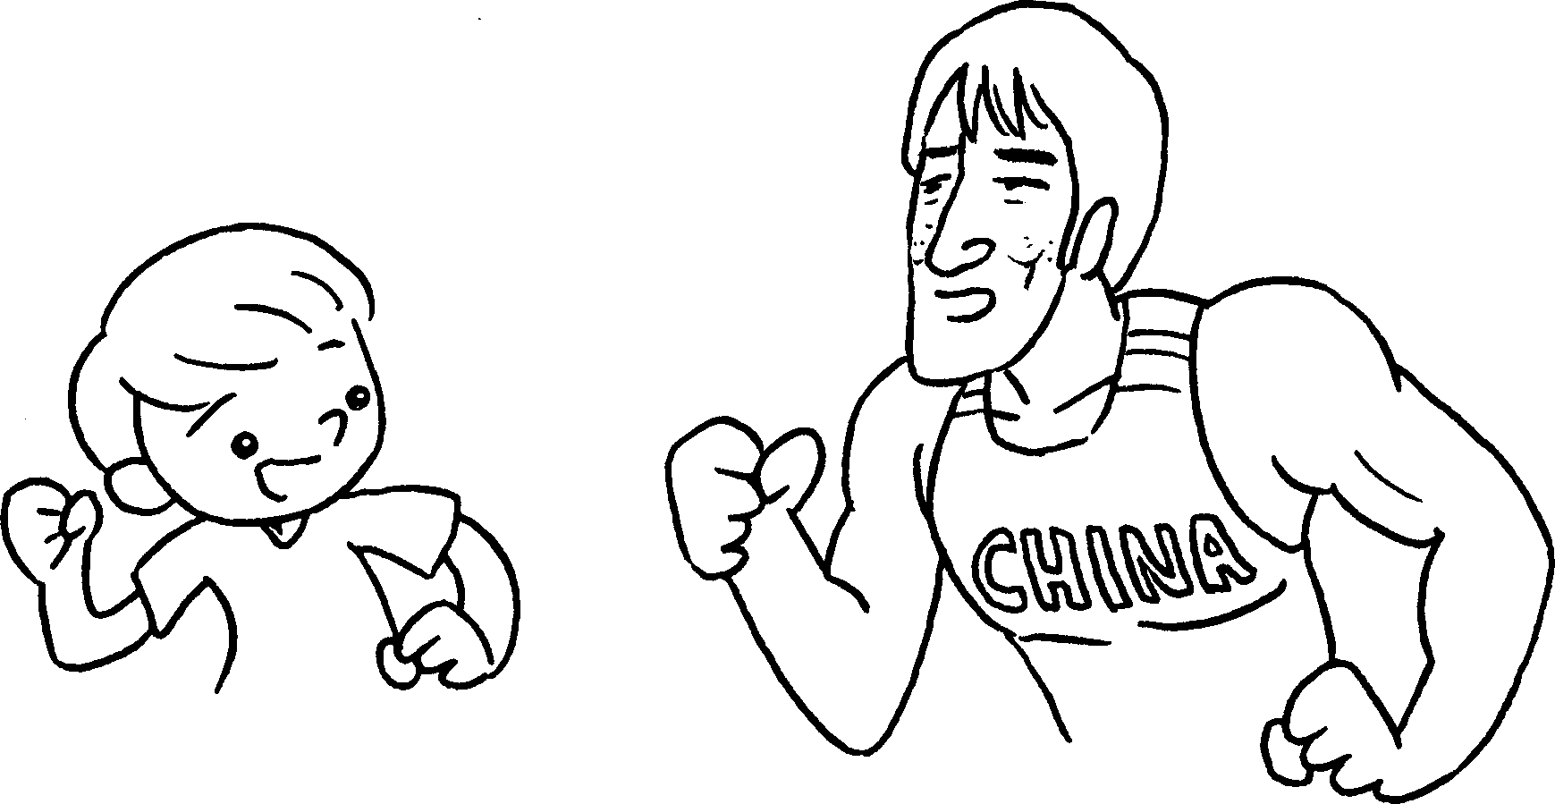 | A :  an athlete?  B :
5  4 years | 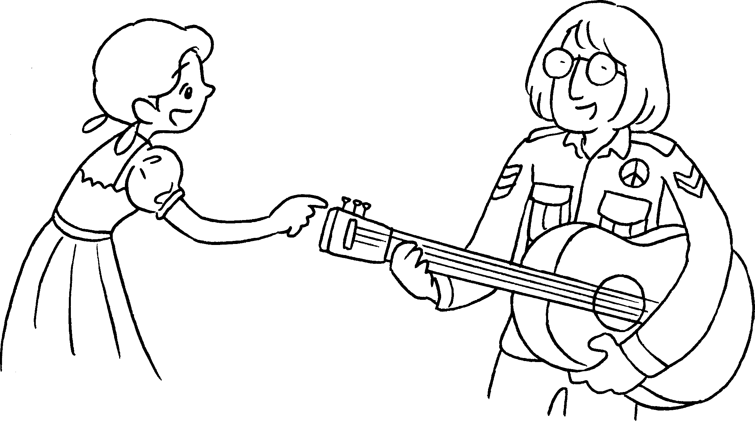 | A :  the guitar?  B :


Book 5A Chapter 7 Graded Worksheets
Worksheet 3⬇⬇⬇
1 been
2 played
’ve / have played for
3 How long been
’ve / have been since
4 How long have you been
I’ve / have been an athlete for 5 years.
5 How long have you played
I’ve / have played the guitar for 4 years.

