- Fantastic people
A hero is someone you admire very much. Read the biographies* and find out the children’s heroes.
* A biography describes the life of a famous person.

FKids’ Magazine October 2008
My hero

My hero is Liu Xiang. He started practising for the 110-metre hurdles twelve years ago. Sun Hai Ping has been his trainer since 1999. Together they have won many competitions. Four years ago, Liu won an Olympic gold medal. In 2006, he set a new world record with a time of 12.88 seconds.
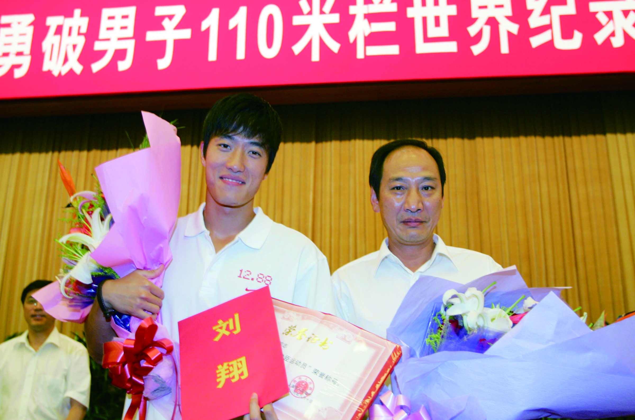
Liu Xiang had lots of difficulties but he never stopped trying. When he was at sports school, some older boys bullied him. Liu never complained, even when training was very difficult and his legs hurt badly. He fought off problems and got great results.
I really admire Liu Xiang because he never gives up. When things are difficult, I am going to try harder.
Angela Lui, 12 years old

FKids’ Magazine October 2008
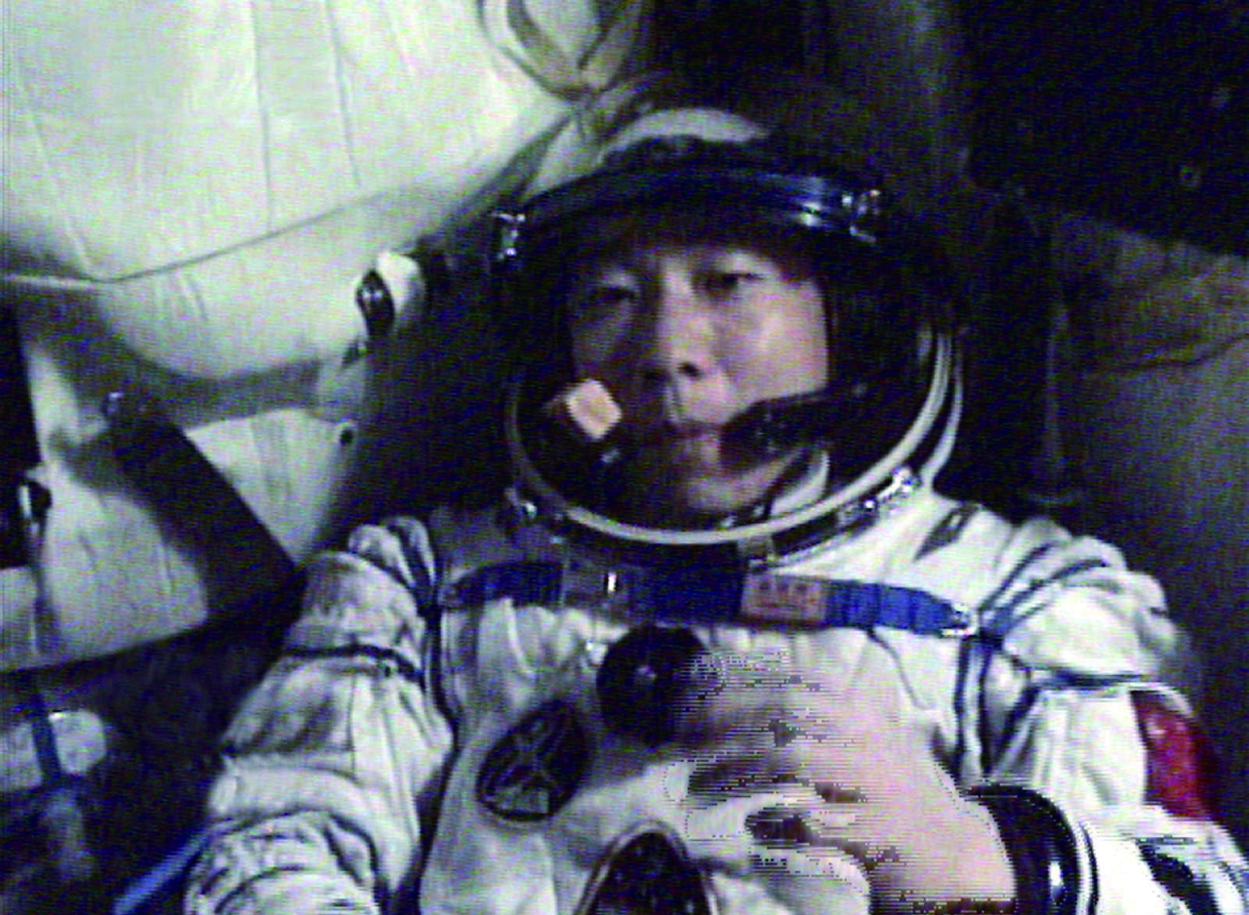
Yang Liwei is my hero. He has been in the Chinese army since 1983. At first he was a pilot but ten years ago, he started astronaut training. In 2003, he became the first Chinese to travel in space. Today Yang is a trainer.

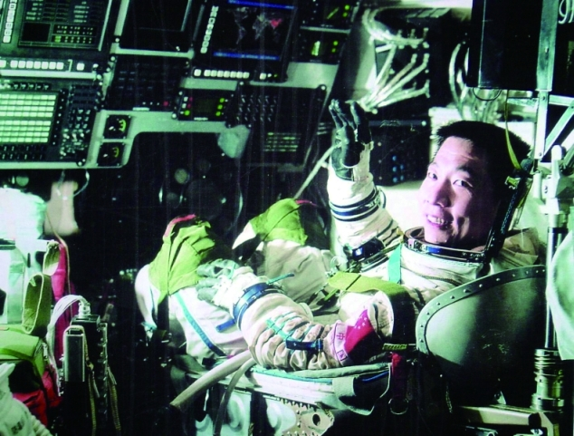
Yang worked very hard. In his first two years of training, Yang did not go to bed before midnight because he was studying so hard.
Yang has worked hard to achieve his dream. I want to do the same.
Danny Au, 11 years old

